PDS W5 Document Change Log
2006-A to 2006-B

Amendment History:

Version | Date | Amendment History
V1.0 | 21.09.05 | Approved

Approvals:

This document requires the following approvals.

Name | Signature | Title | Date of Issue | Version
Ken Lunn
Richard Kavanagh
Geri Oakley
James Hawkins

Document Location

This document is only valid on the day it was printed. Please contact the Document Controller for location details or printing problems.

This is a controlled document.

On receipt of a new version, please destroy all previous versions (unless a specified earlier version is in use throughout the project).

Contents

1. Purpose 4
2. Change Summary 4
3. Change Descriptions 5
3.1. Combined Update 5
3.2. Local Error Death Updates 8
3.3. Enhanced Proxies 10
3.4. Batch Tracing (Letter Generation) 11
3.5. Address Format 13

Purpose
This document describes the changes that have been made from PDS W5 2006-A (PDS P1R2 W5 v10.0 – NPFIT-FNT-TO-DPM-0022.10) to PDS W5 2006-B (PDS 2006-B v1.0 – NPFIT-FNT-TO-DPM-0421.05).

Notes:
- PDS P1R2 W5 v.9.0 relates to MIM 3.1.10 – this was included as part of release P1R2.
- PDS P1R2 W5 v10.0 relates to MIM 3.1.11 – this was originally planned to be included in P1R2 but was finally included in release 2006-A. The changes from PDS P1R2 W5 v9.0 to PDS P1R2 W5 v10.0 are detailed in Document Change Log v1.0 for PDS W5 v10.0.doc (NPFIT-FNT-TO-DPM-0291.04).

Change Summary

- Combined Update. 2006-A included Death Notification, Update Consent and General Update (previously known as PDS Update in the W5) messages. 2006-A also included a PDS Combined Update message. This consolidated the functionality provided by the three individual update messages into a single message. In 2006-B, the PDS Combined Update message has been renamed General Update and the individual Death Notification, Update Consent and General Update messages have been withdrawn.
- Local Error Death Updates (this relates to spine release bundle 312). Functionality has been introduced to allow Person Death Date and Status of Death Notification to be removed via the General Update message.
- Enhanced Proxies (this relates to spine release bundle 313). Functionality has been introduced to allow a proxy to record their willingness to accept calls from a call centre, such as used by Choose and Book.
- Batch Tracing to Support Letter Generation (this relates to spine release bundle 402). Functionality has been introduced to allow the standard Retrieval and Trace messages to be called via a generic batch mechanism.
- Address Format. Guidance relating to the use of the NHAIS address formatting convention has been removed for Advanced Trace, Trace Response, Retrieval Result and Confirm NHS Number Response.

Change Descriptions

Combined Update

Change No: | 1
Document Reference:  (section, page, paragraph, line no,  diagram, table entry, as appropriate) | Merge Death Notification message (section 7.4.1), PDS Update Message (section 7.4.2) and Update Consent message (section 8.1) into one General Update message  Merge PDS Update Response (section 7.4.3) and Update Consent response message (section 8.1.2) into one General Update response message
Description of Change:  (e.g. insertion, deletion, replacement with…) | Merge sections 7.4.1, 7.4.2 and 8.1 into a new section 7.4.1 titled General Update Message  Merge Section 7.4.3 and 8.2 into a new section 7.4.2 titled Update Response  Remove Chapter 8.0
Reason for Change:  (include requestor details) | Requested in response to the business need to send several ‘types’ of update in one message.  The requirement to use a new SCN for each update message is proving cumbersome in practice when more than one message is required for one update. Merging the messages provides capability to send one update for everything.
Date Approved by Project Board
Author: | Phil Brennan

Add:

7.1 Description

This message is used to update PDS with changes to a service user record. A Retrieval Request and Result must have been exchanged (to ensure the latest data is available)between the local system and PDS before updates to the Service User record can be accepted on to the local system and then sent to PDS.

7.4 Business Transactions

1 General Update
2 Update Response

Remove Section 7.4.1 Death Notification Message

Renumber 7.4.2 to 7.4.1

7.4.1 General Update

7.4.1.1 Purpose
This update allows modification of all updateable PDS data fields. For 2006-B, the Death Notification, General Update and Consent update messages have been merged into a single General Update message.

Legal Guardian, Proxy and Family/Close Contacts may be identified by NHS Number. If this is the case the corresponding details (name, address, and telecommunications) should be updated using the appropriate Service User Record. This prevents two sets of details being held for one Service User.

If the NHS number is unknown then the details should be included in the Legal Guardian, Proxy or Family/Close Contacts section.

In both cases the Effective Dates for this contact and the Ranking may be provided.

The consent data items are constrained by RBAC and IG guidance on Consent to record sharing.

The death update items are constrained by RBAC and the IG guidance on death updates.

Summary of data

Add:

Date of Death
Death Notification Status
Originating Authority
Consent to NHS Care Record

7.4.1.2 Business Communication Requirement

Amend the Communication Name to General Update

7.4.1.3 Business Communication Content

New Entries:

Level | Name | Definition | Example | Representation | Cardinality | Constraints and Dependencies
1.5.2 | Start Death group |  |  |  | 0..1
1.5.2.1 | PERSON DEATH DATE |  |  | Date/time | 1..1 | Time optional. Date must be provided in full.
1.5.2.2 | UPDATE MODE (DOD) | Defines the update mode for the data group. |  | Text | 1..1 | Added, altered. Dates will only be removed via the administration portal.
1.5.2 | End Death group
1.5.4 | Start Death Status group |  |  |  | 0..1 | Mandatory if Date of Death Update
1.5.4.1 | STATUS OF DEATH NOTIFICATION | Receipt of death notification |  | Coded | 1..1 | 1=(informal) death notice received via an update from a local NHS organisation such as a GP or Trust, 2=(formal) death notification received from the Registrar of Deaths. An informal update will be rejected if a formal status exists.
1.5.4.2 | UPDATE MODE (STATUS OF DEATH NOTIFICATION) | Defines the update mode for the data group. |  | Text | 1..1 | Added, altered or removed
1.5.4 | End Death Status group
1.6.1 | Start Consent to NHS Care Record Sharing |  |  |  | 0..1
1.6.1.1 | CONSENT TO NHS CARE RECORD SHARING | Consent Status |  | Coded | 1..1 | 1=Express Consent, 2= Express Dissent
1.6.1.2 | DATE LAST CHANGED |  |  | Date | 1..1
1.6.1.3 | CONSENT –SUPPLEMENTARY COMMENTS | Comments arising from any review by a patient with a clinician regarding consent. |  | Text | 0..1
1.6.1.4 | UPDATE MODE (CONSENT TO NHS CARE) | Defines the update mode for the data group. |  | Text | 1..1 | Added, altered or removed
1.6.1 | End Consent to NHS Care Record Sharing
1.15 | Start of Originating Registering Authority group |  |  |  | 0..1 | Mandatory if Date of Death update
1.15.2 | Choice 1  PRIMARY CARE TRUST |  |  | Coded | 0..1
1.15.3 | Start Choice 2 NHAIS group |  |  |  | 0..1
1.15.3.1 | NHAIS system identifier |  |  |  | 1..1
1.15.3.2 | NHAIS user identifier system identifier |  |  |  | 1..1
1.15.3 | End Choice 2 NHAIS group
1.15.4 | Start Choice 3 Other Organisation group |  |  |  | 0..1
1.15.4.1 | OTHER ORGANISATION | OCS Code |  | Coded | 1..1
1.15.4.2 | ORGANISATION TYPE | Type of organisation |  | Coded | 1..1
1.15.4 | End Choice 3 Other organisation group
1.15 | End of Originating Registering Authority group

Renumber 7.4.3 to 7.4.2

Remove Chapter 8.0 Update Consent

Local Error Death Updates

Change No: | 2
Document Reference:  (section, page, paragraph, line no,  diagram, table entry, as appropriate) | 7.4.1 General Update
Description of Change:  (e.g. insertion, deletion, replacement with…) | Update Purpose and Business Communication Content. See below for details.
Reason for Change:  (include requestor details) | Introduced to support spine release bundle 312. Functionality has been introduced to allow Person Death Date and Status of Death Notification to be removed via the General Update message.
Date Approved by Project Board
Author: | Phil Brennan

Section 7.4.1.1 Purpose

Remove:

The data content of the communication is limited to key details, given the nature of the role of the Registrar of Births, Marriages and Deaths. Removal of PERSON DEATH DATE will be restricted to users of the administrative portal. It will not be possible to remove a date of death using this message.

Add:

It is possible to remove Person Death Date and Status of Death Notification (introduced as part of Bundle 312 – Local Error Death Updates). Validation will ensure that if either Person Death Date or Status of Death Notification is removed, the other must also be removed (providing that the death notification is informal, i.e. Status of Death Notification = 1).

If Person Death Date and Status of Death Notification are removed, the Originating Registering Authority group will be automatically removed by PDS i.e. it is not necessary to explicitly remove the Originating Registering Authority group.

In P1R1, Status of Death Notification was not used so there may be records on PDS that have a null Status of Death Notification but a non null Person Death Date. For such cases, it is not possible to determine whether the death was notified “informally” or “formally”. The safest approach is to treat such cases as formal notifications; it will therefore not be possible to remove a Person Death Date if Person Death Date is not null and Status of Death Notification is null.

Update

Level | Name | Definition | Example | Representation | Cardinality | Constraints and Dependencies
1.5.2.1 | PERSON DEATH DATE |  |  | Date/time | 1..1 | Time optional. Date must be provided in full (unless UPDATE MODE = Removed).  If PERSON DEATH DATE is removed, STATUS OF DEATH NOTIFICATION must also be removed (introduced as part of Bundle 312 – Local Error Death Updates).  Attempts to remove PERSON DEATH DATE will be rejected if PERSON DEATH DATE is not null and STATUS OF DEATH NOTIFICATION is null (refer to Section 7.4.1.1).
1.5.2.2 | UPDATE MODE (DOD) | Defines the update mode for the data group. |  | Text | 1..1 | Added, altered or removed.
1.5.2 | End Death group
1.5.4 | Start Death Status group |  |  |  | 0..1 | Only provided if Date of Death present, then it is Mandatory
1.5.4.1 | STATUS OF DEATH NOTIFICATION | Receipt of death notification |  | Coded | 1..1 | 1=(informal) death notice received via an update from a local NHS organisation such as a GP or Trust, 2=(formal) death notification received from the Registrar of Deaths. An informal update will be rejected if a formal status exists.  Note Stillbirths are also recognised with Formal death status.  If STATUS OF DEATH NOTIFICATION is removed, PERSON DEATH DATE must also removed (introduced as part of Bundle 312 – Local Error Death Updates).
1.15 | Start of Originating Registering Authority group |  |  |  | 0..1 | Only provided if Date of Death present, then it is Mandatory.  If Date of Death and Status of Death Notification are removed, the Originating Registering Authority group will be automatically removed by PDS.

Enhanced Proxies
Change No: | 3
Document Reference:  (section, page, paragraph, line no,  diagram, table entry, as appropriate) | 4.4.1 Retrieval Request Message  7.4.1 General Update
Description of Change:  (e.g. insertion, deletion, replacement with…) | Update Additional Data Items and Business Communication Content. See below for details.
Reason for Change:  (include requestor details) | Introduced to support spine release bundle 313. Functionality has been introduced to allow a proxy to record their willingness to accept calls from a call centre, such as used by Choose and Book.
Date Approved by Project Board
Author: | Phil Brennan

Sections 4.4.2.1 / 7.4.1.1 Purpose

Add

Additional data items

Data item added to indicate the willingness of a proxy to accept calls from a call centre, such as used by Choose and Book (introduced as part of Bundle 313 – Enhanced Proxies).

Sections 4.4.2.2 / 7.4.1.2 Business Communication Requirement

Add

Level | Name | Definition | Example | Representation | Cardinality | Constraints and Dependencies
3.13 | PROXY CALL CENTRE CALL-BACK CONSENT | Willingness of a proxy to accept calls from a call centre, such as used by Choose and Book.  Added as part of Bundle 313 – Enhanced Proxies. |  | Coded | 1..1 | If PROXY NHS NUMBER exists, PROXY CALL CENTRE CALL-BACK CONSENT will not be set. CALL CENTRE CALL-BACK CONSENT should be retrieved instead for the patient record identified by PROXY NHS NUMBER.

Batch Tracing (Letter Generation)

Change No: | 4
Document Reference:  (section, page, paragraph, line no,  diagram, table entry, as appropriate) | 4.4.1 Retrieval Request Message  10 Batch Retrieval  11 Batch Trace  12 Appendix A – Generic Batch Request and Response: Proposed Logical Model
Description of Change:  (e.g. insertion, deletion, replacement with…) | Update and add new sections. See below for details.
Reason for Change:  (include requestor details) | Introduced to support spine release bundle 402. Functionality has been introduced to allow the standard Retrieval and Trace messages to be called via a generic batch mechanism.
Date Approved by Project Board
Author: | Phil Brennan

4.4.1.3 Business Communication Content

Update

Level | Name | Definition | Example | Representation | Cardinality | Constraints and Dependencies
0.9.1 | HISTORICAL DATA | Request historical information on retrieval |  | Coded | 1..1 | 0=return current/future values only, 1=return all values including historical data.  Note: when Retrieval Request is used as part of a batch (as described in Section 10), HISTORICAL DATA must be set to 0.

Add

10 Batch Retrieval

10.1 Description

Returns details of multiple patients based on a batch of NHS numbers (introduced as part of Bundle 402 – Batch Tracing). The request and response message definitions are based on the standard Retrieval Request and Result messages and are therefore not repeated here. Refer to Section Error: Reference source not found for details. Note: no historical data will be returned in the response.

The aim is to provide a generic framework to allow any Spine request message to be called as part of a batch. It is intended that a batch will be able to contain a set of requests for a single message type (e.g. Retrieval) or a mixture of request types (e.g. Retrieval and Trace). The generic batch elements are to be defined by the Core Technical Team. Refer to Appendix A for a description of the proposed logical structure for the batch request and response messages (provided for illustrative purposes only).

10.2 Clinical Scenario

One of the consultants at the Optometry department at the RD&E Hospital in Devon is taken ill suddenly and looks likely to be off on long term sick for 3 months. The department manager immediately attempts to rearrange cover for her, but is forced to reschedule a number of appointments within that period. In order to inform all the patients affected it is decided that each one will be sent a letter explaining the situation and offered an alternate appointment. Their local system is NCRS compliant so in order to ensure that the letters go to the most up to date addresses, the administrator puts together a Batch Retrieval request, with NHS Numbers, for all the patients affected. This is sent to the SPINE via the ‘Batch Retrieval’ message. The SPINE returns the ‘Batch Retrieval Response’ with details for each patient. The administrator then proceeds to update the local system where necessary and produce the letters required.

11 Batch Trace

11.1 Description

Provides the ability to search for a set of patients given a suitable combination of name, DoB and address or postcode (introduced as part of Bundle 402 – Batch Tracing). The request and response message definitions are based on the standard Trace and Trace Response messages and are therefore not repeated here. Refer to Sections Error: Reference source not found and Error: Reference source not found for details.

The aim is to provide a generic framework to allow any Spine request message to be called as part of a batch. It is intended that a batch will be able to contain a set of requests for a single message type (e.g. Retrieval) or a mixture of request types (e.g. Retrieval and Trace). The generic batch elements are to be defined by the Core Technical Team. Refer to Appendix A for a description of the proposed logical structure for the batch request and response messages (provided for illustrative purposes only).

11.2 Clinical Scenario

The local PAS system at the A&E in Exeter is about to become NCRS compliant. It has a number of entries for patients without NHS Numbers. In order to reconcile it’s database against the PDS it sends a ‘Batch Trace’ including the details of the patients without numbers. The ‘Batch Trace Response’ returns details of all the exact matches it has found on the PDS and the local system is updated accordingly.

All cases where an exact match was not possible are noted and investigated individually.

12 Appendix A – Generic Batch Request and Response: Proposed Logical Model

Note: the following diagram (supplied by the Spine NASP) presents a proposed logical structure for the batch request and response components. It is provided for illustrative purposes only. It does not necessarily indicate how the final design will be realised.

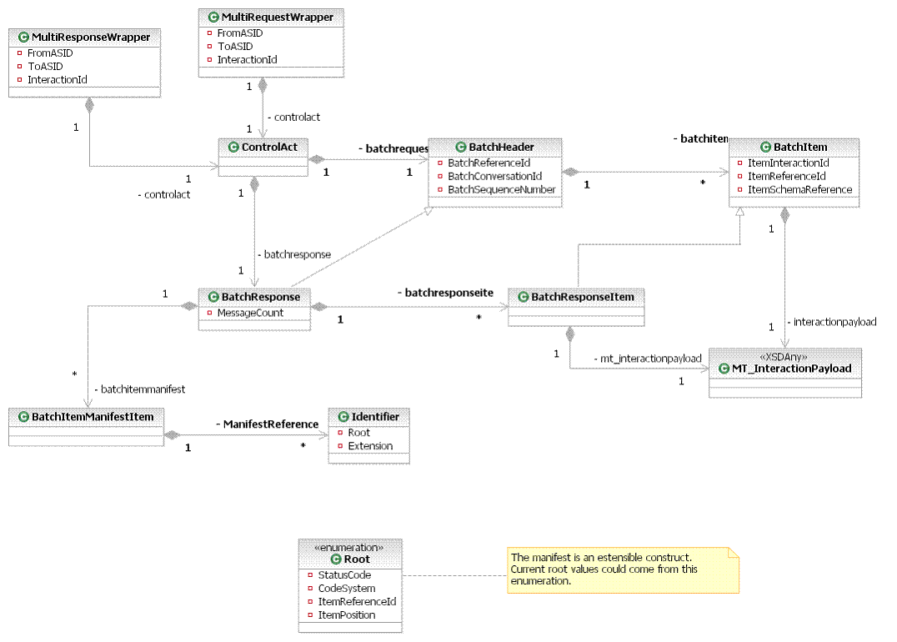

Address Format

Change No: | 5
Document Reference:  (section, page, paragraph, line no,  diagram, table entry, as appropriate) | 2.4 Address Format  Business Communication Content for Advanced Trace, Trace Response, Retrieval Result and Confirm NHS Number
Description of Change:  (e.g. insertion, deletion, replacement with…) | Remove guidance relating to address format. See below for details.
Reason for Change:  (include requestor details) | Guidance relating to the use of the NHAIS address formatting convention will be removed for Advanced Trace, Trace Response, Retrieval Result and Confirm NHS Number Response. This is because the format of addresses currently stored on PDS can not be guaranteed to comply with the NHAIS convention. The guidance relating to the population of addresses on PDS (i.e. via Allocate NHS Number and General Update messages) has been kept.
Date Approved by Project Board
Author: | Phil Brennan

Section 2.4 Address Format

Replace existing text with:

Addresses in PDS are composed of the following components:

- between one and five unstructured address lines
- postcode
- a PAF (Postal Address File) key

Addresses in NHAIS are also stored as 5 address lines plus postcode and PAF key. The following format is used:

- Address Line 1: Premises ID (House Name)
- Address Line 2: No/Thoroughfare
- Address Line 3: Locality
- Address Line 4: Post Town
- Address Line 5: County

The NHAIS address format shall be used when inserting/updating unstructured addresses in PDS, as illustrated below:

PDS Field | Required format
Address 1 | Premises ID
Address 2 | No/Thoroughfare
Address 3 | Locality
Address 4 | Post Town
Address 5 | County
Postcode | Post code

Assumptions and Constraints

- The NHAIS address format will apply to addresses inserted or updated via the Allocate NHS Number and General Update messages. The following address lines are deemed to be mandatory:
- address line 1 OR address line 2 AND
- address line 4

Remove the following text from the Definition and Constraints & Dependencies columns for:

- ADDRESS UNSTRUCTURED in the Advanced Trace message:

Definition

For vernacular addresses, the following formatting convention should be used:

line 1: premises ID
line 2: no/thoroughfare
line 3: locality
line 4: post town
line 5: county

Constraints & Dependencies

For vernacular addresses, it is assumed that each supplied address line will only be matched against the corresponding address line held on PDS i.e. to search against post town address line 4 would need to be supplied.

Remove the following text from the Definition and Constraints & Dependencies columns for:

- ADDRESS UNSTRUCTURED in the Trace Response, Retrieval Result and Confirm NHS Number Response messages

Definition

For vernacular addresses, the following formatting convention should normally apply although there may be some exceptions:

line 1: premises ID
line 2: no/thoroughfare
line 3: locality
line 4: post town
line 5: county

Constraints & Dependencies

The following address lines should normally be mandatory although there may be some exceptions:

- 1 or 2 and
- 4

Replace the existing text in the Definition and Constraints & Dependencies columns for:

- ADDRESS UNSTRUCTURED in the Common Person Group

Definition

For vernacular addresses, if the address is used as part of an update message, the following formatting convention should be used:

line 1: premises ID
line 2: no/thoroughfare
line 3: locality
line 4: post town
line 5: county

Constraints & Dependencies

If the address is used as part of an update message, the following address lines are mandatory:

- 1 or 2 and
- 4

