Communications & Messaging Programme
National Services PSIS Query Business Communication Specification
NCRS Phase 1 Release 2 Build 3

Amendment History

Version | Author | Date | Amendment History
0.6 | Jon Cooper | 11/03/04 | Revision of document post QR returns
0.7 | Jon Cooper | 18/03/04 | Post CTT input
0.8 | Jon Cooper | 19/03/04 | Post TO meeting
1.0 | Jon Cooper | 19/03/04 | Approved Document
1.1 | Jon Cooper | 16/04/04 | Draft - Post BT comments & internal review
1.2 | John Weight | 20/04/04 | Note added to IG section to reflect status of NPfIT/NASP discussions around access control
1.3 | Jon Cooper | 23/04/04 | Removal of ‘Problem Oriented View – Detailed’ related items which were missed previously
1.4 | Jon Cooper | 27/04/04 | Removal of XPointer and all references to it
1.5 | Jon Cooper | 29/04/04 | Removal of superfluous information in message responses; see Change log entries 34 & 35
2.0 |  | 05/05/04 | Approved
2.1 | Jon Cooper | 28/05/04 | Change of Document Number – See Change Log entry 1  Addition of Dissent Override details; see Change Log entry 2-4
2.2 | Jon Cooper | 11/06/04 | Addition of an extra set of Queries post BT discussions – See Change Log entry 5
2.3 | Jon Cooper | 16/06/04 | Replacement of the XML fragment statements as per BT/NPFIT discussions 15/06/04 – See Change log entries 6 & 7
2.4 | Jon Cooper | 16/08/04 | De-scoping of some of the Summary Views – See Change Log entry 8
2.5 | Jon Cooper | 17/09/04 | Revision of Scoping post BT discussions – See Change Log entry 9
2.6 | Jon Cooper | 17/12/04 | Addition of Override Dissent Reason Code table at Section 7.2. This table is now referenced from those message content entries as required

Approvals
This document requires the following approvals.

Name | Signature | Title | Date of Issue | Version
Max Jones |  | Programme Head | 29/04/04 | 2.0
Max Jones |  | Programme Head |  | 3.0

Document Location
This controlled document is only valid on the day it was printed. Please contact the Document Controller for location details or printing problems. On receipt of a new version, please destroy all previous versions (unless a specified earlier version is in use throughout the project).

© Crown Copyright 2004 Unauthorised copying, distribution, renting, lending or communicating to the public of all or a substantial part of any Crown Copyright material is prohibited. Licences for the use of Crown Copyright material are available from Her Majesty's Stationery Office, at http://www.hmso.gov.uk (click on 'Click-Use licences'). All trade marks and logos are the property of their respective owners. The use of any trade mark or logo without the prior written permission of the relevant owner is prohibited.
Related Documents
These documents will provide additional information.

Ref no | Doc Reference Number | Title | Version
1 | NPFIT-NPO-GEN-IP-0067 | Glossary of Terms Consolidated.doc | Latest
2 | NPFIT-NCR-DES-0135 | NHS Care Record Elements | 1.1
3 | NPFIT-TO-MM-MR-1 | Medication Rules for PSIS | 0.8
4 | NPFIT-NDA-GEN-IG-0252 | RBAC Requirements for Issue | 6.1

Glossary of Terms
List any new terms created in this document. Mail the librarian to have these included in the master glossary above [1].

Term | Acronym | Definition
Care Record Elements | CRE | The National Care Record ‘building blocks’ of clinical information. For clarity these are listed as a set of headings which describe the clinical purpose. All clinical information in scope for National Care Records will be classified by these headings. Sub-element headings have also been defined and are recognised in this specification as self-standing headings, in the way they are processed.
Clinical Statement | CS | The basic unit of clinical information. It cannot be safely be broken down further and still be guaranteed to make sense. A clinical statement can be simple (e.g. ‘weight is 72.1 kgs’), or compound, made up of 2 or more subordinate statements (e.g. a ‘blood pressure measurement’ statement and its two components ‘systolic blood pressure 140 mm Hg’, ‘diastolic blood pressure 90 mm Hg’)
Care Event | CE | It is any occasion during which a healthcare professional, and/or the patient, and/or their carer, makes a material contribution to the health care of the patient. Much of the information known about the patient is generated during care events. A GP encounter, the patient’s admission to hospital and an in-patient spell are all care events.
Universally Unique Identifier | UUID | A unique identifier issued by an LSP, or non-LSP (e.g. CSA, ETP, Community Pharmacy) to a Clinical Statement that is entered into one of its systems. This uniquely identifies each Clinical Statement within all Clinical Statements stored electronically within NPfIT. It never changes, and always accompanies the statement when it is communicated as part of a message.HL7 supports the DCE standard UUID
Role Based Access Control | RBAC | The method by which access to stored information is controlled by a combination of authorities based upon Unique User IDs and Role Profile Codes.
Dissent |  | This where a patient has not given consent for their records to be viewed by others.

Contents

1. Purpose 6
2. Introduction 7
3. PSIS Query 10
3.1. Description 10
3.2. Clinical Scenario 10
3.3. Activity Diagram 11
3.4. Business Communications 12
3.4.1. PSIS Query Request 12
3.4.2. PSIS Query Response 14
3.4.3. PSIS Query Reject 15
4. PSIS Detailed Query (aka PSIS Statement Query) 17
4.1. Description 17
4.2. Clinical Scenario 17
4.3. Activity Diagram 18
4.4. Business Communications 19
4.4.1. PSIS Detailed Query Request 19
4.4.2. PSIS Detailed Query Response 21
4.4.3. PSIS Query Reject 22
5. PSIS DPA Subject Access Query 23
5.1. Description 23
5.2. Clinical Scenario 23
5.3. Activity Diagram 24
5.4. Business Communications 25
5.4.1. PSIS DPA Subject Access Query Request 25
5.4.2. PSIS DPA Subject Access Query Response 26
5.4.3. PSIS Query Reject 28
6. PSIS Event Queries 29
6.1. Description 29
6.2. Clinical Scenario 29
6.3. Activity Diagram 30
6.4. Business Communications 31
6.4.1. PSIS Event List Query Request 31
6.4.2. PSIS Event List Query Response 33
6.4.3. PSIS Event Query Request 34
6.4.4. PSIS Event Query Response 36
6.4.5. PSIS Query Reject 37
7. APPENDIX 1 – Code tables 38
7.1. Error Codes (Simple Value) 38
7.2. Override Dissent Reason Codes 38

Purpose

- This document describes in detail the message content of each of the required business communications. Where there are many business processes, these shall be encompassed in separate sections of a single W5
- It forms the deliverable for each Work Stream Domain – Business Communication definition and refinement stage (W5) in accordance with the Communications & Messaging Programme Development methodology
- It lists, at a data level, any issues that have been identified that would hinder development and/or implementation
- It conveys the proposed communications content to the Programme’s Technical (message development) team to enable them to design the required HL7 message constructs; and similarly to the suppliers that will have to build them
- It is a partial, but critical step on the path to a complete message specification being available

NOTE:
- This document describes PSIS Query for Phase 1 Release 2. Further work will be required to define the requirements for Phase 2 Releases 1 & 2.

Introduction

Clinicians may be able gain access to the NHS Care Record Spine (NCRS) using one of the following:

- Via an upgraded compliant legacy application
- Via a new NHS Care Record compliant system
- Via the Clinical Spine Application (CSA) provided by BT

In each of these situations the systems will be required to query the service user’s NHS Care Record as held on PSIS to be able to populate the screens displayed with NHS Care Record data.

It is proposed that there will be a ‘PSIS Query’ to support a logical data extraction at the Care Record Element level. These logical elements are fully defined in the NPfIT - Technology Office - NHS Care Record Elements document v1.2.

Each of the above identified CREs may have an association with one of more other entities. The number of associations possible and the ‘role’ that they play in each association vary according to the specific entities involved in the relationship.

The ‘PSIS Query’ will not only allow the selection of instances of a specific entity but may optionally return the associated or linked entities.

In the PSIS Query, by definition some links may not be returned, in these cases only a pointer or ‘UUID’ to the element will returned. At the lower levels this will point to a physical component of an entity, or ‘clinical statement’. These will be the dispersed parts of the HL7 messages used to populate PSIS in the first instance. Their structure, at the atomic data item level, will vary greatly between the many clinical statement types.

Given the UUID of a physical clinical statement there needs to be a mechanism by which the enquiring clinical application can request the detailed clinical information held within the statement and any other links to, or information contained within, any other linked statements. The use of this query will be restricted to retrieval of information stored on PSIS only.

The ‘PSIS Detailed Query’ has been created to satisfy this requirement; it will support an enquiry on one clinical statement UUID.

Filters and Context

With NCRS development the level of sophistication in filtering and sorting information will increase. The context of the information will provide an important means to filter data. Furthermore, the response data may be filtered in a number of ways, for example by date range. The resultant data will be sorted in reverse chronological order within each CRE type.

In this document filtering has been assumed to occur at the requesting (local) system.
Unless otherwise stated all PSIS queries will ignore a clinical statement that has been cancelled or ‘nullified’ (i.e. has been declared never to have been true).
Contents of the response to a query

Each PSIS query response may contain data relating to one or more Care Record Elements. Each Care Record Element will consist of an XML fragment that comprises the content of the Clinical Statement for that Care Record Element, together with all inherited provenance and context information.

Ordering of the response data

Where the response comprises a set of records, they will appear in the response data in reverse chronological order of entry, by time of entry into PSIS. However, any Clinical Correspondence MUST be returned exactly as it was originally supplied to PSIS by the source system.

Information Governance

Note: The division of responsibility between the NASP and LSPs for access control checks is still under discussion in another thread of NPfIT/NASP activity. The statements made in this document will be superceded by the future outcome of those discussions.

Three levels of validation are required by the NHS Care Record Spine on receipt of a PSIS query of any type. In order of importance these are:

- Service user consent check to prevent patient data being deliberately or accidentally exposed in response to a fraudulent or erroneous request respectively. If this is found to be the case an error response is generated rejecting the query.
- Legitimate relationship check to ensure that the PSIS query request has come from a health or social care professional with a right to access the specified service user’s care record. If this is found not to be the case an error response is generated rejecting the query.
- Role Based Access Control (RBAC) filtering to prevent patient data being exposed to a health or social care professional who does not have the required privileges. [Assumed minimal – still under discussion]

Assumptions:
- The message payload information required to support the Information Governance checks above are the service user’s NHS Number and the PSIS Query requestor’s User Unique Identifier and Role Profile Code.
- In this document it has been assumed that Access Control Frameworks (ACFs) will be applied at both PSIS Query Response Sender and PSIS Query Response receiver

Dissent Override

In special circumstances, it will be necessary for a service user to be able to override the patient’s previously stated dissent to viewing their electronic record. In these instances the service user will first need confirm that they wish to override a patient’s dissent. This confirmation includes a coded reason for doing so and a textural expansion of the reason code. Before confirmation is progressed, the user must be informed by their local system that these data items are a requirement. They must also be informed that the Caldecott Guardian will be immediately informed of any override and that inappropriate use of the override dissent facility can lead to disciplinary action and/or prosecution.

NHS Number validation

It has been assumed throughout this document that the service user has already checked the PDS for the patient’s details. Amongst these details is the NHS Number. Once received by the local system this number must be stored against the local record for the patient. The service user cannot change this number and no interface should allow them to manually enter this for a PSIS Query.

Known Issues

Further work is required to refine the relationship types used to link Care Record Elements and Clinical Statements referred to in this document. This work should also recognise the bi-directional nature of these relationships and the fact that they have attributes of their own.

Technical Errors

In the Activity Diagrams, there is an assumption throughout, that at all stages, technical errors are trapped and appropriate error messages are generated.

PSIS Query

Description

The PSIS Query is intended to allow the local ISP system to construct a query for information regarding one or more specified CREs within a service user’s NHS Care Record. It uses the logical level construct of the NHS Care Record, the CRE type, to form the request, e.g. a request for all ‘Diagnosis’ or all ‘Procedures’ for a service user.

Clinical Scenario

Mr. Frederick Harper, a Consultant Haematologist, wants to gain an insight into the clinical circumstances of his patient, Mr. Peter Pan. He has looked after Peter before because of his Non-Hodgkins Lymphoma.

Mr Pan has been away in the north for the last 2 years and Mr Harper wants to see if Peter has had any further Chemotherapy. Mr. Harper elects to query the information held on Peter’s NHS Care Record. His local Trust systems has been upgraded to allow access to the NHS Care Record Spine and he can now elect to query Peter’s NHS Care Record in a number of different ways. In this instance Dr Harper chooses to view only the ‘Medication’ component of Peter’s record. He also applies a date filter to limit the information return to just the last year. He is presented with this clinical information on his local system. [Note, further PSIS requests may follow to retrieve further clinical detail]

Activity Diagram
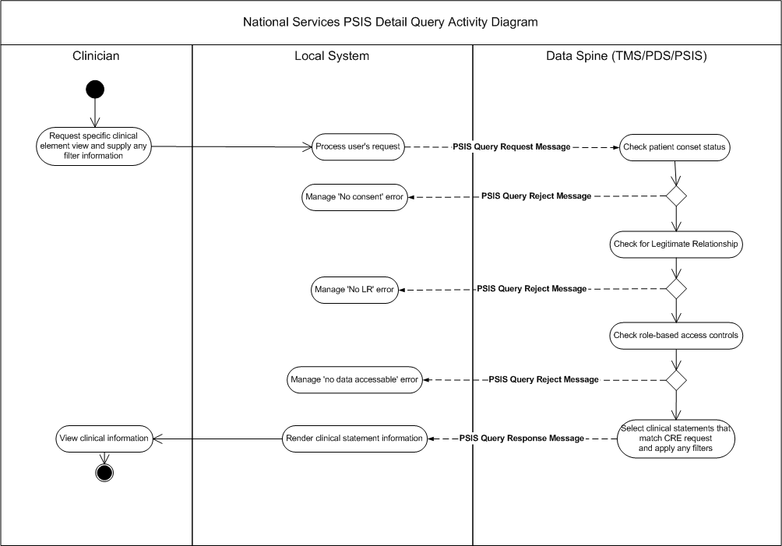

Note: the LR and RBA checks may be performed on the local system

Business Communications
- PSIS Query Request
- PSIS Query Response
- PSIS Query Reject

PSIS Query Request

Purpose

To request PSIS information for a specified service user. The request allows the explicit retrieval of one or more logical data types of the NHS Care Record know as Care Record Elements (CREs). By default only the CRE data attributes and link identifiers are returned.

Business Communication Requirement

Communication Name | PSIS Query Request
Sending Role | Query Sender
Trigger Event | Clinician request via a local ISP system for specific PSIS CRE information
Communication Type | Query
Receiving Role | Query Responder

Business Communication Content

Level | Name Item /  Group | Definition | Example | Representation | Cardinality | Constraints & Dependencies
1 | PSIS Query Information |  |  |  | 1..1
1.1 | PSIS Query ID | Unique identifier for this query message |  | UUID | 1..1
2 | Individual Patient Information |  |  |  | 1..1
2.1 | NHS number | NHS number |  | DD NHS Number | 1..1
3 | Query Originator Information |  |  |  | 1..1
3.1 | User ID | SDS identifier for care professional invoking the query |  | ID | 1..1
3.2 | Role profile Code | The (RBAC) role profile code in which the HCP has requested this query |  | ID | 1..1
4 | Query Detail Information |  |  |  | 1..1
4.1 | CRE type | Care Record Element type as defined in the ‘NHS Care Record Elements’ document |  | SNOMED | 1..1 | List not available yet
5 | Dissent Override information |  |  |  | 1..1
5.1 | Override Dissent Flag | Boolean Flag through which the service user requests that patient dissent should be overridden. |  | Boolean | 1..1 | Values:  1 = Override  0 = No override  Must only be set to 1 if the user has been warned that the patient has dissented and has confirmed that despite this they wish to override dissent.
5.2 | Override Dissent Reason Information |  |  |  | 0..1 | Must be present whenever the override dissent flag is set to 1.
5.2.1 | Override Dissent Reason Code | A code indicating the reason for the override, provided for insertion in the alert that must be raised by the NASP as a consequence of overriding dissent. |  |  | 1..1 | For acceptable values see the listing in Section 7.2
5.2.2 | Override Dissent Reason Text | Further explanation of the reason for override, provided for insertion in the alert that must be raised by the NASP as a consequence of overriding dissent. |  | No existing equivalent in the Data Dictionary. Format for similar free-text fields is AN255 | 1..1 | Free text present when available (i.e. whenever entered by the user).

PSIS Query Response

Purpose

The synchronised response message to the PSIS Query request message returning the appropriate elements of the service user’s NHS Care Record that meet the specified selection criteria.

Business Communication Requirement

Communication Name | PSIS Query Response
Sending Role | Query Response Sender
Trigger Event | Fulfilment of the PSIS query request by the NHS Care Record Service
Communication Type | Query
Receiving Role | Query Response Receiver

Business Communication Content

Level | Name Item/  Group | Definition | Example | Representation | Cardinality
1 | PSIS Query Response Information |  |  |  | 1..1
1.2 | PSIS Query ID | Unique identifier for the original query message |  | UUID | 1..1
2 | Individual Patient Information |  |  |  | 1..1
2.1 | NHS Number |  |  | DD NHS Number | 1..1
3 | Care Event Group |  |  |  | 1..1
3.1 | CRE Type according to request |  |  | SNOMED | 1..1
3.2 | Clinical Statement Group |  |  |  | 1..*
3.2.1 | PSIS Event Persistence Date | Date and time the event was received by PSIS |  | yyyymmddhhmmss | 1..1
3.2.2 | PSIS Event Status | Status of the event |  | Value could be one of the following:  - Normal  - Nullified  - Replaced | 1..1
3.2.3 | PSIS Statement ID | The unique ID for this Clinical Statement |  |  | 1..1
3.2.4 | PSIS Event ID | The unique ID for the PSIS Event which carried this Clinical Statement |  | FocusActOrEvent.id | 1..1
3.2.5 | Clinical Statement Type | The text describing the type of Clinical Statement |  |  | 1..1
3.2.6 | Statement Data | HL7 Statement from the original communication |  |  | 1..1

PSIS Query Reject

The PSIS query reject message can be returned for any of the PSIS queries

Purpose

To inform the ISP system making the query that the request cannot be fulfilled and that no PSIS data can be returned. A reason for failure is returned in the error message

- No Legitimate Relationships exist for the query originator (system user)
- No explicit or implicit Service User Consent exists for Sharing of this Record
- There are no care records corresponding to the NHS Number supplied
- The user’s RBAC does not permit access to any of the response data

Business Communication Requirement

Communication Name | PSIS Query Reject
Sending Role | Query Reject Sender
Trigger Event | Fulfilment of the PSIS query request by the NHS Care Record Service has failed
Communication Type | Query
Receiving Role | Query Reject Receiver

Business Communication Content

Level | Name Item/  Group | Definition | Example | Representation | Cardinality | Constraints & Dependencies
1 | PSIS Query Reject Information |  |  |  | 1..1
1.1 | PSIS Query Reject ID | The Unique identifier for the query which has caused the reject message |  | UUID | 1..1
2 | Individual Patient Information |  |  |  | 1..1
2.1 | NHS number | NHS number |  | DD NHS Number | 1..1
3 | Error information |  |  |  | 1.1
3.1 | Error code | The code used to describe the error which caused the query to fail | PQR-05 | Coded Simple Value (CSV)  See Appendix 1 | 1..1 | These need to be agreed

PSIS Detailed Query (aka PSIS Statement Query)

Description

The PSIS Detailed query allows the local ISP system to interrogate PSIS using one or more explicit clinical statement identifiers (UUIDs). These identifiers will first have to be retrieved by the requesting system by using a PSIS Query message; they represent the links to other components of the care record that are not returned explicitly by that query. The use of the Detailed Query message therefore allows these links to be in a sense ‘traversed’ by supporting the request for detailed information about the care record element referenced by the link, i.e. at the other end of it.

N.B. As this is a further query of an individual UUID returned in a previous query, there is no dissent override required.

Clinical Scenario

Mrs Mary Smith takes a tumble and hurts when on holiday and visits the A&E department at a local hospital. Mary tells the registrar that she
Doctor Bill Jones has seen Mrs Mary Smith, she has told him that whilst on holiday last summer in Blackpool she had recourse to see an Emergency Doctor because her leg became swollen and very painful.
He decides that he needs to view the clinical data around this clinical event. He logs onto his local system and request access to Mary’s NHS Care Record. From a menu option is possible to specific a required Care Record Event Listing. Dr Jones makes the selection. The local system then presents him with a list of the Care Events listed for Mrs Jones.
He sees that there is one for a Blackpool NHS Trust. He clicks on this item reviews the other information returned for that care event. [Note, further PSIS requests may follow to retrieve more clinical detail]

Activity Diagram
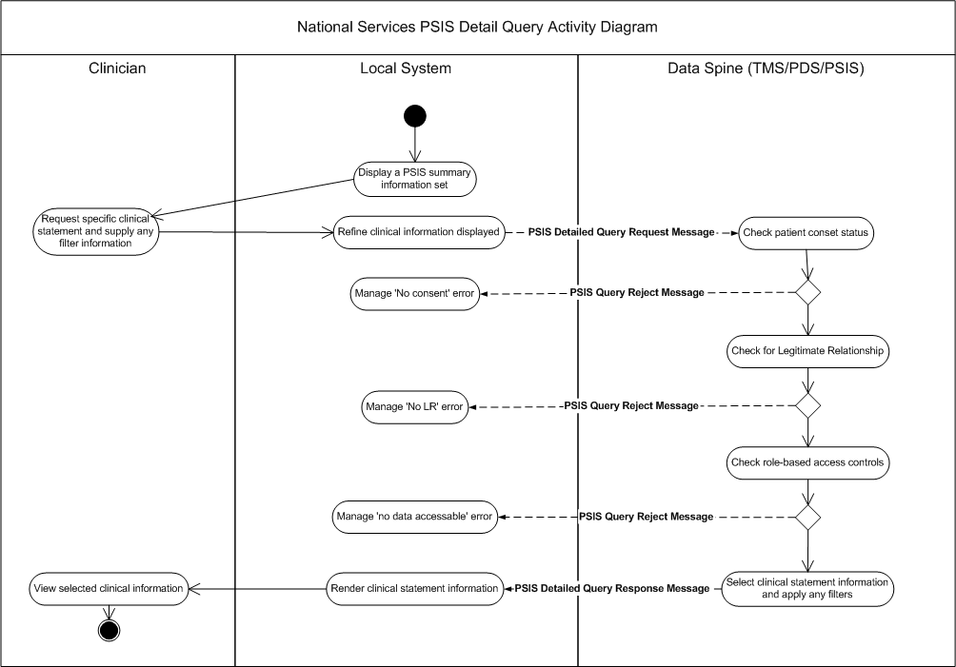

Note: the LR and RBA checks may be performed on the local system

Business Communications

1. PSIS Detailed Query Request
2. PSIS Detailed Query Response
3. PSIS Query Reject

PSIS Detailed Query Request

Purpose

To allow the local ISP system to request care information about one clinical statement given their unique PSIS references or UUIDs. All the information linked to that statement is returned by default.

Business Communication Requirement

Communication Name | PSIS Detailed Query Request
Sending Role | Query Sender
Trigger Event | Clinician request via a local ISP system for information about a specific clinical statements using their UUID identifiers
Communication Type | Query
Receiving Role | Query Responder

Business Communication Content

Level | Name Item/  Group | Definition | Example | Representation | Cardinality | Constraints & Dependencies
1 | PSIS Detailed Query Information |  |  |  | 1..1
1.1 | PSIS Detailed Query ID | Unique identifier for this query message |  | UUID | 1..1
2 | Patient Information |  |  |  | 1.1
2.1 | NHS number | NHS number |  | DD NHS Number | 1..1
3 | Query Originator Information |  |  |  | 1..1
3.1 | User ID | SDS identifier for care professional invoking the query |  | ID | 1..1
3.2 | Role profile Code | The (RBAC) role profile code in which the HCP has requested this query |  | ID | 1..1
4 | Query Detail Information |  |  |  | 1..1
4.1 | Clinical statement identifier | Care Record Element unique identifier (as defined in the ‘NHS Care Record Elements’) or the unique identifier for a linked clinical statement |  | UUID | 1..1
5 | Dissent Override information |  |  |  | 1..1
5.1 | Override Dissent Flag | Boolean Flag through which the service user requests that patient dissent should be overridden. |  | Boolean | 1..1 | Values:  1 = Override  0 = No override  Must only be set to 1 if the user has been warned that the patient has dissented and has confirmed that despite this they wish to override dissent.
5.2 | Override Dissent Reason Information |  |  |  | 0..1 | Must be present whenever the override dissent flag is set to 1.
5.2.1 | Override Dissent Reason Code | A code indicating the reason for the override, provided for insertion in the alert that must be raised by the NASP as a consequence of overriding dissent. |  |  | 1..1 | For acceptable values see the listing in Section 7.2
5.2.2 | Override Dissent Reason Text | Further explanation of the reason for override, provided for insertion in the alert that must be raised by the NASP as a consequence of overriding dissent. |  | No existing equivalent in the Data Dictionary. Format for similar free-text fields is AN255 | 1..1 | Free text present when available (i.e. whenever entered by the user).

PSIS Detailed Query Response

Purpose

The synchronised response message to the PSIS Detailed Query request message returning the specified clinical statement from of the service user’s NHS Care Record.

Business Communication Requirement

Communication Name | PSIS Detailed Query Response
Sending Role | Query Response Sender
Trigger Event | Fulfilment of the PSIS query request by the NHS Care Record Service
Communication Type | Query
Receiving Role | Query Response Receiver

Business Communication Content

Level | Name Item/  Group | Definition | Example | Representation | Cardinality
1 | PSIS Detailed Query Response Information |  |  | identifier | 1..1
1.1 | PSIS Detailed Query ID | Unique identifier for original query message |  | UUID | 1..1
2 | Patient Information |  |  |  | 1..1
2.1 | NHS Number |  |  | DD NHS Number | 1..1
2.2 | CRE Type |  |  |  | 1..1
2.3 | Clinical Statement Group |  |  |  | 1..1
2.3.1 | PSIS Event Persistence Date | Date and time the event was received by PSIS |  | yyyymmddhhmmss | 1..1
2.3.2 | PSIS Event Status | Status of the event |  | Value could be one of the following:  - Normal  - Nullified  - Replaced | 1..1
2.3.3 | PSIS Statement ID | The unique ID for this Clinical Statement |  |  | 1..1
2.3.4 | PSIS Event ID | The unique ID for the PSIS Event which carried this Clinical Statement |  | FocusActOrEvent.id | 1..1
2.3.5 | Clinical Statement Type | The text describing the type of Clinical Statement |  |  | 1..1
2.3.6 | Statement Data | HL7 Statement from the original communication |  |  | 1..1

PSIS Query Reject

As per PSIS Query Reject Message defined in Section 3.4.3

PSIS DPA Subject Access Query

Description

There is considered to be one instance in which a Service User will need to be able to retrieve ALL the data stored (including related Cancelled or Nullified data) against their NHS Care Record – via the Data Protection Agency guidelines. This query is to be called the PSIS DPA Subject Access Query.

N.B. There may be several methods of access by which a patient can either directly retrieve or approach a requisitely authorised person to do so. Questions as to how they receive this data and in what format are outside of the remit of this development. For the purposes of the document we will assume that the patient has approached a third party – a Caldicott Guardian (who may not be a HCP) – who will interact as a RBAC superuser with the NCRS.
It is also assumed that you cannot gain access to this query functionality if you don’t have the appropriate RBAC, and that this will be an auditable process.

Clinical Scenario

Mr Peter Jones decides that he wants to see what has been recorded in his medical record. He finds out from his GP that he has to write to Dr. Gerald Frederickson, the local Caldicott Guardian, giving his full name, address, Date of Birth and NHS Number details (if known).
Peter does so.
Dr Frederickson, on receiving the letter from Peter Jones, logs onto his local terminal using his superuser access. He selects the local patient database and finding Peter on it selects him. The local system performs a PDS Query and Dr Frederickson is shown the updated information.
He then selects the PSIS DPA Subject Access Query function.
The local system prompts for a double check before continuing.
Dr Frederickson then confirms that he wants to retrieve all the held records for Mr Peter Jones, and that he is overriding any dissent.
The local system receives these back and prompts Dr Frederickson as to storage method. He chooses DVD-RW, carefully labelling the disk and the holder before storing them in his lockable safe. He contacts Peter to arrange a day & time in which Peter can collect his copy.

Activity Diagram
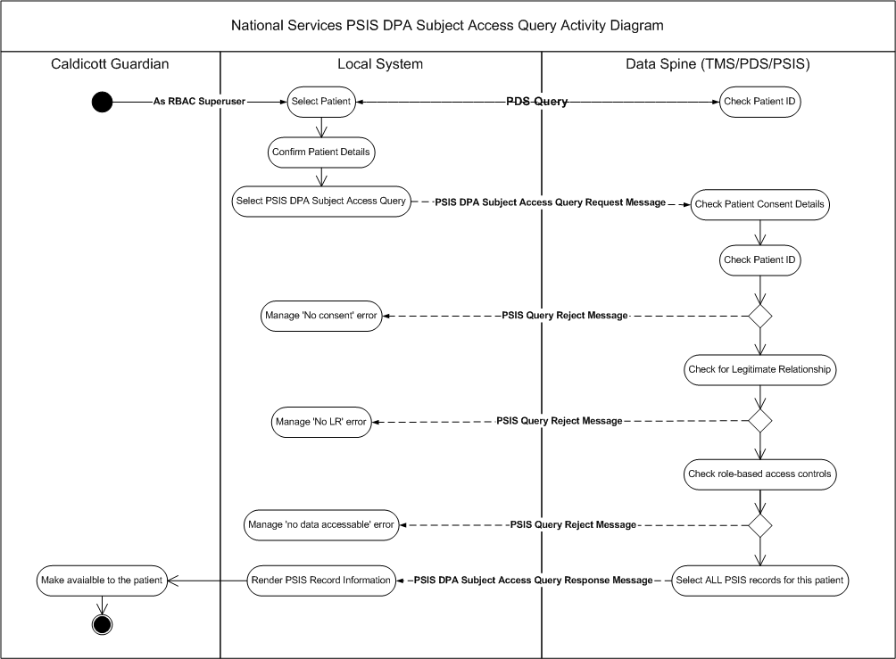

Note: the LR and RBA checks may be performed on the local system

Business Communications

1. PSIS DPA Subject Access Query Request
2. PSIS DPA Subject Access Query Response
3. PSIS Query Reject

PSIS DPA Subject Access Query Request

Purpose

To allow the Service User to request All the care information about him/her held on PSIS. All the information linked to that patient is returned by default.

Business Communication Requirement

Communication Name | PSIS DPA Subject Access Query Request
Sending Role | Query Sender
Trigger Event | Service User request via a local ISP system for all information about themselves
Communication Type | Query
Receiving Role | Query Responder

Business Communication Content

Level | Name Item/  Group | Definition | Example | Representation | Cardinality | Constraints & Dependencies
1 | PSIS DPA Subject Access Query Information |  |  |  | 1..1
1.1 | PSIS DPA Subject Access Query ID | Unique identifier for this query message |  | UUID | 1..1
2 | Individual Patient Information |  |  |  | 1.1
2.1 | NHS number | NHS number |  | DD NHS Number | 1..1
3 | Query Originator Information |  |  |  | 1..1
3.1 | User ID | SDS identifier for care professional invoking the query |  | ID | 1..1
3.2 | Role profile Code | The (RBAC) role profile code in which the HCP has requested this query |  | ID | 1..1 | Must have DPA Authority or equivalent
4 | Dissent Override information |  |  |  | 1..1
4.1 | Override Dissent Flag | Boolean Flag through which the service user requests that patient dissent should be overridden. |  | Boolean | 1..1 | Values:  1 = Override  0 = No override  Must only be set to 1 if the user has been warned that the patient has dissented and has confirmed that despite this they wish to override dissent.
4.2 | Override Dissent Reason Information |  |  |  | 0..1 | Must be present whenever the override dissent flag is set to 1.
4.2.1 | Override Dissent Reason Code | A code indicating the reason for the override, provided for insertion in the alert that must be raised by the NASP as a consequence of overriding dissent. |  |  | 1..1 | For acceptable values see the listing in Section 7.2
4.2.2 | Override Dissent Reason Text | Further explanation of the reason for override, provided for insertion in the alert that must be raised by the NASP as a consequence of overriding dissent. |  | No existing equivalent in the Data Dictionary. Format for similar free-text fields is AN255 | 1..1 | Free text present when available (i.e. whenever entered by the user).

PSIS DPA Subject Access Query Response

Purpose

The synchronised response message to the PSIS DPA Subject Access Query request message returning ALL the clinical statements from of the service user’s NHS Care Record.

Business Communication Requirement

Communication Name | PSIS DPA Subject Access Query Response
Sending Role | Query Response Sender
Trigger Event | Fulfilment of the PSIS DPA Subject Access Query Request by the NHS Care Record Service
Communication Type | Query
Receiving Role | Query Response Receiver

Business Communication Content

Level | Name Item/  Group | Definition | Example | Representation | Cardinality
1 | PSIS DPA Subject Access Query Response Information |  |  |  | 1..1
1.1 | PSIS DPA Subject Access Query ID | Unique identifier for the original query message |  | UUID | 1..1
2 | Individual Patient Information |  |  |  | 1.1
2.1 | NHS Number |  |  | DD NHS Number | 1..1
3 | Care Event Group |  |  |  | 1..*
3.1 | PSIS Event ID | Unique UUID of the PSIS Event |  | From focalAct.ID in original event | 1..1
3.2 | PSIS Event Persistence Date | Date and time the event was received by PSIS |  | yyyymmddhhmmss | 1..1
3.3 | Interaction ID | The interaction type of the message |  |  | 1..1
3.4 | PSIS Event Status |  |  |  | 1..1
3.5 | PSIS Event Type | Description of the event type |  | From focalAct.code in original event | 1..1
3.6 | Event Data | XML f original event payload (i.e. without the transport wrapper and control act) |  |  | 1..1

PSIS Query Reject

As per PSIS Query Reject Message defined in Section 3.4.3

PSIS Event Queries

Description

When messages are sent to PSIS, irrespective of the clinical payload or their source, they are called PSIS Events. These PSIS Events are described by a PSIS Event Type Code and the time at which they arrive on PSIS is the PSIS Event Time.

It may be considered necessary, at some time, to retrieve the whole contents of a PSIS-populating message, possibly if there is a suspicion that some data was not transmitted by the message. The PSIS Event unique identifier code (UUID) is a system code and therefore not accessible to the general user, so there would need to be some way for them to obtain this before identifying the specific message they wish to retrieve.

These PSIS Event Queries are designed to facilitate the eventual retrieval of a single message contents by using an Event UUID which has been selected from a list of others, which were themselves the response to a PSIS Event List query.

Clinical Scenario

Dr Michael Franks is in a Consultation with Mr Peter Parker and cannot find the referral letter he sent out to surgeon, Mr Terence Hill, after Mr Parker’s last visit.

Dr Franks knows the approximate date of the last visit by Peter so he decides to retrieve the whole of the referral message that was sent to PSIS for onward transmission to Mr Hill.

Michael selects the query option for ‘PSIS Event List’. He is prompted to choose, from a list, the PSIS Event Type he is interested in. He chooses ‘Referral’.

On his display unit he is then presented with a list of details for all the referral messages relating to Mr Parker that were sent to PSIS. The listing only shows the PSIS Event, the Event Type descriptor and the Event Time.

Dr Franks looks down the list and selects the Referral Event which he thinks is likely to be the one to Mr. Hill.

This selection prompts the system to perform the PSIS Event Query which retrieves the whole of the PSIS Event contents for that Referral message. This content is then presented to him in a format which he can read.

Activity Diagram
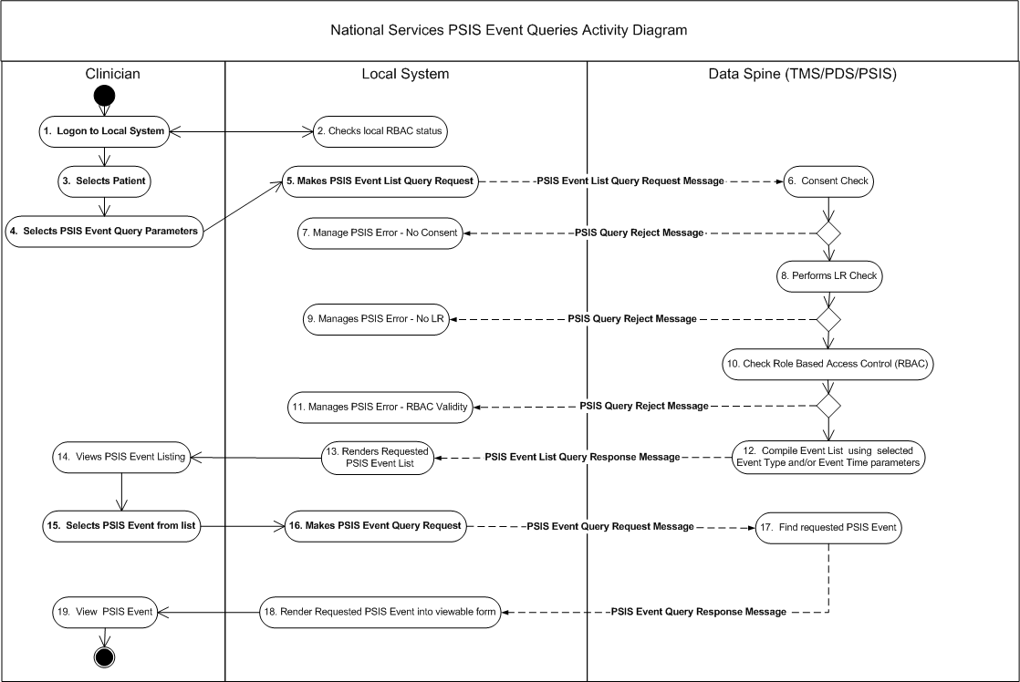

Note: the LR and RBA checks may be performed on the local system

Business Communications

1. PSIS Event List Query Request
2. PSIS Event List Query Response
3. PSIS Event Query Request
4. PSIS Event Query Response
3. PSIS Query Reject

PSIS Event List Query Request

Purpose

To allow the Service User to request a list of the details of all the messages sent to PSIS for a specific patient within a defined date/time range.

Business Communication Requirement

Communication Name | PSIS Event List Query Request
Sending Role | Query Sender
Trigger Event | Service User request via a local ISP system for a list of all PSIS Event messages with or without a constraint by type
Communication Type | Query
Receiving Role | Query Responder

Business Communication Content

Level | Name Item/  Group | Definition | Example | Representation | Cardinality | Constraints & Dependencies
1 | PSIS Event List Query Information |  |  |  | 1..1
1.1 | PSIS Event List Query ID | Unique identifier for this query message |  | UUID | 1..1
2 | Individual Patient Information |  |  |  | 1.1
2.1 | NHS number | NHS number |  | DD NHS Number | 1..1
3 | Query Originator Information |  |  |  | 1..1
3.1 | User ID | SDS identifier for care professional invoking the query |  | ID | 1..1
3.2 | Role profile Code | The (RBAC) role profile code in which the HCP has requested this query |  | ID | 1..1
4 | Query Detail information |  |  |  | 1..1
4.1 | PSIS Event Type | The type of PSIS Event |  | Snomed | 0..1 | Focus Act.Code?  Listing anywhere?
5 | Dissent Override information |  |  |  | 1..1
5.1 | Override Dissent Flag | Boolean Flag through which the service user requests that patient dissent should be overridden. |  | Boolean | 1..1 | Values:  1 = Override  0 = No override  Must only be set to 1 if the user has been warned that the patient has dissented and has confirmed that despite this they wish to override dissent.
5.2 | Override Dissent Reason Information |  |  |  | 0..1 | Must be present whenever the override dissent flag is set to 1.
5.2.1 | Override Dissent Reason Code | A code indicating the reason for the override, provided for insertion in the alert that must be raised by the NASP as a consequence of overriding dissent. |  |  | 1..1 | For acceptable values see the listing in Section 7.2
5.2.2 | Override Dissent Reason Text | Further explanation of the reason for override, provided for insertion in the alert that must be raised by the NASP as a consequence of overriding dissent. |  | No existing equivalent in the Data Dictionary. Format for similar free-text fields is AN255 | 1..1 | Free text present when available (i.e. whenever entered by the user).

PSIS Event List Query Response

Purpose

The synchronised response message to the PSIS Event List Query request. This message returns a list of the details of those messages received by PSIS.

Business Communication Requirement

Communication Name | PSIS Event List Query Response
Sending Role | Query Response Sender
Trigger Event | Fulfilment of the PSIS Event List Query Request by the NHS Care Record Service
Communication Type | Query
Receiving Role | Query Response Receiver

Business Communication Content

Level | Name Item/  Group | Definition | Example | Representation | Cardinality
1 | PSIS Event List Query Response Information |  |  |  | 1..1
1.1 | PSIS Event List Query ID | Unique identifier for the original query message |  | UUID | 1..1
2 | Individual Patient Information |  |  |  | 1.1
2.1 | NHS Number |  |  | DD NHS Number | 1..1
3 | Query Detail Response Information |  |  |  | 1..*
3.1 | PSIS Event Information | Group of information about the message received by PSIS |  |  | 1..1
3.1.1 | PSIS Event ID | The unique identifier for the message as received by PSIS |  | FocusActOrEvent.id | 1..1
3.1.2 | PSIS Event Type | The description of the PSIS Event |  | FocusActOrEvent.code | 1..1
3.1.3 | PSIS Event Persistence Date | The date & time on which the message was received by PSIS | 20050515161922 | yyyymmddhhmmss | 1..1
3.1.4 | PSIS Event Status | The status of the PSIS Event |  | Value could be one of the following:  - Normal  - Nullified  - Replaced | 1..1
3.1.5 | Interaction ID | Interaction ID of the original communication |  |  | 1..1
3.1.6 | PSIS Event Author | Author of the message payload that is the PSIS Event |  | SDS identifiers | 0..1

PSIS Event Query Request

Purpose

To allow the Service User to request all the contents of a specified PSIS Event UUID that has been previously discovered by use of a PSIS Event List Query.

Business Communication Requirement

Communication Name | PSIS Event List Query Request
Sending Role | Query Sender
Trigger Event | Service User request via a local ISP system for all the contents of a specific PSIS Event message
Communication Type | Query
Receiving Role | Query Responder

Business Communication Content

Level | Name Item/  Group | Definition | Example | Representation | Cardinality | Constraints & Dependencies
1 | PSIS Event Query Information |  |  |  | 1..1
1.1 | PSIS Event Query ID | Unique identifier for this query message |  | UUID | 1..1
2 | Individual Patient Information |  |  |  | 1.1
2.1 | NHS number | NHS number |  | DD NHS Number | 1..1
3 | Query Originator Information |  |  |  | 1..1
3.1 | User ID | SDS identifier for care professional invoking the query |  | ID | 1..1
3.2 | Role profile Code | The (RBAC) role profile code in which the HCP has requested this query |  | ID | 1..1
4 | Query Detail information |  |  |  | 1..1
4.1 | PSIS Event ID | The unique identifier for the message as received by PSIS |  | UUID | 1..1
5 | Dissent Override information |  |  |  | 1..1
5.1 | Override Dissent Flag | Boolean Flag through which the service user requests that patient dissent should be overridden. |  | Boolean | 1..1 | Values:  1 = Override  0 = No override  Must only be set to 1 if the user has been warned that the patient has dissented and has confirmed that despite this they wish to override dissent.
5.2 | Override Dissent Reason Information |  |  |  | 0..1 | Must be present whenever the override dissent flag is set to 1.
5.2.1 | Override Dissent Reason Code | A code indicating the reason for the override, provided for insertion in the alert that must be raised by the NASP as a consequence of overriding dissent. |  |  | 1..1 | For acceptable values see the listing in Section 7.2
5.2.2 | Override Dissent Reason Text | Further explanation of the reason for override, provided for insertion in the alert that must be raised by the NASP as a consequence of overriding dissent. |  | No existing equivalent in the Data Dictionary. Format for similar free-text fields is AN255 | 1..1 | Free text present when available (i.e. whenever entered by the user).

PSIS Event Query Response

Purpose

The synchronised response message to the PSIS Event Query request message, returning the entire contents of the message which is identified by the PSIS Event UUID

Business Communication Requirement

Communication Name | PSIS Event Query Response
Sending Role | Query Response Sender
Trigger Event | Fulfilment of the PSIS Event Query Request by the NHS Care Record Service
Communication Type | Query
Receiving Role | Query Response Receiver

Business Communication Content

Level | Name Item/  Group | Definition | Example | Representation | Cardinality
1 | PSIS Event Query Response Information |  |  |  | 1..1
1.1 | PSIS Event Query ID | Unique identifier for the original query message |  | UUID | 1..1
2 | Individual Patient Information |  |  |  | 1.1
2.1 | NHS Number |  |  | DD NHS Number | 1..1
3 | Care Event Group |  |  |  | 1..*
3.1 | PSIS Event ID | Unique UUID of the PSIS Event |  | From focalAct.ID in original event | 1..1
3.2 | PSIS Event Persistence Date | Date and time the event was received by PSIS |  | yyyymmddhhmmss | 1..1
3.3 | Interaction ID | The interaction type of the message |  |  | 1..1
3.4 | PSIS Event Status |  |  |  | 1..1
3.5 | PSIS Event Type | Description of the event type |  | From focalAct.code in original event | 1..1
3.6 | Event Data | XML f original event payload (i.e. without the transport wrapper and control act) |  |  | 1..1

PSIS Query Reject

As per PSIS Query Reject Message defined in Section 3.4.3

APPENDIX 1 – Code tables

Error Codes (Simple Value)

PSIS Query Reject Error Description | Code
No Legitimate Relationships exist for the query originator (system user) | PQR-01
No explicit Service User Consent exists for Sharing of this Record | PQR-02
No implicit Service User Consent exists for Sharing of this Record | PQR-03
No care records corresponding to the NHS Number supplied | PQR-04
The user’s RBAC does not permit access to any of the response data | PQR-05

Override Dissent Reason Codes
Assigned OID: 2.16.840.1.113883.2.1.3.2.4.17.60
Override Dissent Reason Description | Code
No Override | 0
Access made in the public interest | 1
Access required by statute | 2
Access required by Court Order | 3
Access made in the best interests of a patient who now lacks the mental capacity to give consent, either temporarily (because, for example, they are unconscious) or permanently | 4
Access made in the best interests of a non-competent child patient when the parent or guardian of the child has refused to give consent, and where there is insufficient time to obtain a court order. | 5

