

TO: NHS CFH Technical Architects
NHS Systems Suppliers

CC: Keith Naylor, Lead Messaging Architect

20 December 2007

CDA Issues for MIM 7.1.00 and MIM 6.3.00
A defect has been detected in the constrained model used for the CDA documents within the messaging specifications of MIM 6.3.00 and MIM 7.1.00.

The defect is that the NPfIT constrained CDA model has been overly constrained for the “classCode” attribute” within the “Entity” class.

CDA Generic Model Corrections

The RMIM for the generic NPfIT CDA RMIM has been amended to address the defect. The RMIM has been up versioned to POCD_RM000001UK04 ( from POCD_RM000001UK03).
Details of the change are shown below.
Previously the “classCode” has a fixed value of “ENT”, this has been relaxed to a default value of “ENT”.

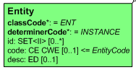
Old Entity Class in POCD_RM000001UK03

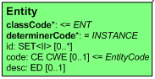
New Entity Class in POCD_RM000001UK04

The impact to the schemas of this correction in the model is detailed below.

Impact of the change to Message Type Schemas
The “classCode” attribute within the NPfIT schemas is mandatory and as such the concept of a “default” code does not transfer to the schema. The impact on the schema is to remove the “fixed” constraint on the attribute.

The change to the schema is highlighted below.

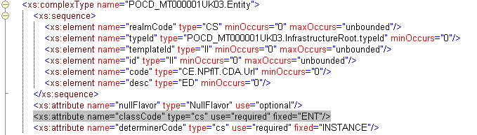
Figure 1 : Old schema POCD_MT000001UK03.xsd

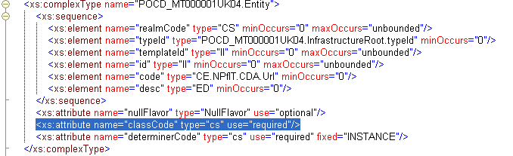
Figure 2 : Revised schema POCD_MT000001UK04.xsd

Impact of the change to Interaction Schemas
The CDA Message Type schema is used by numerous interaction schemas within the MIMs. The interaction schemas are not being up versioned, but instead will be amended so as to reference the new version of the message type schema(POCD_MT000001UK04) as opposed to the old version (POCD_MT000001UK03).

An example of this change is highlighted below :

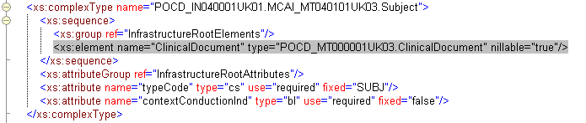
Figure 3 : Old interaction schema example.

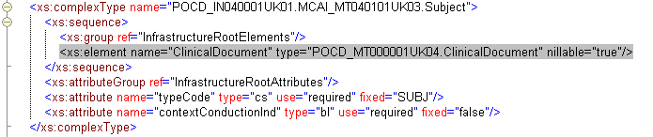
Figure 4 : New interaction schema example.

Interaction Schemas Impacted
The following interactions have been impacted by this change.

Admissions [ MIM 7.1.00 ]
Primary Recipient Admissions Report - POCD_IN040001UK01
PSIS Admissions Report - POCD_IN040002UK01
Copy Admissions Report - POCD_IN040003UK01
Nullify Admissions Report - POCD_IN040004UK01

Ambulance [ MIM 7.1.00 ]
Primary Recipient Ambulance Service Patient Report - POCD_IN030001UK01
PSIS Ambulance Service Patient Report - POCD_IN030002UK01
Copy Ambulance Service Patient Report - POCD_IN030003UK01
Nullify Ambulance Service Patient Report - POCD_IN030004UK01

Discharge [ MIM 6.3.00 + MIM 7.1.00 ]
Primary Recipient Discharge Report - POCD_IN150001UK06
PSIS Discharge Report - POCD_IN150002UK06
Copy Discharge Report - POCD_IN150003UK06
Nullify Discharge Report - POCD_IN150004UK06

Emergency Department [ MIM 6.3.00 + MIM 7.1.00 ]
Primary Recipient Emergency Department Report - POCD_IN160001UK06
PSIS Emergency Department Report - POCD_IN160002UK06
Copy Emergency Department Report - POCD_IN160003UK06
Nullify Emergency Department Report - POCD_IN160004UK06

Health and Social Care [ MIM 7.1.00 ]
Primary Recipient Contact Assessment - POCD_IN010001UK01
PSIS Contact Assessment - POCD_IN010012UK01
Copy Contact Assessment - POCD_IN010002UK01
Primary Recipient Overview Assessment - POCD_IN010003UK01
PSIS Overview Assessment - POCD_IN010013UK01
Copy Overview Assessment - POCD_IN010004UK01
Primary Specialist Assessment Outcome - POCD_IN010005UK01
PSIS Specialist Assessment Outcome - POCD_IN010014UK01
Copy Specialist Assessment Outcome - POCD_IN010006UK01
Primary Recipient Integrated Care and Support Plan - POCD_IN010007UK01
PSIS Recipient Integrated Care and Support Plan - POCD_IN010015UK01
Copy Recipient Integrated Care and Support Plan - POCD_IN010008UK01
Primary Recipient Biographic Information - POCD_IN010009UK01
PSIS Recipient Biographic Information - POCD_IN010016UK01
Copy Recipient Biographic Information - POCD_IN010010UK01
Nullify Health and Social Care Integration Document - POCD_IN010011UK01

HealthSpace [ MIM 6.3.00 + MIM 7.1.00 ]
HealthSpace Summary Send - POCD_IN140001UK05
Nullify HealthSpace Summary - POCD_IN140002UK05

Out of Hours [ MIM 7.1.00 ]
Primary Recipient Out of Hours Report - POCD_IN020001UK01
PSIS Out of Hours Report - POCD_IN020002UK01
Copy Out of Hours Report - POCD_IN020003UK01
Nullify Out of Hours Report - POCD_IN020004UK01

Outpatients [ MIM 6.3.00 + MIM 7.1.00 ]
Primary Recipient Outpatient Report - POCD_IN170001UK06
PSIS Outpatient Report - POCD_IN170002UK06
Copy Outpatient Report - POCD_IN170003UK06
Nullify Outpatient Report - POCD_IN170004UK06

Sealed Envelopes [ MIM 6.3.00 + MIM 7.1.00 ]
Refusal To Seal Report Originating System - POCD_AR180001UK01
Refusal To Seal Report Receiving System (PSIS) - POCD_AR180002UK01
Seal Report Originating System - POCD_AR180003UK01
Seal Report Receiving System (PSIS) - POCD_AR180004UK01
UnSeal Report Originating System - POCD_AR180005UK01
UnSeal Report Receiving System (PSIS) - POCD_AR180006UK01
Notification of Seal Event Originating System - PRPA_AR000501UK01
Notification of Seal Event Receiving System - PRPA_AR000502UK01

Diagnostic Imaging [ MIM 7.1.00 ]
Primary Recipient Diagnostic Imaging Report - POCD_IN050001UK01
PSIS Diagnostic Imaging Report - POCD_IN050002UK01
Copy Diagnostic Imaging Report - POCD_IN050003UK01
Nullify Diagnostic Imaging Report - POCD_IN050004UK01

Mental Health (MH) [ MIM 7.1.00 ]
Primary Recipient MH and Subst. Misuse Specialist Services Entry Assessment - POCD_IN060001UK01
Primary Recipient MH and Subst. Misuse Specialist Services Update Assessment - POCD_IN060002UK01
Primary Recipient MH and Subst. Misuse Specialist Services Exit Assessment - POCD_IN060003UK01
Primary Recipient MH and Subst. Misuse Specialist Services CRS (CPA) - POCD_IN060004UK01
Primary Recipient MH and Subst. Misuse Specialist Services CRS (MOC) - POCD_IN060005UK01
Primary Recipient MH and Subst. Misuse Specialist Services CRS (Unspecified) - POCD_IN060006UK01
Primary Recipient MH Act Assessment Outside Specialist Services - POCD_IN060007UK01
Primary Recipient MH Act Assessment Update Non-Specialist Services - POCD_IN060008UK01
PSIS MH and Subst. Misuse Specialist Services Entry Assessment - POCD_IN060009UK01
PSIS MH and Subst. Misuse Specialist Services Update Assessment - POCD_IN060010UK01
PSIS MH and Subst. Misuse Specialist Services Exit Assessment - POCD_IN060011UK01
PSIS MH and Subst. Misuse Specialist Services CRS (CPA) - POCD_IN060012UK01
PSIS MH and Subst. Misuse Specialist Services CRS (MOC) - POCD_IN060013UK01
PSIS MH and Subst. Misuse Specialist Services CRS (Unspecified) - POCD_IN060014UK01
PSIS MH Act Assessment Outside Specialist Services - POCD_IN060015UK01
PSIS MH Act Assessment Update Non-Specialist Services - POCD_IN060016UK01
Copy MH and Subst. Misuse Specialist Services Entry Assessment - POCD_IN060017UK01
Copy MH and Subst. Misuse Specialist Services Update Assessment - POCD_IN060018UK01
Copy MH and Subst. Misuse Specialist Services Exit Assessment - POCD_IN060019UK01
Copy MH and Subst. Misuse Specialist Services CRS (CPA) - POCD_IN060020UK01
Copy MH and Subst. Misuse Specialist Services CRS (MOC) - POCD_IN060021UK01
Copy MH and Subst. Misuse Specialist Services CRS (Unspecified) - POCD_IN060022UK01
Copy Mental Health Act Assessment Outside Specialist Services - POCD_IN060023UK01
Copy Mental Health Act Assessment Update Non-Specialist Services - POCD_IN060024UK01
Nullify Mental Health Document - POCD_IN010025UK01

NHS Direct [ MIM 7.1.00 ]
Primary Recipient NHS Direct Report - POCD_IN070001UK01
PSIS NHS Direct Report - POCD_IN070002UK01
Copy NHS Direct Report - POCD_IN070003UK01
Nullify NHS Direct Report - POCD_IN070004UK01

Defect Resolution.
The corrections descried above will be present in the MIM 7.1.00 release (publish date 21/12/2007).

Additionally a MIM 6.3.01 release will be scheduled to address the changes required to MIM 6.3.00

Contact Details.
If you have any questions, please raise them at the CMASG or email them to richard.kavanagh@nhs.net.

Yours sincerely,

Richard Kavanagh

Interoperability Development Manager
Data Standards & Products

