NHS CFH National Spine
4166
2007-A Demographics Design Interface Model REQ075

Issue 7 BT Approved (Awaiting NHS CFH Approval)
Systems Engineering
23 January 2007

Copyright
© British Telecommunications plc 2007
Registered Office: 81 Newgate Street, London EC1A 7AJ

Confidentiality
All information in this document is provided in confidence for the sole purpose of adjudication of the document and shall not be used for any other purpose and shall not be published or disclosed wholly or in part to any other party without BT’s prior permission in writing and shall be held in safe custody. These obligations shall not apply to information which is published or becomes known legitimately from some source other than BT.
Many of the product, service and company names referred to in this document are trademarks or registered trademarks.
They are all hereby acknowledged.

Notice
To the extent that this document contains any information concerning Clinical Safety (such term having its ordinary meaning until a specific definition may be agreed upon by NHS CFH and the Contractor) or any other information not specifically mandated by the Project Agreement, it is shared by the Contractor with NHS CFH on a voluntary, Confidential and 'without prejudice' basis for the purpose of informing NHS CFH and advancing mutual learning on the subject matter concerned.

Distribution
Spine Programme Management Office | 1 Sovereign Street  Leeds  LS1 4BT

Document Control
Title | 4166 2007-A Demographics Design Interface Model REQ075
Author | Mark Herrick

Owner (Responsible for Approval of Issued Versions)
Name | Role
Chris Leary | Head of Requirements Management

Review Panel
Name | Role
Spine Commercial G | Commercial
SE Quality Assurance G | SE QA
Spine Security Doc Reviews G | Security
David Deighton | Release Architect
Damien O'Gara | Messaging Sub System Functional Lead (Sub-System B.A.s)
Gavin Mander | Demographics Sub System Functional Lead (Sub-System Designers)
Michael Earnshaw | Demographics Lead Architect (Sub-System Architects)
Rob Stanger | Development Partner
QA Test G | Testing

Change History
Issue | Date | Author/ Editor | Details of Change
Issue 1 Draft A | 19th April 2006 | Mark Herrick | Draft for Internal review
Issue 1 Draft B | 14th July 2006 | Mark Herrick | Draft for Internal review
Issue 1 | 28th July 2006 | Mark Herrick | Incorporated NHS CFH comments.
Issue 2 Draft A | 15th August 2006 | Mark Herrick | Incorporated NHS CFH comments.
Issue 2 | 25th August 2006 | Mark Herrick | Incorporated Internal Review Comments.
Issue 3a | 12th September 2006 | Mark Herrick | Incorporated NHS CFH comments.
Issue 3 | 14th September 2006 | Mark Herrick | Incorporated NHS CFH comments.
Issue 4 Draft A | 20th September 2006 | Mark Herrick | Incorporated NHS CFH comments.
Issue 4 Draft B | 29 September 2006 | Mark Herrick | Incorporated NHS CFH comments.
Issue 4 | 20th October 2006 | Mark Herrick | Incorporated NHS CFH and Logica comments.
Issue 5 | 12 December 2006 | Mark Herrick | Incorporated NHS CFH and Internal Review comments.
Issue 6 | 17 January 2007 | Mark Herrick | Incorporated NHS CFH comments.  Incorporated Back Office Location and Paper Record Tracking CCNs
Issue 7 | 23 January 2007 | Mark Herrick | Incorporated NHS CFH comments.

Table of Contents
1 Introduction 7
1.1 Purpose 7
1.2 Scope 7
2 Logical View 9
2.1 Class Summaries 9
2.1.1 Data Types 9
2.1.1.1 HL7 Data Type Classes 9
2.1.1.2 Primitive Data Types 16
2.1.1.3 Enumerated Data Types 17
2.1.2 Common Request and Response Classes 18
2.1.2.1 LoggingContext 18
2.1.2.2 PDSHeader 18
2.1.3 Common Patient Classes 20
2.1.4 Request and Response Classes 21
2.1.4.1 Simple Trace 21
2.1.4.2 Advanced Trace 30
2.1.4.3 Batch Trace 42
2.1.4.4 Retrieve Patient 52
2.1.4.5 Confirm NHS Number 74
2.1.4.6 Allocate NHS Number 81
2.1.4.7 Update Patient 93
2.1.4.8 Create Initial Record 118
2.1.4.9 Cross Check Trace 147
3 References 157
4 Glossary of Terms 158

Introduction

Purpose
This document describes the Design Interface Model (DIM) for the Demographic services provided by SPINE release 2007-A of the NHS NPfIT Spine implementation.
This document is intended to provide a design abstraction that provides a set of views that describes a service at a level of detail that has close to a 1-1 mapping with the interface technology (e.g. XML). It is produced during the Spine Realisation Phase.
The information within this document provides systems implementers (architects, designers and builders) with necessary information (or references to information held outside this document) for implementation of the MIM.

Scope
This document covers 2007-A and covers the following model elements to describe the realisation of the business services.
- Class Diagrams describing the system events
- Class detail tables showing the detail of each attribute, its cardinality, importance (mandatory, or optional) type and its purpose.
The following are not included in this document and are included in the Logical Interface Model [LIM] Reference: 2007-A Demographics ‘Logical Interface Model’ REQ075 Issue 4:
- Context Model summarising the exchange of events between Spine and Spine Actors.
- Spine system use cases describing, the actions of the Spine in fulfilling the needs of the NHS CFH-sub-system (Spine actor).
- Spine Sub-system use cases describing, in more detail, the processing of the particular Spine service (the sub-system use case, however, is driven by an actor internal to the Spine).
- A Spine System Analysis Model containing the following:
  - Spine System Use Case Realisations; using a sequence diagram to show the ordering of messages (the realisation of the business event as a Spine System Event/Signal) to fulfil the BUC Realisation
  - A static class diagram describing the system event (both requesting and responding).
  - The event processed by a Spine boundary class. This is provided by a statechart showing the states of the boundary classes.
This document does not provide information about the implementation of the message (such as HL7 details). This information is provided in the MIM related to the PDS. This document does not describe validation performed within the PDS application, and does not attempt to describe the message subsets used by external systems.

Logical View

Class Summaries

Data Types

HL7 Data Type Classes
Classes have been defined to represent some of the HL7 data types. These are used where more than a single String value needs to be passed (e.g. in the case of II, where both root and extension attributes need to be passed).
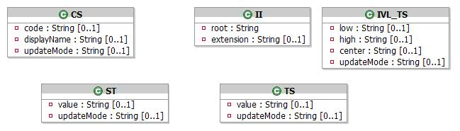
HL7 Data Type Classes

CS
Coded Simple Value. This is used to pass a code and, optionally, additional text. Where this type is referenced in the Class definitions, the appropriate HL7 flavour (Coded Only or Coded Plain) is indicated in the Information column.
Attribute | Type | Values | Cardinality | Definition
code | String |  | 0..1 | The primary code value originally used to encode a statement. Will not be present where an updateMode of "removed" is used, but mandatory otherwise.
displayName | String |  | 0..1 | The text or rubric associated with the code. Will not be present where an updateMode of "removed" is used.
updateMode | UpdateMode | - added  - altered  - clear  - removed  - set | 0..1 | Indicates whether this item should be added, altered or removed. Values are "added",  "altered",  "removed",  "set", and "clear".  This value will be null for a patient create (cudMood="C"), or Birth Notification.  The values "set" and "clear" are not exposed to HL7 messaging and will only be used within the Spine by, for example, NSTS.

II
Instance Identifier
Attribute | Type | Values | Cardinality | Definition
extension | String |  | 0..1 | Real World Identifier if OID used
root | String |  | 1 | UUID or OID

IVL_TS
Interval of Points in Time. Represents a bounded or unbounded date/time range, or a point in time.
Valid combinations of these attributes are as follows:
"low" only,
"high" only,
"center" only
"low" and "high" together.
Attribute | Type | Values | Cardinality | Definition
center | String |  | 0..1 | Timestamp Format. See section 2.1.1.1.6
high | String |  | 0..1 | Timestamp Format. See section 2.1.1.1.6
low | String |  | 0..1 | Timestamp Format. See section 2.1.1.1.6
updateMode | UpdateMode | - added  - altered  - clear  - removed  - set | 0..1 | Indicates whether this item should be added, altered, or removed. Values are "added",  "altered",  "removed",  "set", and "clear".  This value will be null for a patient create (cudMood="C"), or Birth Notification.  The values "set" and "clear" are not exposed to HL7 messaging and will only be used within the Spine by, for example, NSTS.

ST
String data is sent as the element content for any element of this type
Attribute | Type | Values | Cardinality | Definition
updateMode | UpdateMode | - added  - altered  - clear  - removed  - set | 0..1 | Indicates whether this item should be added, altered, or removed. Values are "added",  "altered",  "removed",  "set", and "clear".  This value will be null for a patient create (cudMood="C"), or Birth Notification.  The values "set" and "clear" are not exposed to HL7 messaging and will only be used within the Spine by, for example, NSTS.
value | String |  | 0..1 | String data. Will not be present where an updateMode of "removed" is used, but mandatory otherwise.

TS
Represents a single point in time.
Attribute | Type | Values | Cardinality | Definition
updateMode | UpdateMode | - added  - altered  - clear  - removed  - set | 0..1 | Indicates whether this item should be added, altered, or removed. Values are "added",  "altered",  "removed",  "set", and "clear".  This value will be null for a patient create (cudMood="C"), or Birth Notification.  The values "set" and "clear" are not exposed to HL7 messaging and will only be used within the Spine by, for example, NSTS.
value | String |  | 0..1 | Timestamp Format. Will not be present where an updateMode of "removed" is used, but mandatory otherwise.

Timestamp Format
An attribute marked as Timestamp format is a string that represents a time of one of the following types: Year, Year and Month, Date, Date and Time. This is represented logically as follows:
- yyyyMMddHHmmss
where:
- yyyy: year
- MM: month
- dd: day
- HH: hours
- mm: minutes
- ss: seconds
This is implemented as a string in one of the following formats:
- Date and Time: yyyyMMddHHmmss or
- yyyyMMddHHmm or
- yyyyMMddHH
- Date Only: yyyyMMdd
- Date Month: yyyyMM
- Date Year: yyyy

Preferred Written Communication Format
Wherever a preferredWrittenCommunicationFormat occurs in the Classes, it is represented as an instance of CS.

Code Value
Some of the values passed between TMS and the PDS will be coded values taken from HL7 vocabularies and data types. The name of the vocabulary or data type (e.g. Confidentiality, Request Response, cs_PostalAddressUse) for each such value is indicated in the Information column of the following tables. Refer to the NPfIT Message Implementation Manual documentation for details.

Gender
Wherever a Gender occurs in the Classes, it is represented as an instance of CS. Refer to the MIM for more details.

NHS Number
Wherever an NHS Number occurs in the Classes, it is represented as follows: an instance of II in which:
- root contains the type of the NHS Number
- extension contains the NHS Number
Refer to the MIM for more details.

Care Provider Code
Wherever a Care Provider Code occurs in the Classes, it is represented as follows: an instance of II in which:
- root contains the type of the Care Provider Code
- extension contains the Care Provider Code
Refer to the MIM for more details.

SourceSystem/Source
PDSHeader.SourceSystem will generally hold SDS Accredited System Identifier with the following exceptions:
- In releases prior to 2007-A, DSA is used a fixed string of “DSA” and will move to a SDS ASID in 2006-B onwards. Therefore historic DSA data may have a SourceSystem of either “DSA” or a SDS ASIS.
- NSTS has and continues to use a fixed string of “NSTS”.
- NHAIS updates are currently received from NSTS and so also use a fixed string of “NSTS”, with the exception of NHAIS utilising Allocate NHS Number, in which case a SDS ASID is provided.
- P1R1 systems supplied a NHS Directory Service Org Code
Source attributes returned from Advanced Trace, Create Initial and Retrieve Patient will contain one of the above values depending on the system that modified the data.

Primitive Data Types
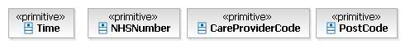
Primitive Data Types
A number of primitive data types have been used throughout this document for consistency. These represent datatypes that hold more structured, or coded information than a free format string, but, unlike enumerated types, they do not have a finite number of values. This added detail is provided for clarity and consistency, and will not be carried through to the physical objects, whose attributes will be implemented as the relevant primitive java data types such as String, Integer etc.

Enumerated Data Types
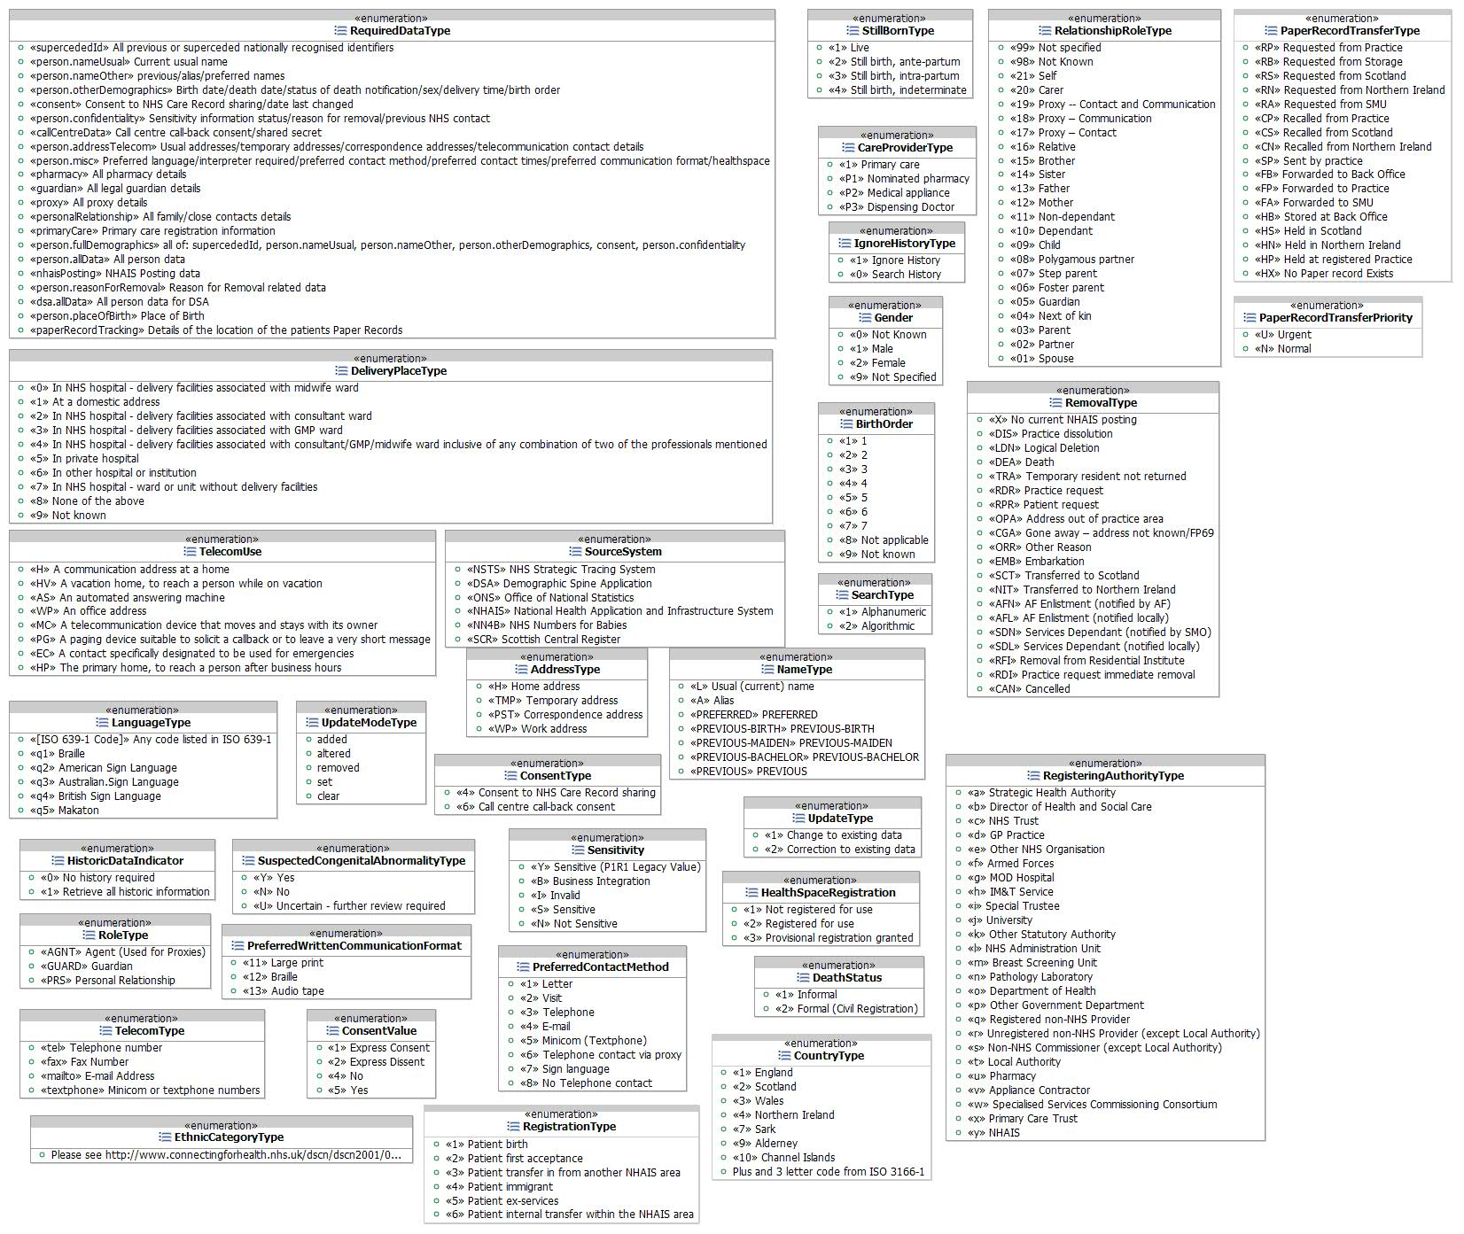
Enumerated Data Types
To provide added detail, datatypes with a fixed number of well defined values have been created as enumerated types within this document. This added detail is provided for clarity and consistency, and will not be carried through to the physical objects, whose attributes will be implemented as the relevant primitive java data types such as String, Integer etc.

Common Request and Response Classes
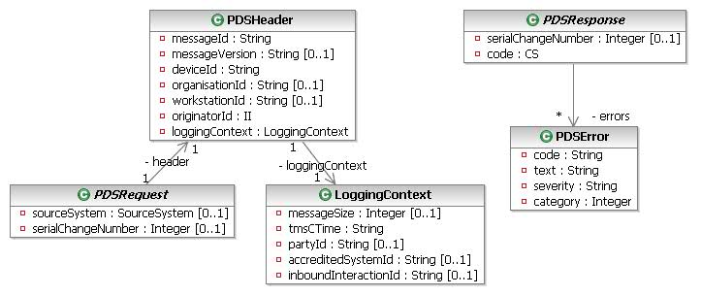
Common Request and Response Classes

LoggingContext
Encapsulates information only required for logging.
Attribute | Type | Values | Cardinality | Definition
accreditedSystemId | String |  | 0..1 | Used to populate the "AccreditedSystemID" field of the ALI v1.7 for performance log points.
inboundInteractionId | String |  | 0..1 | Used to populate the "InteractionID" field of the ALI v1.7 for performance log points.
messageSize | Integer |  | 0..1 | Used to populate the "size" field of the ALI v1.7 for performance log points.
partyId | String |  | 0..1 | Used to populate the "PartyID" field of the ALI v1.7 for performance log points.
tmsCTime | String |  | 1 | Used to populate the "start time" field of the ALI v1.7 for performance log points.

PDSHeader
Common data for all PDS requests, extracted from the HL7 wrapper of the request message.
Attribute | Type | Values | Cardinality | Definition
deviceId | String |  | 1 | Device Id of the sender (Messaging Endpoint Identifier).
loggingContext | LoggingContext |  | 1 | Describes the information to be logged for this message.
messageId | String |  | 1 | The id of the incoming message
messageVersion | String |  | 0..1 | The version code of the incoming message. This will not be populated by NSTS.
organisationId | String |  | 0..1 | Organisation code of the originator of the message
originatorId | II |  | 1 | The ID of the originator of the message.
workstationId | String |  | 0..1 | The SDS Workstation id from the incoming message. This will not be populated by NSTS or P1R1 messages.

Common Patient Classes
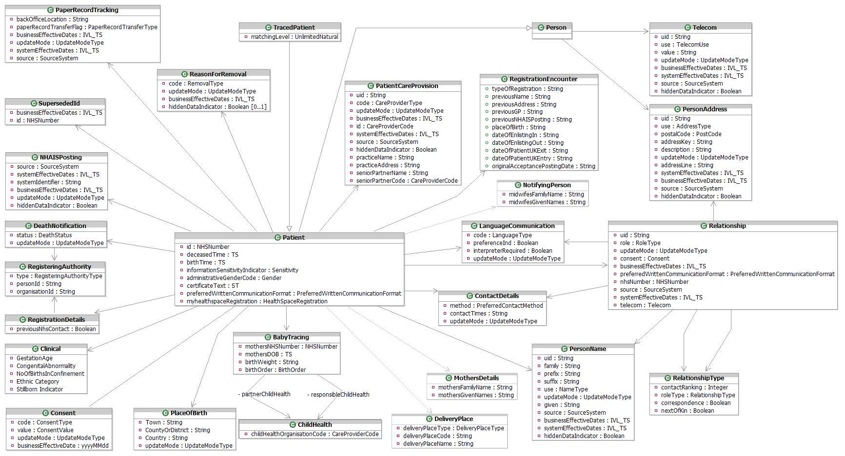
Common Patient Classes

Request and Response Classes

Simple Trace
Simple Trace provides a simple search facility which attempts to uniquely identify a person using a minimal set of search criteria. Simple Trace can also be accessed as a batch as well as an ordinary message. A summary set of demographic information (current and future dated), including the NHS number, is returned if a single exact match is found, otherwise a suitable status is returned. See the [SSRS] for further details of the response codes and the effect of the Information Sensitivity Indicator.

Simple Trace Request
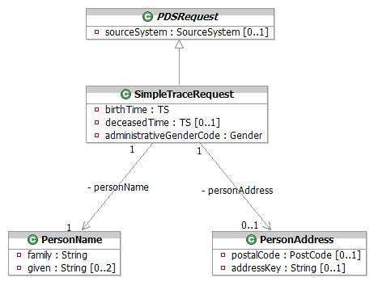
Simple Trace Request

PersonAddress
This class is used to hold either the Postcode OR the PAF Address Key of the person to optionally aid in identifying the patient. The Postcode or PAF key will be used to search all address types. The structure of this class is based on the HL7 AD data type.
Attribute | Type | Values | Cardinality | Definition
addressKey | String |  | 0..1 | PAF Key
postalCode | PostCode |  | 0..1 | The UK format Postcode, 8 character string: ZZ99 3VZ. AS PER BS7666. As per BS7666.  The 8 characters field allows a space to be inserted to differentiate between the inward and outward segments of the code, enabling full use to be made of Royal Mail postcode functionality.

PersonName
Details of the surname and (optionally) forename(s) of the person to search for. The Name details will be compared to all name types (i.e. usual, previous, preferred, alias). The structure of this class is based on the HL7 PN data type.
Attribute | Type | Values | Cardinality | Definition
family | String |  | 1 | The surname or family name of the patient.
given | String |  | 0..2 | Up to two given names.

SimpleTraceRequest
Encapsulates the parameters used in a SimpleTrace with the intention of finding a single patient record.
Attribute | Type | Values | Cardinality | Definition
administrativeGenderCode | Gender | 2 - Female  1 - Male  0 - Not Known  9 - Not Specified | 1 | A code identifying the Gender of the person being searched for. From Sex Vocabulary.
birthTime | TS |  | 1 | The birth date of the person being searched for as a single point in time. Date Only.
deceasedTime | TS |  | 0..1 | The death date of the person being searched for as a single point in time. Date Only.

Simple Trace Response
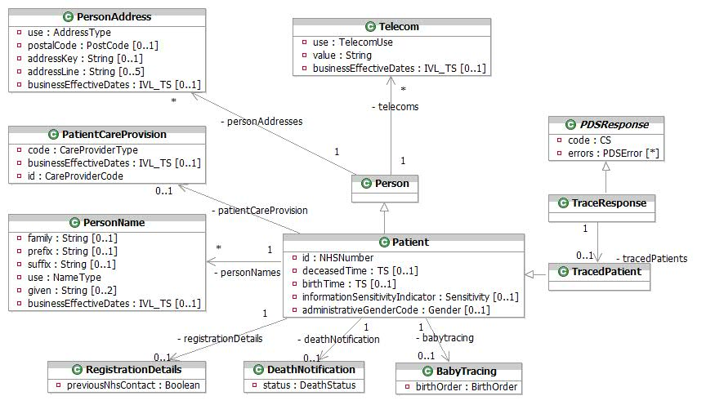
Simple Trace Response

BabyTracing
This encapsulates birth information about the patient.
Attribute | Type | Values | Cardinality | Definition
birthOrder | BirthOrder | 1 - 1  2 - 2  3 - 3  4 - 4  5 - 5  6 - 6  7 - 7  8 - Not applicable  9 - Not known | 1 | Describes the sequence in the case of multiple births (e.g. twins, triplets etc). For births that are not a part of a multiple birth, this will be set to 1. Note that permissible values are 1-9, with any value between 1 and 7 inclusive indicating the actual birth order number, 8 meaning "Not applicable" and 9 meaning "Not known".

DeathNotification
Details about a death notification.
Attribute | Type | Values | Cardinality | Definition
status | DeathStatus | 2 - Formal (Civil Registration)  1 - Informal | 1 | Coded value. From DeathNotification vocabulary.  1 (Informal) death notice received via an update from a local NHS Organisation such as GP or Trust  2 (Formal) death notice received from Registrar of Deaths

Patient
This class extends Person to hold additional information for an NHS Patient matched by the trace.
Attribute | Type | Values | Cardinality | Definition
administrativeGenderCode | Gender | 2 - Female  1 - Male  0 - Not Known  9 - Not Specified | 0..1 | The gender of the patient.
birthTime | TS |  | 0..1 | The person’s date and time of birth as a single point in time.
deceasedTime | TS |  | 0..1 | The person’s date and time of death as a single point in time.
id | NHSNumber |  | 1 | NHS Number or temporary NHS number issued by an NHAIS registration authority or Old style NHS number.
informationSensitivityIndicator | Sensitivity | B - Business Integration  I - Invalid  N - Not Sensitive  S - Sensitive  Y - Sensitive (P1R1 Legacy Value) | 0..1 | Indicates the patient’s details are marked as sensitive. Only values "B", "S" and "Y" are returned by Simple Trace.

PatientCareProvision
The patient’s current GP Practice.
Attribute | Type | Values | Cardinality | Definition
businessEffectiveDates | IVL_TS |  | 0..1 | The effective dates for this care provision relationship as a range, supplied in the Low and High attributes of the IVL_TS. Business Effective Dates are full dates without time.
code | CareProviderType | P3 - Dispensing Doctor  P2 - Medical appliance  P1 - Nominated pharmacy  1 - Primary care | 1 | Coded value. From PatientCareProvisionType vocabulary. Only a value of "1" is relevant to a Simple Trace.
id | CareProviderCode |  | 1 | The GP Practice Code.

Person
Person is an abstract class that has the Patient Class as a generalisation class. Other generalisations exist but are not shown on this diagram for clarity.

PersonAddress
This class is used to hold address details for a person. Simple Trace will only return the patient’s current (and where available any future) usual ("H") address. The structure of this class is based on the HL7 AD data type.
Attribute | Type | Values | Cardinality | Definition
addressKey | String |  | 0..1 | PAF Key
addressLine | String |  | 0..5 | 5 address lines - excludes postcode, may be vernacular or PAF-derived. For vernacular addresses, the following formatting convention should normally apply although there may be some exceptions:  line 1: premises ID  line 2: no/thoroughfare  line 3: locality  line 4: post town  line 5: county  The following address lines should normally be mandatory although there may be some exceptions:  • 1 or 2 and  • 4
businessEffectiveDates | IVL_TS |  | 0..1 | The dates for which this address data is/was current as a range, supplied in the Low and High attributes of the IVL_TS. Business Effective Dates are full dates without time.
postalCode | PostCode |  | 0..1 | The UK format Postcode, 8 character string: ZZ99 3VZ. AS PER BS7666.  The 8 characters field allows a space to be inserted to differentiate between the inward and outward segments of the code, enabling full use to be made of Royal Mail postcode functionality.
use | AddressType | PST - Correspondence address  H - Home address  TMP - Temporary address  WP - Work address | 1 | Coded value. From cs_PostalAddressUse HL7 data type. Only "H" will be returned from a Simple Trace.

PersonName
This class is used to hold name details for a person within the NHS. Multiple PersonName instances may be returned, representing alternative names for the patient. Only current (and where available any future) data is returned. The structure of this class is based on the HL7 PN data type.
Attribute | Type | Values | Cardinality | Definition
businessEffectiveDates | IVL_TS |  | 0..1 | The dates for which this name data is/was current as a range, supplied in the Low and High attributes of the IVL_TS. Business Effective Dates are full dates without time.
family | String |  | 0..1 | The surname or family name of the patient.
given | String |  | 0..2 | Up to two given names. If the patient has more than 2 given names, these will be concatenated in the 2nd given name attribute with a space between each name.
prefix | String |  | 0..1 | A prefix, or title for the name, such as Mr, Mrs, etc.
suffix | String |  | 0..1 | The suffix for the patient name (i.e. Jnr or Snr).
use | NameType | A - Alias  PREFERRED - PREFERRED  PREVIOUS - PREVIOUS  PREVIOUS-BACHELOR - PREVIOUS-BACHELOR  PREVIOUS-BIRTH - PREVIOUS-BIRTH  PREVIOUS-MAIDEN - PREVIOUS-MAIDEN  L - Usual (current) name | 1 | The type of name this data represents. Only usual, alias and preferred name types are relevant to this interaction

RegistrationDetails
Details of the Registration Process.
Attribute | Type | Values | Cardinality | Definition
previousNhsContact | Boolean |  | 1 | Previous contact with the NHS - i.e. 2nd Acceptance.

Telecom
Specifies a means of communicating with the patient by telephone, fax, e-mail etc. Multiple instances of Telecom will be returned representing multiple contact methods. Only current (and where available future) data is returned.
Attribute | Type | Values | Cardinality | Definition
businessEffectiveDates | IVL_TS |  | 0..1 | The dates for which this telecom data is/was current as a range, supplied in the Low and High attributes of the IVL_TS. Business Effective Dates are full dates without time.
use | TelecomUse | H - A communication address at a home  EC - A contact specifically designated to be used for emergencies  PG - A paging device suitable to solicit a callback or to leave a very short message  MC - A telecommunication device that moves and stays with its owner  HV - A vacation home, to reach a person while on vacation  AS - An automated answering machine  WP - An office address  HP - The primary home, to reach a person after business hours | 1 | Describes the kind of telecom contact information that is held, e.g. whether it is a home phone number, a work phone number, a mobile phone number etc. Coded value. From cs_TelecommunicationAddressUse HL7 data type. Refer to NPfIT MIM for applicable values.
value | String |  | 1 | The contact method and number separated by a colon. i.e. "tel:01234 567890".

TracedPatient
Contains the current details of the matched patient where a match was found.

TraceResponse
Encapsulates the information returned from a trace request, containing the single matched patient.

Advanced Trace
Advanced Trace allows an external system to identify a Patient based on an NHS Number or a variety of search criteria including name, address and a date range for either birth or death. Historic data may optionally also be searched, and/or returned. Current and future dated data is always returned. Multiple matching records may be returned, along with a MatchingLevel (this will only be populated for an algorithmic search) for each match, indicating the confidence of the match.
See the PDS [SSRS] for details of the responses returned by Advanced Trace.

Advanced Trace Request
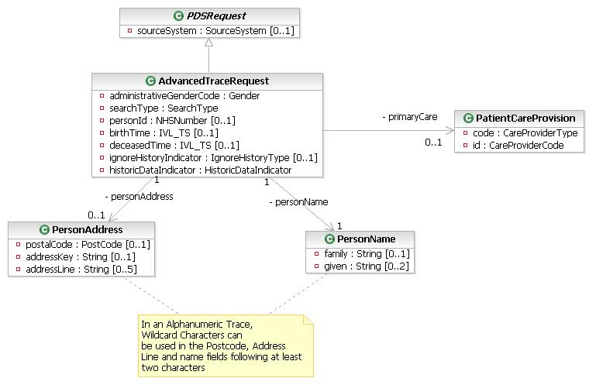
Advanced Trace Request

AdvancedTraceRequest
Encapsulates the parameters required for an Advanced Trace.
Attribute | Type | Values | Cardinality | Definition
administrativeGenderCode | Gender | 2 - Female  1 - Male  0 - Not Known  9 - Not Specified | 1 | The sex of the patient to search for. Coded value from the Sex vocabulary.
birthTime | IVL_TS |  | 0..1 | The person’s date of birth. Both open and closed date ranges are also supported. Mandatory for alphanumeric searches and optional for other types of search.
deceasedTime | IVL_TS |  | 0..1 | The person’s optional date of death. Both open and closed date ranges are also supported.
historicDataIndicator | HistoricDataIndicator | 0 - No history required  1 - Retrieve all historic information | 1 | Should the search return historic patient records? Future dated data is returned regardless of the value of this indicator.
ignoreHistoryIndicator | IgnoreHistoryType | 1 - Ignore History  0 - Search History | 0..1 | Indicates whether to also search historic data. This is only relevant (and is mandatory) to alphanumeric traces.
personId | NHSNumber |  | 0..1 | The NHS Number of the patient being traced. If provided, all other advanced trace parameters will be ignored. May be New Style, Old Style or Temporary NHS Number.
searchType | SearchType | 2 - Algorithmic  1 - Alphanumeric | 1 | The search type to perform.

PatientCareProvision
This class allows a search for a patient to include either the GP or Practice code for the patient.
Attribute | Type | Values | Cardinality | Definition
code | CareProviderType | P3 - Dispensing Doctor  P2 - Medical appliance  P1 - Nominated pharmacy  1 - Primary care | 1 | Coded value. From PatientCareProvisionType vocabulary. Only "1" is relevant in an Advanced Trace Request.
id | CareProviderCode |  | 1 | Either the GP Code or GP Practice Code.

PersonAddress
This class is used to pass address details for a person to search for. The address details will be compared to all addresses (usual, correspondence, temporary). The structure of this class is based on the HL7 AD data type.
Attribute | Type | Values | Cardinality | Definition
addressKey | String |  | 0..1 | PAF Key. Wildcards are not allowed in the addressKey.
addressLine | String |  | 0..5 | Up to 5 lines of address data. For alphanumeric traces, partial addresses can be used, by using part of the address line, and a wildcard character.
postalCode | PostCode |  | 0..1 | The UK format Postcode, 8 character string: ZZ99 3VZ. AS PER BS7666.  The 8 characters field allows a space to be inserted to differentiate between the inward and outward segments of the code, enabling full use to be made of Royal Mail postcode functionality.  For alphanumeric traces, partial post codes can be used, by using part of the post code, and a wildcard character.

PersonName
This class is used to pass name details for the person to search for. The name details will be compared to all name types (i.e. usual, previous, preferred, alias). The structure of this class is based on the HL7 PN data type.
Attribute | Type | Values | Cardinality | Definition
family | String |  | 0..1 | The surname or family name of the patient. This is mandatory in an Alphanumeric Trace. Wildcard characters are supported following 2 characters.
given | String |  | 0..2 | Up to two given names. Wildcard characters are supported following 2 characters.

Advanced Trace Response
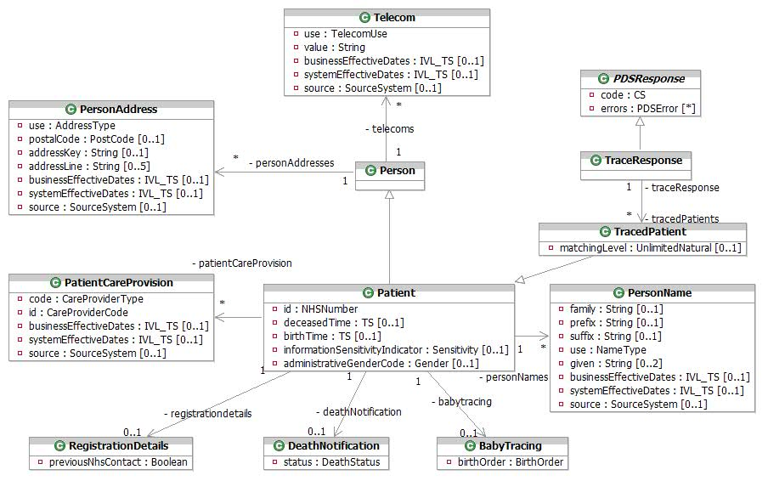
Advanced Trace Response

BabyTracing
This encapsulates the data containing birth order of the patient where relevant.
Attribute | Type | Values | Cardinality | Definition
birthOrder | BirthOrder | 1 - 1  2 - 2  3 - 3  4 - 4  5 - 5  6 - 6  7 - 7  8 - Not applicable  9 - Not known | 1 | For a birth registration this is mandatory and describes the sequence in the case of multiple births (e.g. twins, triplets etc). For births that are not a part of a multiple birth, this will be set to 1. Note that permissible values are 1-9, with any value between 1 and 7 inclusive indicating the actual birth order number, 8 meaning "Not applicable" and 9 meaning "Not known".

DeathNotification
Details about a death notification for the patient, where relevant.
Attribute | Type | Values | Cardinality | Definition
status | DeathStatus | 2 - Formal (Civil Registration)  1 - Informal | 1 | Coded value. From DeathNotification vocabulary.  1 (Informal) death notice received via an update from a local NHS Organisation such as GP or Trust  2 (Formal) death notice received from Registrar of Deaths

Patient
This class extends Person to hold additional information for an NHS Patient matched by the trace.
Attribute | Type | Values | Cardinality | Definition
administrativeGenderCode | Gender | 2 - Female  1 - Male  0 - Not Known  9 - Not Specified | 0..1 | The gender of the patient.
birthTime | TS |  | 0..1 | The person’s date and time of birth as a single point in time.
deceasedTime | TS |  | 0..1 | The person’s date and time of death as a single point in time.
id | NHSNumber |  | 1 | NHS number of patient. This can be new style, temporary NHS number issued by an NHAIS registration authority or Old style NHS number.
informationSensitivityIndicator | Sensitivity | B - Business Integration  I - Invalid  N - Not Sensitive  S - Sensitive  Y - Sensitive (P1R1 Legacy Value) | 0..1 | Indicates the patient’s details are marked as sensitive. Only values "B", "S" and "Y" are returned by Advanced Trace.

PatientCareProvision
An instance of this class identifies a primary care organization or GP responsible for a Patient over a period of time. Current data is always returned. History is only returned when historicDataIndicator is set to "1".
Attribute | Type | Values | Cardinality | Definition
businessEffectiveDates | IVL_TS |  | 0..1 | The effective dates for this care provision relationship as a range, supplied in the Low and High attributes of the IVL_TS. Business Effective Dates are full dates without time.
code | CareProviderType | P3 - Dispensing Doctor  P2 - Medical appliance  P1 - Nominated pharmacy  1 - Primary care | 1 | Coded value. From PatientCareProvisionType vocabulary. Only a value of "1" is relevant to Advanced Trace Response.
id | CareProviderCode |  | 1 | Either the GP Code or GP Practice Code.
source | SourceSystem | A valid NHS Directory Service Organisation Code  A valid SDS Accredited System Identifier  DSA – Demographic Spine Application  NSTS – NHS Strategic Tracing System | 0..1 | The source of this data. Only returned when the historicDataIndicator is set to “1”.
systemEffectiveDates | IVL_TS |  | 0..1 | System generated effective dates for this data item as a range, supplied in the Low and High attributes of the IVL_TS. For current and future dated data, only the Low attribute will be set. Only returned when the historicDataIndicator is set to “1”.

Person
Person is an abstract class that has the Patient Class as a generalisation class. Other generalisations exist but are not shown on this diagram for clarity.

PersonAddress
This class is used to hold address details for a person. The use attribute describes the use made of the address. Multiple PersonAddresses may be returned, representing alternative addresses for the patient. Current and Future dated data is always returned. History is only returned when historicDataIndicator is set to "1". The structure of this class is based on the HL7 AD data type.
Attribute | Type | Values | Cardinality | Definition
addressKey | String |  | 0..1 | PAF Key
addressLine | String |  | 0..5 | 5 address lines - excludes postcode, may be vernacular or PAF-derived. For vernacular addresses, the following formatting convention should normally apply although there may be some exceptions:  line 1: premises ID  line 2: no/thoroughfare  line 3: locality  line 4: post town  line 5: county  The following address lines should normally be mandatory although there may be some exceptions:  • 1 or 2 and  • 4
businessEffectiveDates | IVL_TS |  | 0..1 | The dates for which this data is/was current as a range, supplied in the Low and High attributes of the IVL_TS. Business Effective Dates are full dates without time.
postalCode | PostCode |  | 0..1 | The UK format Postcode, 8 character string: ZZ99 3VZ. AS PER BS7666.  The 8 characters field allows a space to be inserted to differentiate between the inward and outward segments of the code, enabling full use to be made of Royal Mail postcode functionality.
source | SourceSystem | A valid NHS Directory Service Organisation Code  A valid SDS Accredited System Identifier  DSA – Demographic Spine Application  NSTS – NHS Strategic Tracing System | 0..1 | The source of this data. Only returned when the historicDataIndicator is set to “1”.
systemEffectiveDates | IVL_TS |  | 0..1 | System generated effective dates for this data item as a range, supplied in the Low and High attributes of the IVL_TS. For current and future dated data, only the Low attribute will be set. Only returned when the historicDataIndicator is set to “1”.
use | AddressType | PST - Correspondence address  H - Home address  TMP - Temporary address  WP - Work address | 1 | Coded value. From cs_PostalAddressUse HL7 data type. Only a value of "H" is relevant to Advanced Trace.

PersonName
This class is used to hold name details for a person within the NHS. Multiple PersonName instances may be returned, representing alternative names for the patient. Current and future dated data is always returned, and historic data is only returned if the historicDataIndicator was set in the Advanced Trace Request.The structure of this class is based on the HL7 PN data type.
Attribute | Type | Values | Cardinality | Definition
businessEffectiveDates | IVL_TS |  | 0..1 | The dates for which this name data is/was current as a range, supplied in the Low and High attributes of the IVL_TS. Business Effective Dates are full dates without time.
family | String |  | 0..1 | The surname or family name of the patient.
given | String |  | 0..2 | Up to two given names. If the patient has more than 2 given names, these will be concatenated in the 2nd given name attribute with a space between each name.
prefix | String |  | 0..1 | A prefix, or title for the name, such as Mr, Mrs, etc.
source | SourceSystem | A valid NHS Directory Service Organisation Code  A valid SDS Accredited System Identifier  DSA – Demographic Spine Application  NSTS – NHS Strategic Tracing System | 0..1 | The source of this data. Only returned when the historicDataIndicator is set to “1”.
suffix | String |  | 0..1 | The suffix for the patient name (i.e. Jnr or Snr).
systemEffectiveDates | IVL_TS |  | 0..1 | System generated effective dates for this data item as a range, supplied in the Low and High attributes of the IVL_TS. For current and future dated data, only the Low attribute will be set. Only returned when the historicDataIndicator is set to “1”.
use | NameType | A - Alias  PREFERRED - PREFERRED  PREVIOUS - PREVIOUS  PREVIOUS-BACHELOR - PREVIOUS-BACHELOR  PREVIOUS-BIRTH - PREVIOUS-BIRTH  PREVIOUS-MAIDEN - PREVIOUS-MAIDEN  L - Usual (current) name | 1 | The type of name this data represents. Only usual, alias and preferred name types are relevant to this interaction.

RegistrationDetails
Details of the Registration Process.
Attribute | Type | Values | Cardinality | Definition
previousNhsContact | Boolean |  | 1 | Previous contact with the NHS - i.e. 2nd Acceptance.

Telecom
Specifies a means of communicating with the patient by telephone, fax, e-mail etc. Current and Future dated data is always returned. History is only returned when historicDataIndicator is set to "1". Multiple instances of Telecom will be returned representing multiple contact methods.
Attribute | Type | Values | Cardinality | Definition
businessEffectiveDates | IVL_TS |  | 0..1 | The dates for which this telecom data is/was current as a range, supplied in the Low and High attributes of the IVL_TS. Business Effective Dates are full dates without time.
systemEffectiveDates | IVL_TS |  | 0..1 | System generated effective dates for this data item as a range, supplied in the Low and High attributes of the IVL_TS. For current and future dated data, only the Low attribute will be set. Only returned when the historicDataIndicator is set to “1”.
source | SourceSystem | A valid NHS Directory Service Organisation Code  A valid SDS Accredited System Identifier  DSA – Demographic Spine Application  NSTS – NHS Strategic Tracing System | 0..1 | The source of this data. Only returned when the historicDataIndicator is set to “1”.
use | TelecomUse | H - A communication address at a home  EC - A contact specifically designated to be used for emergencies  PG - A paging device suitable to solicit a callback or to leave a very short message  MC - A telecommunication device that moves and stays with its owner  HV - A vacation home, to reach a person while on vacation  AS - An automated answering machine  WP - An office address  HP - The primary home, to reach a person after business hours | 1 | Describes the kind of telecom contact information that is held, e.g. whether it is a home phone number, a work phone number, a mobile phone number etc. Coded value. From cs_TelecommunicationAddressUse HL7 data type. Refer to NPfIT MIM for applicable values.
value | String |  | 1 | The contact method and number separated by a colon. i.e. "tel:01234 567890".

TracedPatient
Contains the current details of the matched patient where a match was found.
Attribute | Type | Values | Cardinality | Definition
matchingLevel | UnlimitedNatural |  | 0..1 | The percentage confidence level for this match to 2 dp.  This will only be populated for an algorithmic search.

TraceResponse
Encapsulates the information returned from a trace request, containing the multiple matched patient’s.

Batch Trace
Batch Trace is provided to support a HL7 based bulk data cleansing interface. TMS unpacks the batches and hands them to the PDS. If a New Style NHS Number is present, the PDS first carries out a Cross Check Trace, and should that fail, or no New Style NHS Number is present, it performs an Advanced Trace. When an Advanced Trace is called the Retrieve History Indicator is set to 1 (true) and the Ignore History Indicator is set to 0 (false). Current and Future dated data is always returned. If a cross-check trace is invoked and is successful, historic data will not be returned. The results are returned to TMS which batches them back for return to the originating system. See the [SSRS] for details on return codes.

Batched Trace Request
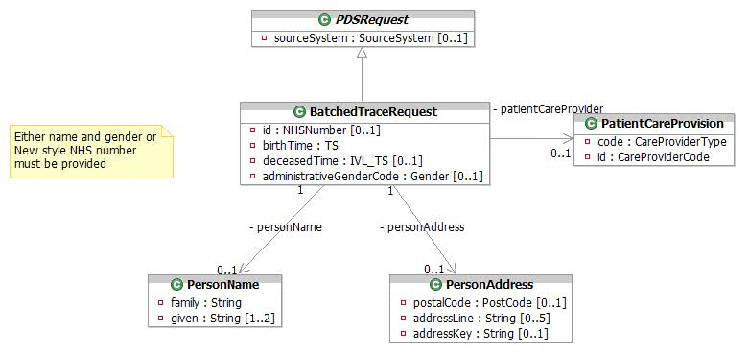
Batched Trace Request

BatchedTraceRequest
Encapsulates the parameters used in a BatchTrace.
Attribute | Type | Values | Cardinality | Definition
administrativeGenderCode | Gender | 2 - Female  1 - Male  0 - Not Known  9 - Not Specified | 0..1 | A code identifying the Gender of the person being searched for. From Sex Vocabulary.
birthTime | TS |  | 1 | The birth date of the person being searched for as a single point in time. Full date format only - no time.
deceasedTime | IVL_TS |  | 0..1 | The death date or a range of death dates of the person being searched for.
id | NHSNumber |  | 0..1 | NHS number of patient. All types of NHS number are supported but cross check trace will only be invoked where a new style NHS number is present.

PatientCareProvision
This class allows a search for a patient to include either the GP or Practice code for the patient.
Attribute | Type | Values | Cardinality | Definition
code | CareProviderType | P3 - Dispensing Doctor  P2 - Medical appliance  P1 - Nominated pharmacy  1 - Primary care | 1 | Coded value. From PatientCareProvisionType vocabulary. Only a value of "1" is relevant to Batch Trace.
id | CareProviderCode |  | 1 | Either the GP Code or GP Practice Code.

PersonAddress
This class is used to hold the Postcode, PAF Address Key or Address Lines of the person to optionally aid in identifiying the patient. The structure of this class is based on the HL7 AD data type.
Attribute | Type | Values | Cardinality | Definition
addressKey | String |  | 0..1 | PAF Key
addressLine | String |  | 0..5 | 5 address lines - excludes postcode, may be vernacular or PAF-derived. For vernacular addresses, the following formatting convention should normally apply although there may be some exceptions:  line 1: premises ID  line 2: no/thoroughfare  line 3: locality  line 4: post town  line 5: county  The following address lines should normally be mandatory although there may be some exceptions:  • 1 or 2 and  • 4
postalCode | PostCode |  | 0..1 | The UK format Postcode, 8 character string: ZZ99 3VZ. AS PER BS7666.  The 8 characters field allows a space to be inserted to differentiate between the inward and outward segments of the code, enabling full use to be made of Royal Mail postcode functionality.

PersonName
Details of the surname and (optionally) forename(s) of the person to search for. The structure of this class is based on the HL7 PN data type.
Attribute | Type | Values | Cardinality | Definition
family | String |  | 1 | The surname or family name of the patient.
given | String |  | 1..2 | Up to two given names.

Batched Trace Response
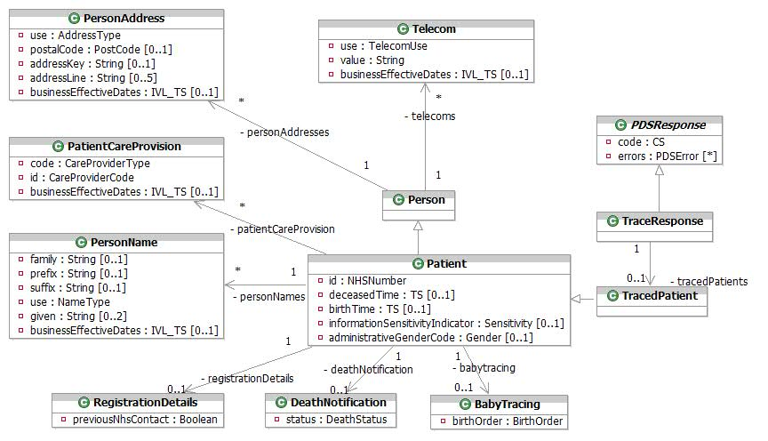
Batched Trace Response

BabyTracing
This encapsulates birth information about the patient.
Attribute | Type | Values | Cardinality | Definition
birthOrder | BirthOrder | 1 - 1  2 - 2  3 - 3  4 - 4  5 - 5  6 - 6  7 - 7  8 - Not applicable  9 - Not known | 1 | Describes the sequence in the case of multiple births (e.g. twins, triplets etc). For births that are not a part of a multiple birth, this will be set to 1. Note that permissible values are 1-9, with any value between 1 and 7 inclusive indicating the actual birth order number, 8 meaning "Not applicable" and 9 meaning "Not known".

DeathNotification
Details about a death notification.
Attribute | Type | Values | Cardinality | Definition
status | DeathStatus | 2 - Formal (Civil Registration)  1 - Informal | 1 | Coded value. From DeathNotification vocabulary.  1 (Informal) death notice received via an update from a local NHS Organisation such as GP or Trust  2 (Formal) death notice received from Registrar of Deaths

Patient
This class extends Person to hold additional information for an NHS Patient matched by the trace.
Attribute | Type | Values | Cardinality | Definition
administrativeGenderCode | Gender | 2 - Female  1 - Male  0 - Not Known  9 - Not Specified | 0..1 | The gender of the patient.
birthTime | TS |  | 0..1 | The person’s date and time of birth as a single point in time.
deceasedTime | TS |  | 0..1 | The person’s date and time of death as a single point in time.
id | NHSNumber |  | 1 | The Patient’s NHS Number or temporary NHS number issued by an NHAIS registration authority or Old style NHS number.
informationSensitivityIndicator | Sensitivity | B - Business Integration  I - Invalid  N - Not Sensitive  S - Sensitive  Y - Sensitive (P1R1 Legacy Value) | 0..1 | Indicates the patient’s details are marked as sensitive Only values "B", "S" and "Y" are returned by Batch Trace.

PatientCareProvision
An instance of this class identifies a primary care organization or GP responsible for a Patient over a period of time. In this case, this will be the patient’s GP code or GP Practice code.
Attribute | Type | Values | Cardinality | Definition
businessEffectiveDates | IVL_TS |  | 0..1 | The effective dates for this care provision relationship as a range, supplied in the Low and High attributes of the IVL_TS. Business Effective Dates are full dates without time.
code | CareProviderType | P3 - Dispensing Doctor  P2 - Medical appliance  P1 - Nominated pharmacy  1 - Primary care | 1 | Coded value. From PatientCareProvisionType vocabulary. Only a code of "1" is returned by Batch Trace.
id | CareProviderCode |  | 1 | The GP Code or Practice Code.

Person
Person is an abstract class that has the Patient Class as a generalisation class. Other generalisations exist but are not shown on this diagram for clarity.

PersonAddress
This class is used to hold address details for a person. Batch Trace will only return the patient’s usual ("H") address. The structure of this class is based on the HL7 AD data type.
Attribute | Type | Values | Cardinality | Definition
addressKey | String |  | 0..1 | PAF Key
addressLine | String |  | 0..5 | 5 address lines - excludes postcode, may be vernacular or PAF-derived. For vernacular addresses, the following formatting convention should normally apply although there may be some exceptions:  line 1: premises ID  line 2: no/thoroughfare  line 3: locality  line 4: post town  line 5: county  The following address lines should normally be mandatory although there may be some exceptions:  • 1 or 2 and  • 4
businessEffectiveDates | IVL_TS |  | 0..1 | The dates for which this address data is/was current as a range, supplied in the Low and High attributes of the IVL_TS. Business Effective Dates are full dates without time.
postalCode | PostCode |  | 0..1 | The UK format Postcode, 8 character string: ZZ99 3VZ. AS PER BS7666.  The 8 characters field allows a space to be inserted to differentiate between the inward and outward segments of the code, enabling full use to be made of Royal Mail postcode functionality.
use | AddressType | PST - Correspondence address  H - Home address  TMP - Temporary address  WP - Work address | 1 | Coded value. From cs_PostalAddressUse HL7 data type. Only "H" type addresses are supported by Batch Trace Response.

PersonName
This class is used to hold name details for a person within the NHS. Multiple PersonName instances may be returned, representing alternative names for the patient. The structure of this class is based on the HL7 PN data type.
Attribute | Type | Values | Cardinality | Definition
businessEffectiveDates | IVL_TS |  | 0..1 | The dates for which this name data is/was current as a range, supplied in the Low and High attributes of the IVL_TS. Business Effective Dates are full dates without time.
family | String |  | 0..1 | The surname or family name of the patient.
given | String |  | 0..2 | Up to two given names. If the patient has more than 2 given names, these will be concatenated in the 2nd given name attribute with a space between each name.
prefix | String |  | 0..1 | A prefix, or title for the name, such as Mr, Mrs, etc.
suffix | String |  | 0..1 | The suffix for the patient name (i.e. Jnr or Snr).
use | NameType | A - Alias  PREFERRED - PREFERRED  PREVIOUS - PREVIOUS  PREVIOUS-BACHELOR - PREVIOUS-BACHELOR  PREVIOUS-BIRTH - PREVIOUS-BIRTH  PREVIOUS-MAIDEN - PREVIOUS-MAIDEN  L - Usual (current) name | 1 | The type of name this data represents. Only Usual, Alias and Preferred name types are supported by Batch Trace.

RegistrationDetails
Details of the Registration Process.
Attribute | Type | Values | Cardinality | Definition
previousNhsContact | Boolean |  | 1 | Previous contact with the NHS - i.e. 2nd Acceptance.

Telecom
Specifies a means of communicating with the patient by telephone, fax, e-mail etc. Multiple instances of Telecom will be returned representing multiple contact methods.
Attribute | Type | Values | Cardinality | Definition
businessEffectiveDates | IVL_TS |  | 0..1 | The dates for which this telecom data is/was current as a range, supplied in the Low and High attributes of the IVL_TS. Business Effective Dates are full dates without time.
use | TelecomUse | H - A communication address at a home  EC - A contact specifically designated to be used for emergencies  PG - A paging device suitable to solicit a callback or to leave a very short message  MC - A telecommunication device that moves and stays with its owner  HV - A vacation home, to reach a person while on vacation  AS - An automated answering machine  WP - An office address  HP - The primary home, to reach a person after business hours | 1 | Describes the kind of telecom contact information that is held, e.g. whether it is a home phone number, a work phone number, a mobile phone number etc. Coded value. From cs_TelecommunicationAddressUse HL7 data type. Refer to NPfIT MIM for applicable values.
value | String |  | 1 | The contact method and number separated by a colon. i.e. "tel:01234 567890".

TracedPatient
Contains the current details of the matched patient where a match was found.

TraceResponse
Encapsulates the information returned from a trace request, containing the single matched patient.

Retrieve Patient
Retrieve Patient allows the originating system to retrieve the requested patient demographic data from the PDS and optionally to also retrieve historic data. Current and future dated data is always returned. Retrieve Patient can also be accessed as a batch as well as an ordinary message.
The informationSensitivityIndicator may dictate what information can be returned. When set to "I", no patient data is returned. When set to "Y" only the patient’s NHS Number and informationSensitivityIndicator is returned. When set to "S" the requested data is returned, but the patient’s addresses, telecom details, patient care provider and relationships are filtered from the result.

Retrieve Patient Request
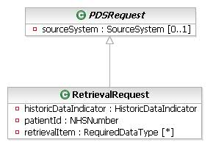
Retrieve Patient Request

RetrievalRequest
Encapsulates the information required in a retrieval request.
Attribute | Type | Values | Cardinality | Definition
historicDataIndicator | HistoricDataIndicator | 0 - No history required  1 - Retrieve all historic information | 1 | The history indicator is used to indicate whether or not historic data is to be returned in addition to current data. When set, the history is returned for the following items:  • Name  • Address  • Telecom  • Relationship  • CareProvider  • SupersededIds (Effective To dates only).
patientId | NHSNumber |  | 1 | The NHS Number of the patient to retrieve. This can either be New Style NHS Number or temporary NHS number issued by an NHAIS registration authority or Old style NHS number
retrievalItem | RequiredDataType | personalRelationship - All family/close contacts details  guardian - All legal guardian details  person.fullDemographics - all of: supercededId, person.nameUsual, person.nameOther, person.otherDemographics, consent, person.confidentiality,  person.allData - All person data  dsa.allData - All person data for DSA  pharmacy - All pharmacy details  supercededId - All previous or superceded nationally recognised identifiers  proxy - All proxy details  person.otherDemographics - Birth date/death date/status of death notification/sex/delivery time/birth order  callCentreData - Call centre call-back consent/shared secret  consent - Consent to NHS Care Record sharing/date last changed  person.nameUsual - Current usual name  nhaisPosting - NHAIS Posting data  person.placeOfBirth - Place of Birth  person.misc - Preferred language/interpreter required/preferred contact method/preferred contact times/preferred communication format/healthspace  person.nameOther - previous/alias/preferred names  primaryCare - Primary care registration information  person.reasonForRemoval - Reason for Removal related data  person.confidentiality - Sensitivity information status/reason for removal/previous NHS contact  person.addressTelecom - Usual addresses/temporary addresses/correspondence addresses/telecommunication contact details.  paperRecordTracking - Details of the location of the patients Paper Records | * | Required data filter describing which data items to be returned. When this is unspecified (ie Null), only the serialChangeNumber of the patient will be returned.  NOTE: when DSA or NHAIS is retrieving reasonForRemoval, they get back the actual value (or nothing if there is a null value), but when other systems are retrieving reasonForRemoval, they get back value X (or nothing if there is a null value).

Retrieve Patient Response
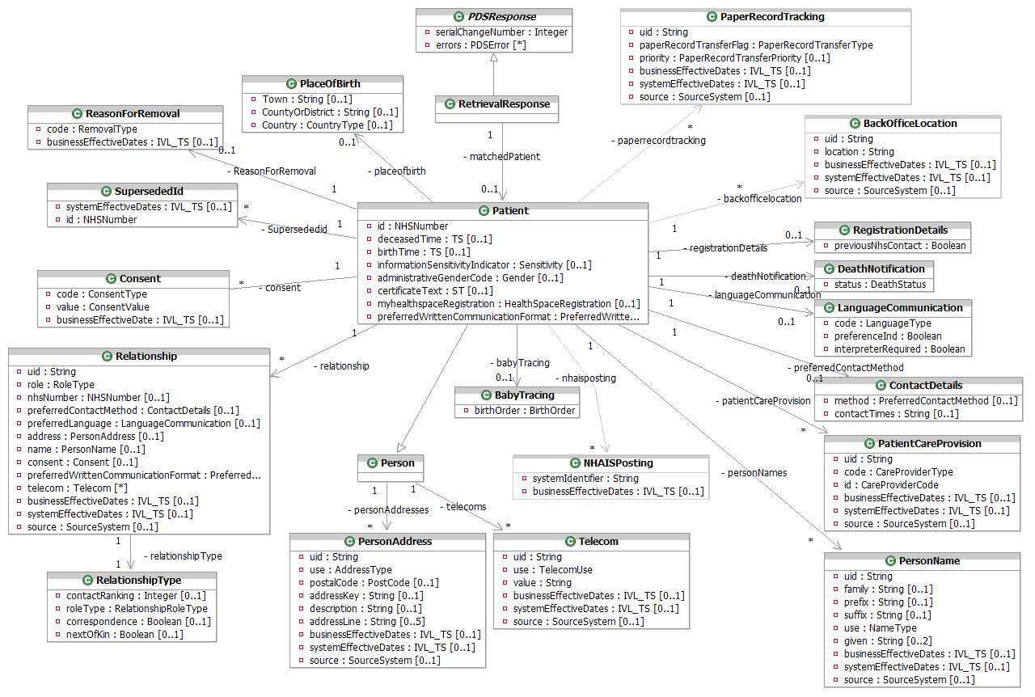
Retrieve Patient Response

BabyTracing
This encapsulates birth data for the patient, containing mother’s NHS number and Date of Birth etc.
Attribute | Type | Values | Cardinality | Definition
birthOrder | BirthOrder | 1 - 1  2 - 2  3 - 3  4 - 4  5 - 5  6 - 6  7 - 7  8 - Not applicable  9 - Not known | 1 | For a birth registration this is mandatory and describes the sequence in the case of multiple births (e.g. twins, triplets etc). For births that are not a part of a multiple birth, this will be set to 1. Note that permissible values are 1-9, with any value between 1 and 7 inclusive indicating the actual birth order number, 8 meaning "Not applicable" and 9 meaning "Not known".

Consent
Details of consent status for care record sharing or call-centre call-back. Patients may opt in or out of having their care records shared with other clinicians, or receiving callbacks from NHS Call Centres.
Attribute | Type | Values | Cardinality | Definition
businessEffectiveDate | IVL_TS |  | 0..1 | Date last changed as single point in time. Full Date Only, without time. Not used for call-back consent.
code | ConsentType | 6 - Call centre call-back consent  4 - Consent to NHS Care Record sharing | 1 | Coded value. From DemographicObservationType vocabulary ('4','6')
value | ConsentValue | 1 - Express Consent  2 - Express Dissent  4 - No  5 - Yes | 1 | Coded value from Consent vocabulary. 1 and 2 apply to NHS Care Record Sharing. 4 and 5 apply to Call Centre call-back.

ContactDetails
Details of the patient’s preferences for contact times and methods.
Attribute | Type | Values | Cardinality | Definition
contactTimes | String |  | 0..1 | Text describing preferred contact times, e.g. 'Evenings Only'.
method | PreferredContactMethod | 4 - E-mail  1 - Letter  5 - Minicom (Textphone)  8 - No Telephone contact  7 - Sign language  3 - Telephone  6 - Telephone contact via proxy  2 - Visit | 0..1 | Indicates how the person would prefer to be contacted, such as by Letter, Phone etc. Coded value. From PreferredContactMethod vocabulary.

DeathNotification
Details about the patient’s death status, if applicable.
Attribute | Type | Values | Cardinality | Definition
status | DeathStatus | 2 - Formal (Civil Registration)  1 - Informal | 1 | Coded value. From DeathNotification vocabulary.  1 (Informal) death notice received via an update from a local NHS Organisation such as GP or Trust  2 (Formal) death notice received from Registrar of Deaths

LanguageCommunication
Details of the language preference of the patient where not English.
Attribute | Type | Values | Cardinality | Definition
code | LanguageType | q2 - American Sign Language  [ISO 639-1 Code] - Any code listed in ISO 639-1  q3 - Australian.Sign Language  q1 - Braille  q4 - British Sign Language  q5 - Makaton | 1 | Language code. Coded value from HumanLanguage.
interpreterRequired | Boolean |  | 1 | Indicates whether an interpreter is required for this person.
preferenceInd | Boolean |  | 1 | Always 1 ("true") in this case as this identifies the patient's preferred language.

NHAISPosting
This represents the NHAIS Posting, a code use to identify an NHAIS System.
Attribute | Type | Values | Cardinality | Definition
systemIdentifier | String |  | 1 | The identifier of the NHAIS system to which the patient is registered.
businessEffectiveDates | IVL_TS |  | 0..1 | The dates for which this data is/was current as a range, supplied in the Low and High attributes of the IVL_TS. Business Effective Dates are full dates without time.

PaperRecordTracking
Fields to help keep track of the location of a patient’s paper record.
Attribute | Type | Values | Cardinality | Definition
uid | String |  | 1 | A unique identifier for this object within the patient record, which will be used to control the update semantics.
paperRecordTransferFlag | PaperRecordTransferType | RP - Requested from Practice  RB - Requested from Storage  RS - Requested from Scotland  RN - Requested from Northern Ireland  RA - Requested from SMU  CP - Recalled from Practice  CS - Recalled from Scotland  CN - Recalled from Northern Ireland  SP - Sent by practice  FB - Forwarded to Back Office  FP - Forwarded to Practice  FA - Forwarded to SMU  HB - Stored at Back Office  HS - Held in Scotland  HN - Held in Northern Ireland  HP - Held at registered Practice  HX - No Paper record Exists | 1 | Coded value to track movement of paper records
priority | PaperRecordTransferPriority | U – Urgent  N - Normal | 0..1 | The priority of the transfer
businessEffectiveDates | IVL_TS |  | 0..1 | The time period in which this information is valid as a range, supplied in the Low and High attributes of the IVL_TS. Business Effective Dates are full dates without time.
systemEffectiveDates | IVL_TS |  | 0..1 | System generated effective dates for this data item as a range, supplied in the Low and High attributes of the IVL_TS. Only returned when the historicDataIndicator is set to “1”.
source | SourceSystem | A valid NHS Directory Service Organisation Code  A valid SDS Accredited System Identifier  DSA – Demographic Spine Application  NSTS – NHS Strategic Tracing System | 0..1 | The source of this data. Only returned when the historicDataIndicator is set to “1”.

Patient
This class extends Person to hold additional information for the retrieved Patient.
Attribute | Type | Values | Cardinality | Definition
administrativeGenderCode | Gender | 2 - Female  1 - Male  0 - Not Known  9 - Not Specified | 0..1 | The gender of the patient.
birthTime | TS |  | 0..1 | The person’s date and time of birth as a single point in time.
certificateText | ST |  | 0..1 | Also known as "shared secret".
deceasedTime | TS |  | 0..1 | The person’s date and time of death as a single point in time.
id | NHSNumber |  | 1 | The NHS number of patient. This can be new style, temporary NHS number issued by an NHAIS registration authority or Old style NHS number.
informationSensitivityIndicator | Sensitivity | B - Business Integration  I - Invalid  N - Not Sensitive  S - Sensitive  Y - Sensitive (P1R1 Legacy Value) | 0..1 | Indicates the patient’s details are marked as sensitive. This is only included in the response when it is set to "B", "S" or "Y".
myhealthspaceRegistration | HealthSpaceRegistration | 1 - Not registered for use  3 - Provisional registration granted  2 - Registered for use | 0..1 | A status indicator of the patient’s registration with HealthSpace
preferredWrittenCommunicationFormat | PreferredWrittenCommunicationFormat | 13 - Audio tape  12 - Braille  11 - Large print | 0..1 | The patient’s preferred communication format.

PatientCareProvision
An instance of this class identifies a GP, primary care organization, or Nominated Pharmacy responsible for a Patient over a period of time.
Attribute | Type | Values | Cardinality | Definition
businessEffectiveDates | IVL_TS |  | 0..1 | The dates for which this data is/was current as a range, supplied in the Low and High attributes of the IVL_TS. This is only relevant to primary care, i.e. not relevant to pharmacy data. Business Effective Dates are full dates without time.
code | CareProviderType | P3 - Dispensing Doctor  P2 - Medical appliance  P1 - Nominated pharmacy  1 - Primary care | 1 | Coded value. From PatientCareProvisionType vocabulary. This vocabulary now includes the type of pharmacy as "P1", "P2", "P3".
id | CareProviderCode |  | 1 | One of:  - GP Code,  - GP Practice Code,  - National Pharmacy Code.
source | SourceSystem | A valid NHS Directory Service Organisation Code  A valid SDS Accredited System Identifier  DSA – Demographic Spine Application  NSTS – NHS Strategic Tracing System | 0..1 | The source of this data. This will be provided with primary care data but is not relevant to pharmacy data. Only returned when the historicDataIndicator is set to “1”.
systemEffectiveDates | IVL_TS |  | 0..1 | System generated effective dates for this data item as a range, supplied in the Low and High attributes of the IVL_TS. This will be provided with primary care data but is not relevant to pharmacy data. For current data, only the Low attribute will be set. Only returned when the historicDataIndicator is set to “1”.
uid | String |  | 1 | A unique identifier for this object within the patient record, which will be used to control the update semantics.

Person
Person is an abstract class that has the Patient Class as a generalisation class. Other generalisations exist but are not shown on this diagram for clarity.

PersonAddress
This class is used to hold address details for a person. The use attribute describes the use made of the address (home, temporary, etc). The structure of this class is based on the HL7 AD data type.
Attribute | Type | Values | Cardinality | Definition
addressKey | String |  | 0..1 | PAF Key
addressLine | String |  | 0..5 | 5 address lines - excludes postcode, may be vernacular or PAF-derived. For vernacular addresses, the following formatting convention should normally apply although there may be some exceptions:  line 1: premises ID  line 2: no/thoroughfare  line 3: locality  line 4: post town  line 5: county  The following address lines should normally be mandatory although there may be some exceptions:  • 1 or 2 and  • 4
businessEffectiveDates | IVL_TS |  | 0..1 | The dates for which this data is/was current as a range, supplied in the Low and High attributes of the IVL_TS. Business Effective Dates are full dates without time.
description | String |  | 0..1 | Textual description of the usage of a temporary address. For example "On Holiday". For temporary address only (i.e. where the use="TMP").
postalCode | PostCode |  | 0..1 | The UK format Postcode, 8 character string: ZZ99 3VZ. AS PER BS7666.  The 8 characters field allows a space to be inserted to differentiate between the inward and outward segments of the code, enabling full use to be made of Royal Mail postcode functionality.
source | SourceSystem | A valid NHS Directory Service Organisation Code  A valid SDS Accredited System Identifier  DSA – Demographic Spine Application  NSTS – NHS Strategic Tracing System | 0..1 | The source of this data. Only returned when the historicDataIndicator is set to “1”.
systemEffectiveDates | IVL_TS |  | 0..1 | System generated effective dates for this data item as a range, supplied in the Low and High attributes of the IVL_TS. For current and future dated data, only the Low attribute will be set. Only returned when the historicDataIndicator is set to “1”.
uid | String |  | 1 | A unique identifier for this object within the patient record, which will be used to control the update semantics.
use | AddressType | PST - Correspondence address  H - Home address  TMP - Temporary address  WP - Work address | 1 | Coded value. From cs_PostalAddressUse HL7 data type. Only values 'H' (usual address), 'TMP' and 'PST' are relevant to this interaction.

PersonName
This class is used to hold name details for a person within the NHS. The structure of this class is based on the HL7 PN data type.
Attribute | Type | Values | Cardinality | Definition
businessEffectiveDates | IVL_TS |  | 0..1 | The dates for which this name data is/was current as a range, supplied in the Low and High attributes of the IVL_TS. Business Effective Dates are full dates without time.
family | String |  | 0..1 | The surname or family name of the patient.
given | String |  | 0..2 | Up to two given names. If the patient has more than 2 given names, these will be concatenated in the 2nd given name attribute with a space between each name.
prefix | String |  | 0..1 | A prefix, or title for the name, such as Mr, Mrs, etc.
source | SourceSystem | A valid NHS Directory Service Organisation Code  A valid SDS Accredited System Identifier  DSA – Demographic Spine Application  NSTS – NHS Strategic Tracing System | 0..1 | The source of this data. Only returned when the historicDataIndicator is set to “1”.
suffix | String |  | 0..1 | The suffix for the patient name (i.e. Jnr or Snr).
systemEffectiveDates | IVL_TS |  | 0..1 | System generated effective dates for this data item as a range, supplied in the Low and High attributes of the IVL_TS. For current and future dated data, only the Low attribute will be set. Only returned when the historicDataIndicator is set to “1”.
uid | String |  | 1 | A unique identifier for this object within the patient record, which will be used to control the update semantics.
use | NameType | A - Alias  PREFERRED - PREFERRED  PREVIOUS - PREVIOUS  PREVIOUS-BACHELOR - PREVIOUS-BACHELOR  PREVIOUS-BIRTH - PREVIOUS-BIRTH  PREVIOUS-MAIDEN - PREVIOUS-MAIDEN  L - Usual (current) name | 1 | The type of name this data represents. Possible types are:  L = usual (current) name,  A = alias name,  PREFERRED,  PREVIOUS-BIRTH,  PREVIOUS-MAIDEN,  PREVIOUS-BACHELOR  PREVIOUS

PlaceOfBirth
Details of the patient’s place of birth in as much detail as is available, i.e., may just be the country the patient was born in, but could also be the county and/or the town. At least one of these attributes must be populated.
Attribute | Type | Values | Cardinality | Definition
Country | countryType |  | 0..1 | Country of birth.
CountyOrDistrict | String |  | 0..1 | County/Metropolitan district of birth.
Town | String |  | 0..1 | Town/City of birth.

ReasonForRemoval
This represents the reason a patient has been removed.
Attribute | Type | Values | Cardinality | Definition
businessEffectiveDates | IVL_TS |  | 0..1 | The time period in which this information is valid as a range, supplied in the Low and High attributes of the IVL_TS. Business Effective Dates are full dates without time.
code | RemovalType | DEA - Death  EMB - Embarkation  SCT - Transferred to Scotland  NIT - Transferred to Northern Ireland  AFN - AF Enlistment (notified by AF)  AFL - AF Enlistment (notified locally)  SDN - Services Dependant (notified by SMO)  SDL - Services Dependant (notified locally)  TRA - Temporary resident not returned  RFI - Removal from Residential Institute  RDI - Practice request immediate removal  RDR - Practice request  RPR - Patient request  OPA - Address out of practice area  CGA - Gone away – address not known/FP69  DIS - Practice dissolution  LDN - Logical Deletion  X - No current NHAIS posting.  ORR - Other Reason  CAN - Cancelled | 1 | Coded Only. From RemovalType vocabulary.  If the source system is DSA or NHAIS, the full removal type is returned, otherwise only X="No current NHAIS Posting." is returned where relevant.

RegistrationDetails
Details of the Registration Process.
Attribute | Type | Values | Cardinality | Definition
previousNhsContact | Boolean |  | 1 | Previous contact with the NHS - i.e. 2nd Acceptance.

Relationship
Details of relationships between the patient and other parties which are relevant to the PDS. These may be Proxy, Legal Guardian, or Family/Close Contact type relationships. Where only an NHS Number is returned, further Retrieval Requests should be made to fetch the corresponding details for the related persons.
Attribute | Type | Values | Cardinality | Definition
address | PersonAddress |  | 0..1 | This class is used to hold address details for a person. This shall be present where an NHS number for the related person is not present, and shall not be present where an NHS number for the related person is present. The use attribute describes the use made of the address, and will always be "H" - Usual Address in this case. The structure of this class is based on the HL7 AD data type.
businessEffectiveDates | IVL_TS |  | 0..1 | The time period in which the relationship was valid as a range, supplied in the Low and High attributes of the IVL_TS. Business Effective Dates are full dates without time.
consent | Consent |  | 0..1 | Details of consent status for call-centre call-back. This is only relevant where the role type is 'AGNT' (Agent - used for Proxies).
name | PersonName |  | 0..1 | This class is used to hold name details for a person within the NHS, and shall contain the persons usual name. This shall be present where an NHS number for the related person is not present, and shall not be present where an NHS number for the related person is present. The structure of this class is based on the HL7 PN data type.
nhsNumber | NHSNumber |  | 0..1 | The NHS Number of the related person (where known). This will be a new style NHS number only.
preferredContactMethod | ContactDetails |  | 0..1 | Details of the patient’s preferences for contact times and methods. This may be present where an NHS number for the related person is not present, and shall not be present where an NHS number for the related person is present.
preferredLanguage | LanguageCommunication |  | 0..1 | Details of the language preference of the patient where not English. This may be present where an NHS number for the related person is not present, and shall not be present where an NHS number for the related person is present.
preferredWrittenCommunicationFormat | PreferredWrittenCommunicationFormat | 13 - Audio tape  12 - Braille  11 - Large print | 0..1 | This details of a person’s preferred written communication format. This may be present where an NHS number for the related person is not present, and shall not be present where an NHS number for the related person is present.
role | RoleType | AGNT - Agent (Used for Proxies)  GUARD - Guardian  PRS - Personal Relationship | 1 | Specify the role for this relationship.  'AGNT' = Proxy,  'GUARD' = Legal Guardian,  'PRS' = Personal Relationships.
source | SourceSystem | A valid NHS Directory Service Organisation Code  A valid SDS Accredited System Identifier  DSA – Demographic Spine Application  NSTS – NHS Strategic Tracing System | 0..1 | The source of this data. Only returned when the historicDataIndicator is set to “1”.
systemEffectiveDates | IVL_TS |  | 0..1 | System generated effective dates for this data item as a range, supplied in the Low and High attributes of the IVL_TS. Only returned when the historicDataIndicator is set to “1”.
telecom | Telecom |  | * | The related person’s telecoms details. This may be present where an NHS number for the related person is not present, and shall not be present where an NHS number for the related person is present.
uid | String |  | 1 | A unique identifier for this object within the patient record, which will be used to control the update semantics.

RelationshipType
Details describing the type of the relationship.
Attribute | Type | Values | Cardinality | Definition
contactRanking | Integer |  | 0..1 | The order in which contact should normally be made with related persons.
correspondence | Boolean |  | 0..1 | This is used to indicate that correspondence should be copied to the person related to the patient. 1 ('True') if correspondence is to be copied.
nextOfKin | Boolean |  | 0..1 | Indicates that the role is that of a next of kin. 1 ('True') if person is the patient's next of kin.
roleType | RelationshipType | 15 - Brother  20 - Carer  09 - Child  10 - Dependant  13 - Father  06 - Foster parent  05 - Guardian  12 - Mother  04 - Next of kin  11 - Non-dependant  98 - Not Known  99 - Not specified  03 - Parent  02 - Partner  08 - Polygamous partner  18 - Proxy – Communication  17 - Proxy – Contact  19 - Proxy -- Contact and Communication  16 - Relative  21 - Self  14 - Sister  01 - Spouse  07 - Step parent | 1 | This indicates further typing of the related person within the overall relationship role - i.e. the type of proxy, the type of guardian or the type of personal relationship. The values for this attribute will be taken from the PersonRelationshipType vocabulary in the MIM.

RetrievalResponse
Encapsulates the information returned for a retrieval request.

SupersededId
Information about any previous NHS Numbers the patient may have had.
Attribute | Type | Values | Cardinality | Definition
systemEffectiveDates | IVL_TS |  | 0..1 | The time at which this ID was Superseded. Only the "high" element of the IVL_TS will be populated. Only returned when the historicDataIndicator is set to “1”.
id | NHSNumber |  | 1 | The superseded NHS Number of the patient. This may be a New, Old or Temporary Style NHS Number.

Telecom
Specifies a means of communicating with the patient by telephone, fax, e-mail etc.
Attribute | Type | Values | Cardinality | Definition
businessEffectiveDates | IVL_TS |  | 0..1 | The dates for which this telecom data is/was current as a range, supplied in the Low and High attributes of the IVL_TS. Business Effective Dates are full dates without time.
source | SourceSystem | A valid NHS Directory Service Organisation Code  A valid SDS Accredited System Identifier  DSA – Demographic Spine Application  NSTS – NHS Strategic Tracing System | 0..1 | The source of this data. Only returned when the historicDataIndicator is set to “1”.
systemEffectiveDates | IVL_TS |  | 0..1 | System generated effective dates for this data item as a range, supplied in the Low and High attributes of the IVL_TS. Only returned when the historicDataIndicator is set to “1”.
uid | String |  | 1 | A unique identifier for this object within the patient record, which will be used to control the update semantics.
use | TelecomUse | H - A communication address at a home  EC - A contact specifically designated to be used for emergencies  PG - A paging device suitable to solicit a callback or to leave a very short message  MC - A telecommunication device that moves and stays with its owner  HV - A vacation home, to reach a person while on vacation  AS - An automated answering machine  WP - An office address  HP - The primary home, to reach a person after business hours | 1 | Describes the kind of telecom contact information that is held, e.g. whether it is a home phone number, a work phone number, a mobile phone number etc. Coded value. From cs_TelecommunicationAddressUse HL7 data type. Refer to NPfIT MIM for applicable values.
value | String |  | 1 | The contact method and number separated by a colon. i.e. "tel:01234 567890". Must be present unless the updateMode is "removed".

BackOfficeLocation
The Back Office location for the PCT in which the patient resides.
Attribute | Type | Values | Cardinality | Definition
Location | String |  | 1 | The Back Office location for the PCT in which the patient resides. This will be an NHAIS cipher, Scottish Area Health Board code, or one of “NI” (Northern Ireland) or “NBO” (National Back Office).
businessEffectiveDates | IVL_TS |  | 0..1 | The dates for which this Back Office Location data is/was current as a range, supplied in the Low and High attributes of the IVL_TS. Business Effective Dates are full dates without time.
source | SourceSystem | A valid NHS Directory Service Organisation Code  A valid SDS Accredited System Identifier  DSA – Demographic Spine Application  NSTS – NHS Strategic Tracing System | 0..1 | The source of this data. Only returned when the historicDataIndicator is set to “1”.
systemEffectiveDates | IVL_TS |  | 0..1 | System generated effective dates for this data item as a range, supplied in the Low and High attributes of the IVL_TS. Only returned when the historicDataIndicator is set to “1”.
uid | String |  | 1 | A unique identifier for this object within the patient record, which will be used to control the update semantics.

Confirm NHS Number
Confirm NHS Number is used to confirm the details held by the PDS match those held by an external system for the given NHS Number. It is similar to a retrieval request, but has a fixed result set. Both current and future dated data is returned. The merging of patient’s records, and the patient’s informationSensitivityIndicator may effect the data returned - see the PDS [SSRS] for details.

Confirm NHS Number Request
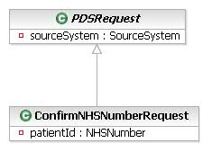
Confirm NHS Number Request

ConfirmNHSNumberRequest
Encapsulates information required for the ConfirmNHSNumberRequest transaction.
Attribute | Type | Values | Cardinality | Definition
patientId | NHSNumber |  | 1 | The NHS Number, Old Format NHS Number or temporary NHS Number of the patient to confirm.

Confirm NHS Number Response
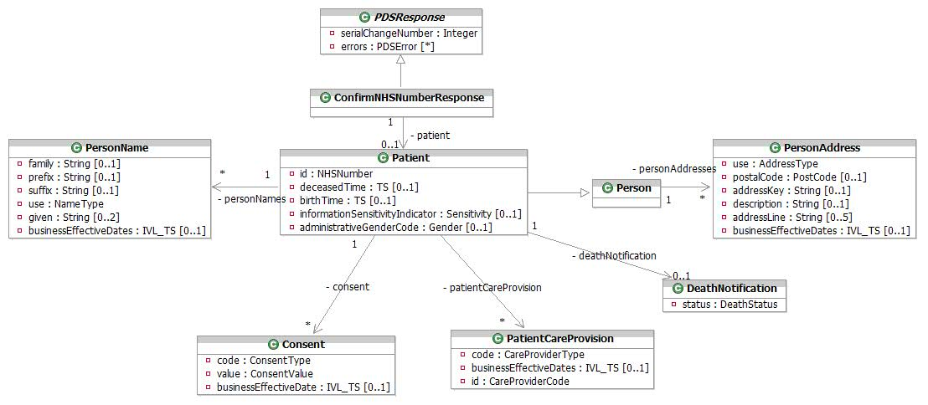
Confirm NHS Number Response

ConfirmNHSNumberResponse
Encapsulates the information returned by the ConfirmNHSNumber transaction.

Consent
Details of consent status for care record sharing or call-centre call-back. Patients may opt in or out of having their care records shared with other clinicians, or receiving callbacks from NHS Call Centres.
Attribute | Type | Values | Cardinality | Definition
businessEffectiveDate | IVL_TS |  | 0..1 | Date last changed as single point in time. Date Only. Not used for call-back consent. Business Effective Dates are full dates without time.
code | ConsentType | 6 - Call centre call-back consent  4 - Consent to NHS Care Record sharing | 1 | Coded value. From DemographicObservationType vocabulary ('4','6')
value | ConsentValue | 1 - Express Consent  2 - Express Dissent  4 - No  5 - Yes | 1 | Coded value from Consent vocabulary. 1 and 2 apply to NHS Care Record Sharing. 4 and 5 apply to Call Centre call-back.

DeathNotification
Details about the patient’s death notification, if applicable.
Attribute | Type | Values | Cardinality | Definition
status | DeathStatus | 2 - Formal (Civil Registration)  1 - Informal | 1 | Coded value. From DeathNotification vocabulary.

Patient
This class extends Person to hold the current information for an NHS Patient matching the supplied NHS Number.
Attribute | Type | Values | Cardinality | Definition
administrativeGenderCode | Gender | 2 - Female  1 - Male  0 - Not Known  9 - Not Specified | 0..1 | The gender of the patient.
birthTime | TS |  | 0..1 | The person’s date of birth as a single point in time. Date only - no time.
deceasedTime | TS |  | 0..1 | The person’s date and time of death as a single point in time.
id | NHSNumber |  | 1 | The current NHS number of patient. This may be a New Style NHS Number or temporary NHS number issued by an NHAIS registration authority or Old style NHS number
informationSensitivityIndicator | Sensitivity | B - Business Integration  I - Invalid  N - Not Sensitive  S - Sensitive  Y - Sensitive (P1R1 Legacy Value) | 0..1 | Indicates the patient’s details are marked as sensitive. Only values "B", "S" and "Y" are returned.

PatientCareProvision
An instance of this class identifies a primary care organization or Nominated Pharmacy responsible for a Patient over a period of time.
Attribute | Type | Values | Cardinality | Definition
businessEffectiveDates | IVL_TS |  | 0..1 | The effective dates for this care provision relationship as a range, supplied in the Low and High attributes of the IVL_TS. Business Effective Dates are full dates without time. Not applicable if this is a Pharmacy.
code | CareProviderType | P3 - Dispensing Doctor  P2 - Medical appliance  P1 - Nominated pharmacy  1 - Primary care | 1 | Coded value. From PatientCareProvisionType vocabulary. This vocab now includes the type of pharmacy as "P1", "P2", "P3". Only one of each type of pharmacy data can be supplied.
id | CareProviderCode |  | 1 | One of:  - GP Practice Code,  - National Pharmacy Code.

Person
Person is an abstract class that has the Patient Class as a generalisation class. Other generalisations exist but are not shown on this diagram for clarity.

PersonAddress
This class is used to hold address details for a person. The use attribute describes the use made of the address (home, temporary, etc). The structure of this class is based on the HL7 AD data type.
Attribute | Type | Values | Cardinality | Definition
addressKey | String |  | 0..1 | PAF Key
addressLine | String |  | 0..5 | 5 address lines - excludes postcode, may be vernacular or PAF-derived. For vernacular addresses, the following formatting convention should normally apply although there may be some exceptions:  line 1: premises ID  line 2: no/thoroughfare  line 3: locality  line 4: post town  line 5: county  The following address lines should normally be mandatory although there may be some exceptions:  • 1 or 2 and  • 4
businessEffectiveDates | IVL_TS |  | 0..1 | The dates for which this data is/was current as a range, supplied in the Low and High attributes of the IVL_TS. Business Effective Dates are full dates without time.
description | String |  | 0..1 | Textual description of the usage of a temporary address. For example "On Holiday". For temporary address only (i.e. where the use="TMP").
postalCode | PostCode |  | 0..1 | The UK format Postcode, 8 character string: ZZ99 3VZ. AS PER BS7666.  The 8 characters field allows a space to be inserted to differentiate between the inward and outward segments of the code, enabling full use to be made of Royal Mail postcode functionality.
use | AddressType | PST - Correspondence address  H - Home address  TMP - Temporary address  WP - Work address | 1 | Coded value. From cs_PostalAddressUse HL7 data type. Only values 'H' (usual address) and 'TMP' are relevant to this interaction.

PersonName
Instances of this class hold various types of name details for a person. The structure of this class is based on the HL7 PN data type.
Attribute | Type | Values | Cardinality | Definition
businessEffectiveDates | IVL_TS |  | 0..1 | The dates for which this data is/was current as a range, supplied in the Low and High attributes of the IVL_TS. Business Effective Dates are full dates without time.
family | String |  | 0..1 | The surname or family name of the patient.
given | String |  | 0..2 | Up to two given names. If the patient has more than 2 given names, these will be concatenated in the 2nd given name attribute with a space between each name.
prefix | String |  | 0..1 | A prefix, or title for the name, such as Mr, Mrs, etc.
suffix | String |  | 0..1 | The suffix for the patient name (i.e. Jnr or Snr).
use | NameType | A - Alias  PREFERRED - PREFERRED  PREVIOUS - PREVIOUS  PREVIOUS-BACHELOR - PREVIOUS-BACHELOR  PREVIOUS-BIRTH - PREVIOUS-BIRTH  PREVIOUS-MAIDEN - PREVIOUS-MAIDEN  L - Usual (current) name | 1 | The type of name this data represents. Only usual, alias and preferred name types are relevant to this interaction.

Allocate NHS Number
AllocateNHSNumber provides a facility for an external system to request the allocation of an NHS Number for a patient who cannot be found on the PDS, typically following an Advanced Trace.

Allocate NHS Number Request
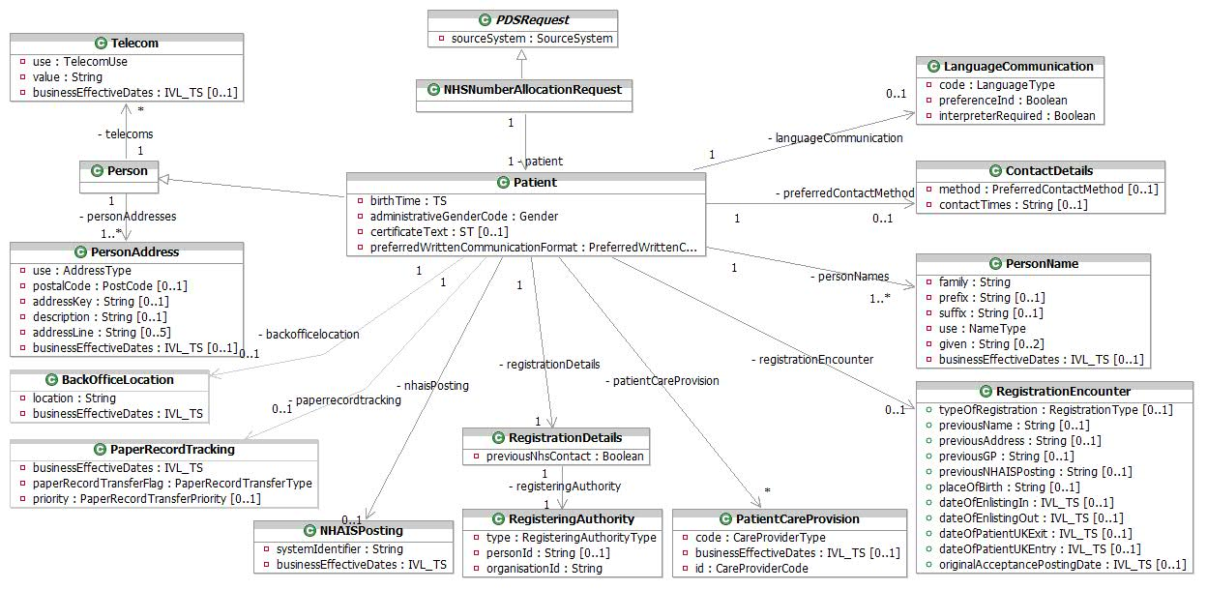
Allocate NHS Number Request
An Allocate NHS Number Request will contain adequate information to allocate a new NHS Number for a patient.

ContactDetails
Details of the patient’s preferences for contact times and methods.
Attribute | Type | Values | Cardinality | Definition
contactTimes | String |  | 0..1 | Text describing preferred contact times, e.g. 'Evenings Only'.
method | PreferredContactMethod | 4 - E-mail  1 - Letter  5 - Minicom (Textphone)  8 - No Telephone contact  7 - Sign language  3 - Telephone  6 - Telephone contact via proxy  2 - Visit | 0..1 | Indicates how the person would prefer to be contacts, such as by Phone, Letter etc. Coded value. From PreferredContactMethod vocabulary.

LanguageCommunication
Details of the language preference of the patient where not English.
Attribute | Type | Values | Cardinality | Definition
code | LanguageType | q2 - American Sign Language  [ISO 639-1 Code] - Any code listed in ISO 639-1  q3 - Australian.Sign Language  q1 - Braille  q4 - British Sign Language  q5 - Makaton | 1 | Language code. Coded value from HumanLanguage.
interpreterRequired | Boolean |  | 1 | Indicates whether an interpreter is required for this person.
preferenceInd | Boolean |  | 1 | Boolean. Always 1 ("true") in this interaction.

NHAISPosting
This represents the NHAIS Posting, a code use to identify an NHAIS System. It is only supplied by NHAIS.
Attribute | Type | Values | Cardinality | Definition
systemIdentifier | String |  | 1 | The identifier of the NHAIS system to which the patient is registered.
businessEffectiveDates | IVL_TS |  | 1 | The dates for which this data is/was current as a range, supplied in the Low and High attributes of the IVL_TS. Business Effective Dates are full dates without time.

NHSNumberAllocationRequest
Encapsulates the information required for an NHS Number Allocation Request.

Patient
This class extends Person to hold additional information for the Patient for which an NHS Number is being requested.
Attribute | Type | Values | Cardinality | Definition
administrativeGenderCode | Gender | 2 - Female  1 - Male  0 - Not Known  9 - Not Specified | 1 | The gender of the patient.
birthTime | TS |  | 1 | The person’s date of birth as a single point in time. A full date of birth (not including time) must be given.
certificateText | ST |  | 0..1 | Also known as "shared secret".
preferredWrittenCommunicationFormat | PreferredWrittenCommunicationFormat | 13 - Audio tape  12 - Braille  11 - Large print | 0..1 | This details a person’s preferred written communication format.

PatientCareProvision
An instance of this class identifies a primary care organization, or Nominated Pharmacy responsible for a Patient.
Attribute | Type | Values | Cardinality | Definition
businessEffectiveDates | IVL_TS |  | 0..1 | The effective dates for this care provision relationship as a range, supplied in the Low and High attributes of the IVL_TS. Business Effective Dates are full dates without time. Not applicable if this is a Pharmacy, but mandatory for Primary Care. This date must not be in the future.
code | CareProviderType | P3 - Dispensing Doctor  P2 - Medical appliance  P1 - Nominated pharmacy  1 - Primary care | 1 | Coded value. From PatientCareProvisionType vocabulary. This vocab now includes the type of pharmacy as "P1", "P2", "P3". Only one of each type of pharmacy data can be supplied.
id | CareProviderCode |  | 1 | One of:  - GP Practice Code,  - National Pharmacy Code.

Person
Person is an abstract class that has the Patient Class as a generalisation class. Other generalisations exist but are not shown on this diagram for clarity.

PersonAddress
This class is used to hold address details for a person. The use attribute describes the use made of the address (home, temporary, etc). The structure of this class is based on the HL7 AD data type.
Attribute | Type | Values | Cardinality | Definition
addressKey | String |  | 0..1 | PAF Key
addressLine | String |  | 0..5 | 5 address lines - excludes postcode, may be vernacular or PAF-derived. For vernacular addresses, the following formatting convention should be used:  line 1: premises ID  line 2: no/thoroughfare  line 3: locality  line 4: post town  line 5: county  The following address lines are mandatory:  • 1 or 2 and  • 4
businessEffectiveDates | IVL_TS |  | 0..1 | The dates for which this data is/was current as a range, supplied in the Low and High attributes of the IVL_TS. Business Effective Dates are full dates without time.
description | String |  | 0..1 | Textual description of the usage of a temporary address. For example "On Holiday". For temporary address only (i.e. where the use="TMP").
postalCode | PostCode |  | 0..1 | The UK format Postcode, 8 character string: ZZ99 3VZ. AS PER BS7666.  The 8 characters field allows a space to be inserted to differentiate between the inward and outward segments of the code, enabling full use to be made of Royal Mail postcode functionality.
use | AddressType | PST - Correspondence address  H - Home address  TMP - Temporary address  WP - Work address | 1 | Coded value. From cs_PostalAddressUse HL7 data type. Only values 'H' (usual address), 'TMP' and 'PST' are relevant to this interaction.

PersonName
This class is used to hold name details for a person within the NHS. One occurrence of current usual name shall be provided, up to one occurrence of a preferred name may be provided, and any number of occurrences of alias and previous name types may also be provided. The structure of this class is based on the HL7 PN data type.
Attribute | Type | Values | Cardinality | Definition
businessEffectiveDates | IVL_TS |  | 0..1 | The dates for which this data is/was current as a range, supplied in the Low and High attributes of the IVL_TS. Business Effective Dates are full dates without time.
family | String |  | 1 | The surname or family name of the patient.
given | String |  | 0..2 | Up to two given names. If the patient has more than 2 given names, these will be concatenated in the 2nd given name attribute with a space between each name.
prefix | String |  | 0..1 | A prefix, or title for the name, such as Mr, Mrs, etc.
suffix | String |  | 0..1 | The suffix for the patient name (i.e. Jnr or Snr).
use | NameType | A - Alias  PREFERRED - PREFERRED  PREVIOUS - PREVIOUS  PREVIOUS-BACHELOR - PREVIOUS-BACHELOR  PREVIOUS-BIRTH - PREVIOUS-BIRTH  PREVIOUS-MAIDEN - PREVIOUS-MAIDEN  L - Usual (current) name | 1 | The type of name this data represents. Possible types are:  L = usual (current) name,  A = alias name,  PREFERRED,  PREVIOUS-BIRTH,  PREVIOUS-MAIDEN,  PREVIOUS-BACHELOR  PREVIOUS

RegisteringAuthority
Provides details of the authority for the PDS registration.
Attribute | Type | Values | Cardinality | Definition
organisationId | String |  | 1 | NHAIS cypher or NACS code of registering organisation
personId | String |  | 0..1 | NHAIS User Id.
type | RegisteringAuthorityType | v - Appliance Contractor  f - Armed Forces  m - Breast Screening Unit  o - Department of Health  b - Director of Health and Social Care  d - GP Practice  h - IM&T Service  t - Local Authority  g - MOD Hospital  y - NHAIS  l - NHS Administration Unit  c - NHS Trust  s - Non-NHS Commissioner (except Local Authority)  p - Other Government Department  e - Other NHS Organisation  k - Other Statutory Authority  n - Pathology Laboratory  u - Pharmacy  x - Primary Care Trust  q - Registered non-NHS Provider  i - Special Trustee  w - Specialised Services Commissioning Consortium  a - Strategic Health Authority  j - University  r - Unregistered non-NHS Provider (except Local Authority) | 1 | Coded value from RegisteringAuthorityType vocabulary, for instance: Strategic Health Authority, NHS Trust, GP Practice.

RegistrationDetails
Details of the Registration Process.
Attribute | Type | Values | Cardinality | Definition
previousNhsContact | Boolean |  | 1 | Previous contact with the NHS - i.e. 2nd Acceptance.

RegistrationEncounter
The patient’s GP Registration details. This is only supplied by NHAIS.
Attribute | Type | Values | Cardinality | Definition
dateOfEnlistingIn | IVL_TS |  | 0..1 | Date of Enlisting in.  Date format – Single Point in Time - YYYYMMDD
dateOfEnlistingOut | IVL_TS |  | 0..1 | Date of Enlisting out.  Date format - Single Point in Time - YYYYMMDD
dateOfPatientUKEntry | IVL_TS |  | 0..1 | Date of Patient UK Entry  Date format - Single Point in Time - YYYYMMDD
dateOfPatientUKExit | IVL_TS |  | 0..1 | Date of Patient UK Exit  Date format - Single Point in Time - YYYYMMDD
originalAcceptancePostingDate | IVL_TS |  | 0..1 | Original Acceptance Posting Date  Date format - Single Point in Time - YYYYMMDD
placeOfBirth | String |  | 0..1 | Place of Birth
previousAddress | String |  | 0..1 | Previous address.
previousGP | String |  | 0..1 | Previous GP
previousName | String |  | 0..1 | Previous Name.
previousNHAISPosting | String |  | 0..1 | Previous NHAIS Posting.
typeOfRegistration | RegistrationType | 1 - Patient birth  2 - Patient first acceptance  3 - Patient transfer in from another NHAIS area  4 - Patient immigrant  5 - Patient ex-services  6 - Patient internal transfer within the NHAIS area | 0..1 | Type of registration.

Telecom
Specifies a means of communicating with the patient by telephone, fax, e-mail etc.
Attribute | Type | Values | Cardinality | Definition
businessEffectiveDates | IVL_TS |  | 0..1 | The dates for which this telecom data is/was current as a range, supplied in the Low and High attributes of the IVL_TS. Business Effective Dates are full dates without time.
use | TelecomUse | H - A communication address at a home  EC - A contact specifically designated to be used for emergencies  PG - A paging device suitable to solicit a callback or to leave a very short message  MC - A telecommunication device that moves and stays with its owner  HV - A vacation home, to reach a person while on vacation  AS - An automated answering machine  WP - An office address  HP - The primary home, to reach a person after business hours | 1 | Describes the kind of telecom contact information that is held, e.g. whether it is a home phone number, a work phone number, a mobile phone number etc. Coded value. From cs_TelecommunicationAddressUse HL7 data type.
value | String |  | 1 | The contact method and number separated by a colon. i.e. "tel:01234 567890".

PaperRecordTracking
Fields to help keep track of the location of a patient’s paper record.
Attribute | Type | Values | Cardinality | Definition
paperRecordTransferFlag | PaperRecordTransferType | RP - Requested from Practice  RB - Requested from Storage  RS - Requested from Scotland  RN - Requested from Northern Ireland  RA - Requested from SMU  CP - Recalled from Practice  CS - Recalled from Scotland  CN - Recalled from Northern Ireland  SP - Sent by practice  FB - Forwarded to Back Office  FP - Forwarded to Practice  FA - Forwarded to SMU  HB - Stored at Back Office  HS - Held in Scotland  HN - Held in Northern Ireland  HP - Held at registered Practice  HX - No Paper record Exists | 1 | Coded value to track movement of paper records.
priority | PaperRecordTransferPriority | U – Urgent  N - Normal | 0..1 | The priority of the transfer
businessEffectiveDates | IVL_TS |  | 1 | The dates for which this data is/was current as a range, supplied in the Low and High attributes of the IVL_TS. Business Effective Dates are full dates without time.

BackOfficeLocation
The Back Office location for the PCT in which the patient resides.
Attribute | Type | Values | Cardinality | Definition
location | String |  | 1 | The Back Office location for the PCT in which the patient resides. This will be an NHAIS cypher.
businessEffectiveDates | IVL_TS |  | 1 | The dates for which this data is/was current as a range, supplied in the Low and High attributes of the IVL_TS. Business Effective Dates are full dates without time.

Allocate NHS Number Response
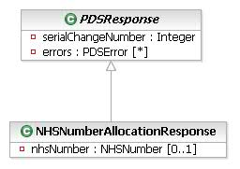
Allocate NHS Number Response
The NHS Number Allocation Response contains the patient’s newly allocated NHS Number if the allocation was successful.

NHSNumberAllocationResponse
Encapsulates the NHS Number returned from an Number Allocation Request if the Request was successful.
Attribute | Type | Values | Cardinality | Definition
nhsNumber | NHSNumber |  | 0..1 | The NHS Number allocated for the patient. This would only not be returned if an error occurred.

Update Patient
Update Patient updates the demographic record of a patient, or create a record where none exists. It is used by Accredited Systems and NHAIS.

General Update Request
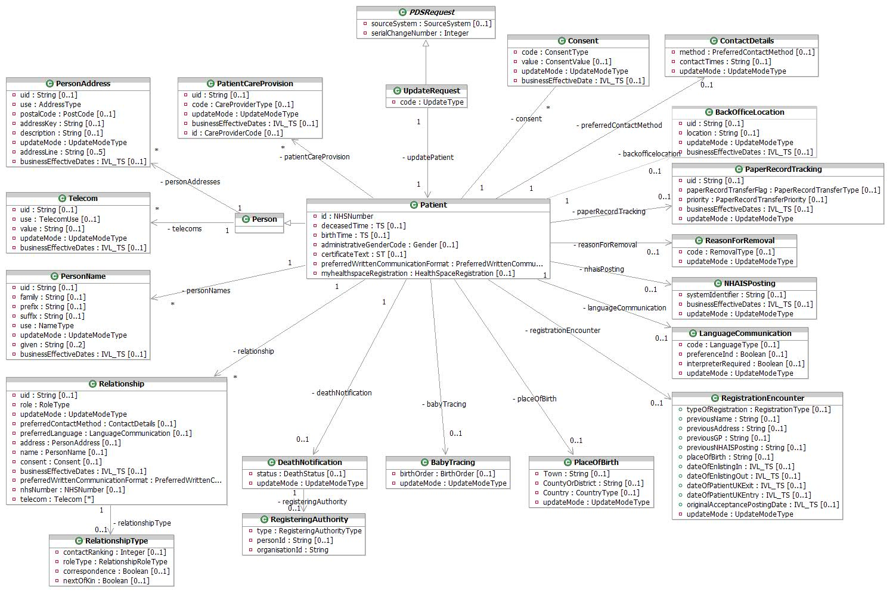
General Update Request

BabyTracing
This encapsulates the patient’s birth data.
Attribute | Type | Values | Cardinality | Definition
birthOrder | BirthOrder | 1 - 1  2 - 2  3 - 3  4 - 4  5 - 5  6 - 6  7 - 7  8 - Not applicable  9 - Not known | 0..1 | Describes the sequence in the case of multiple births (e.g. twins, triplets etc). For births that are not a part of a multiple birth, this will be set to 1. Note that permissible values are 1-9, with any value between 1 and 7 inclusive indicating the actual birth order number, 8 meaning "Not applicable" and 9 meaning "Not known". Not provided where updateMode is "removed".
updateMode | UpdateModeType | - added  - altered  - clear  - removed  - set | 1 | Indicates whether this item should be added, altered, or removed. Values are "added",  "altered",  "removed",  "set", and "clear".  This value will be null for a patient create (cudMood="C"), or Birth Notification.  The values "set" and "clear" are not exposed to HL7 messaging and will only be used within the Spine by, for example, NSTS.

Consent
Details of consent status for care record sharing or call-centre call-back. Patients may opt in or out of having their care records shared with other clinicians, or receiving callbacks from NHS Call Centres.
Attribute | Type | Values | Cardinality | Definition
businessEffectiveDate | IVL_TS |  | 0..1 | Date last changed as single point in time. Business Effective Dates are full dates without time. This will not be present where the updateMode is "removed" but where the updateMode is "altered" or "added" it shall be given where the type of consent is consent to NHS care record sharing.
code | ConsentType | 6 - Call centre call-back consent  4 - Consent to NHS Care Record sharing | 1 | Coded value. From DemographicObservationType vocabulary ('4','6')
updateMode | UpdateModeType | - added  - altered  - clear  - removed  - set | 1 | Indicates whether this item should be added, altered, or removed.  Values are: "added", "altered" and "removed".  Consent to NHS Care Record Sharing can only be removed by back office.
value | ConsentValue | 1 - Express Consent  2 - Express Dissent  4 - No  5 - Yes | 0..1 | Coded value from Consent vocabulary. 1 and 2 apply to NHS Care Record Sharing. 4 and 5 apply to Call Centre call-back. This field shall be provided where updateMode is "added" or "altered". This field shall not be provided where the updateMode is "removed".

ContactDetails
Details of the patient’s preferences for contact times and methods.
Attribute | Type | Values | Cardinality | Definition
contactTimes | String |  | 0..1 | Text describing preferred contact times, e.g. 'Evenings Only'. This will not be present where the updateMode is "removed".
method | PreferredContactMethod | 4 - E-mail  1 - Letter  5 - Minicom (Textphone)  8 - No Telephone contact  7 - Sign language  3 - Telephone  6 - Telephone contact via proxy  2 - Visit | 0..1 | Indicates how the person would prefer to be contacts, such as by Phone, Letter etc. Coded value. From PreferredContactMethod vocabulary. This will not be present where the updateMode is "removed".
updateMode | UpdateModeType | - added  - altered  - clear  - removed  - set | 1 | Indicates whether this item should be added, altered, or removed.  Values are: "added", "altered" and "removed".

DeathNotification
Details about the patient’s death notification, if applicable.
Attribute | Type | Values | Cardinality | Definition
status | DeathStatus | 2 - Formal (Civil Registration)  1 - Informal | 0..1 | Coded value. From DeathNotification vocabulary. This shall not be present when death status is being removed.  Only DSA, NSTS, NN4B and ONS can update the PDS with value 2.
updateMode | UpdateModeType | - added  - altered  - clear  - removed  - set | 1 | Indicates whether this item should be added, altered, or removed.  Values are: "added", "altered" and "removed".

LanguageCommunication
Details of the language preference of the patient where not English.
Attribute | Type | Values | Cardinality | Definition
code | LanguageType | q2 - American Sign Language  [ISO 639-1 Code] - Any code listed in ISO 639-1  q3 - Australian.Sign Language  q1 - Braille  q4 - British Sign Language  q5 - Makaton | 0..1 | Language code. Coded value from HumanLanguage. This shall not be present when a language is being removed.
interpreterRequired | Boolean |  | 0..1 | Indicates whether an interpreter is required for this person. Must be present unless the updateMode is "removed".
preferenceInd | Boolean |  | 0..1 | 1 ("true") if code identifies the patient's preferred language. This shall not be present when a language is being removed.
updateMode | UpdateModeType | - added  - altered  - clear  - removed  - set | 1 | Indicates whether this item should be added, altered, or removed.  Values are: "added", "altered" and "removed".

NHAISPosting
This represents the NHAIS Posting, a code use to identify an NHAIS System.
Attribute | Type | Values | Cardinality | Definition
businessEffectiveDates | IVL_TS |  | 0..1 | The time period in which this information is valid as a range, supplied in the Low and High attributes of the IVL_TS. Business Effective Dates are full dates without time. Where the updateMode is added or altered, business effective dates shall be provided.  Where the updateMode is removed, the business effective “To” date may optionally be set (a business effective “from” date shall not be set).
systemIdentifier | String |  | 0..1 | The identifier of the NHAIS system to which the patient is registered. This shall not be present when NHAIS posting is being removed.
updateMode | UpdateModeType | - added  - altered  - clear  - removed  - set | 1 | Indicates whether this item should be added, altered, or removed. Values are "added",  "altered",  "removed",  "set", and "clear".  This value will be null for a patient create (cudMood="C"), or Birth Notification.  The values "set" and "clear" are not exposed to HL7 messaging and will only be used within the Spine by, for example, NSTS.

PaperRecordTracking
Fields to help keep track of the location of a patient’s paper record.
Attribute | Type | Values | Cardinality | Definition
paperRecordTransferFlag | PaperRecordTransferType | RP - Requested from Practice  RB - Requested from Storage  RS - Requested from Scotland  RN - Requested from Northern Ireland  RA - Requested from SMU  CP - Recalled from Practice  CS - Recalled from Scotland  CN - Recalled from Northern Ireland  SP - Sent by practice  FB - Forwarded to Back Office  FP - Forwarded to Practice  FA - Forwarded to SMU  HB - Stored at Back Office  HS - Held in Scotland  HN - Held in Northern Ireland  HP - Held at registered Practice  HX - No Paper record Exists | 0..1 | Coded value to track movement of paper records. This will not be present when updateMode is “removed”. This shall be present where a paper record transfer is being added or altered.
priority | PaperRecordTransferPriority | U – Urgent  N - Normal | 0..1 | The priority of the transfer. This will not be present when the updateMode is “removed”. This may be present where a paper record transfer is being added or altered.
uid | String |  | 0..1 | A unique identifier for this object within the patient record, which will be used to control the update semantics. This must be present unless the updateMode is “added”
businessEffectiveDates | IVL_TS |  | 0..1 | The dates for which this data is/was current as a range, supplied in the Low and High attributes of the IVL_TS. Business Effective Dates are full dates without time. Business Effective Dates are full dates without time. Where the updateMode is added or altered, business effective dates shall be provided.  Where the updateMode is removed, business effective dates shall not be provided.
updateMode | UpdateModeType | - added  - altered  - clear  - removed  - set | 1 | Indicates whether this item should be added, altered, or removed. Values are "added",  "altered",  "removed",  "set", and "clear".  This value will be null for a patient create (cudMood="C"), or Birth Notification.  The values "set" and "clear" are not exposed to HL7 messaging and will only be used within the Spine by, for example, NSTS.

Patient
This class extends Person to hold additional information to update for an NHS Patient.
Attribute | Type | Values | Cardinality | Definition
administrativeGenderCode | Gender | 2 - Female  1 - Male  0 - Not Known  9 - Not Specified | 0..1 | The gender of the patient. This cannot be removed.
birthTime | TS |  | 0..1 | The person’s date and time of birth as a single point in time. Only full date or full date and time is supported. Date of birth cannot be removed.
certificateText | ST |  | 0..1 | Also known as "shared secret".
deceasedTime | TS |  | 0..1 | The person’s date and time of death as a single point in time. Only full date or full date and time is supported.
id | NHSNumber |  | 1 | NHS number of patient. This can be new style, temporary NHS number issued by an NHAIS registration authority or Old style NHS number.
myhealthspaceRegistration | HealthSpaceRegistration | 1 - Not registered for use  3 - Provisional registration granted  2 - Registered for use | 0..1 | A status indicator of the patient’s registration with HealthSpace
preferredWrittenCommunicationFormat | PreferredWrittenCommunicationFormat | 13 - Audio tape  12 - Braille  11 - Large print | 0..1 | This details a person’s preferred written communication format.

PatientCareProvision
An instance of this class identifies a primary care organization, or Nominated Pharmacy responsible for a Patient over a period of time. This can only be updated by NHAIS/NSTS or GP/GP Practice. Only NHAIS/NSTS can remove primary care data (i.e. GP Practice).
Attribute | Type | Values | Cardinality | Definition
businessEffectiveDates | IVL_TS |  | 0..1 | The effective dates for this care provision relationship as a range, supplied in the Low and High attributes of the IVL_TS. Not applicable if this is a Pharmacy.  Where a Primary Care registration is being added or altered, business effective dates shall be present. Where a Primary Care registration is being removed, business effective dates shall not be present, except where NHAIS is removing a Primary Care registration, in which case, the business effective to date may be set.The effective from date must not be in the future. Business Effective Dates are full dates without time.
code | CareProviderType | P3 - Dispensing Doctor  P2 - Medical appliance  P1 - Nominated pharmacy  1 - Primary care | 0..1 | Coded value. From PatientCareProvisionType vocabulary. This vocab now includes the type of pharmacy as "P1", "P2", "P3". This shall not be present when a patient care provision is being removed. This shall be present where a patient care provision is being added or altered. Only one of each type of pharmacy data can be provided.
id | CareProviderCode |  | 0..1 | One of:  - GP Practice Code,  - National Pharmacy Code.  Must be present unless the updateMode is "removed"', but shall not be present when a patient care provision is being removed.
uid | String |  | 0..1 | A unique identifier for this object within the patient record, which will be used to control the update semantics. This shall be provided where data is being altered or removed but shall not be present where data is being added.
updateMode | UpdateModeType | - added  - altered  - clear  - removed  - set | 1 | Indicates whether this item should be added, altered, or removed.  Values are: "added", "altered" and "removed".

Person
Person is an abstract class that has the Patient Class as a generalisation class. Other generalisations exist but are not shown on this diagram for clarity.

PersonAddress
This class is used to hold address details for a person. The use attribute describes the use made of the address (home, temporary, etc). The structure of this class is based on the HL7 AD data type.
Attribute | Type | Values | Cardinality | Definition
addressKey | String |  | 0..1 | PAF Key. This shall not be present when an address is being removed.
addressLine | String |  | 0..5 | 5 address lines - excludes postcode, may be vernacular or PAF-derived. For vernacular addresses, the following formatting convention should be used:  line 1: premises ID  line 2: no/thoroughfare  line 3: locality  line 4: post town  line 5: county  The following address lines are mandatory where an address is being added or altered:  • 1 or 2 and  • 4  This shall not be present when an address is being removed.
businessEffectiveDates | IVL_TS |  | 0..1 | The dates for which this data is/was current as a range, supplied in the Low and High attributes of the IVL_TS. Business Effective Dates are full dates without time. Where the updateMode is added or altered, business effective dates should be provided if possible, but are not mandatory. Where the updateMode is removed, business effective dates shall not be provided.
description | String |  | 0..1 | Textual description of the usage of a temporary address. For example "On Holiday". For temporary address only (i.e. where the use="TMP"). This shall not be present when an address is being removed.
postalCode | PostCode |  | 0..1 | The UK format Postcode, 8 character string: ZZ99 3VZ. AS PER BS7666.  The 8 characters field allows a space to be inserted to differentiate between the inward and outward segments of the code, enabling full use to be made of Royal Mail postcode functionality.  This shall not be present when an address is being removed.
uid | String |  | 0..1 | A unique identifier for this object within the patient record, which will be used to control the update semantics. This shall be provided where data is being altered or removed but shall not be present where data is being added.
updateMode | UpdateModeType | - added  - altered  - clear  - removed  - set | 1 | Indicates whether this item should be added, altered, or removed.  Values are: "added", "altered" and "removed".
use | AddressType | PST - Correspondence address  H - Home address  TMP - Temporary address  WP - Work address | 1 | Coded value. From cs_PostalAddressUse HL7 data type. Only values 'H' (usual address), 'TMP' and 'PST' are relevant to this interaction. Where an address is being altered, this must contain the same value already associated with the address data item identified by the uid attribute

PersonName
This class is used to hold name details for a person within the NHS. The structure of this class is based on the HL7 PN data type.
Attribute | Type | Values | Cardinality | Definition
businessEffectiveDates | IVL_TS |  | 0..1 | The dates for which this data is/was current as a range, supplied in the Low and High attributes of the IVL_TS. Business Effective Dates are full dates without time. Where the updateMode is added or altered, business effective dates should be provided if possible, but are not mandatory. Where the updateMode is removed, business effective dates shall not be provided.
family | String |  | 0..1 | The surname or family name of the patient. This shall not be present when a name is being removed, but is mandatory otherwise.
given | String |  | 0..2 | Up to two given names. If the patient has more than 2 given names, these will be concatenated in the 2nd given name attribute with a space between each name. This shall not be present when a name is being removed.
prefix | String |  | 0..1 | A prefix, or title for the name, such as Mr, Mrs, etc. This shall not be present when a name is being removed.
suffix | String |  | 0..1 | The suffix for the patient name (i.e. Jnr or Snr). This shall not be present when a name is being removed.
uid | String |  | 0..1 | A unique identifier for this object within the patient record, which will be used to control the update semantics. This shall be provided where data is being altered or removed but shall not be present where data is being added.
updateMode | UpdateModeType | - added  - altered  - clear  - removed  - set | 1 | Indicates whether this item should be added, altered, or removed.  Values are: "added", "altered" and "removed".
use | NameType | A - Alias  PREFERRED - PREFERRED  PREVIOUS - PREVIOUS  PREVIOUS-BACHELOR - PREVIOUS-BACHELOR  PREVIOUS-BIRTH - PREVIOUS-BIRTH  PREVIOUS-MAIDEN - PREVIOUS-MAIDEN  L - Usual (current) name | 1 | The type of name this data represents. Possible types are:  L = usual (current) name,  A = alias name,  PREFERRED,  PREVIOUS-BIRTH,  PREVIOUS-MAIDEN,  PREVIOUS-BACHELOR  PREVIOUS  NOTE: Usual name cannot be removed  Where a name is being altered, this must contain the same value already associated with the name data item identified by the uid attribute.

PlaceOfBirth
Details of the patient’s place of birth in as much detail as is available, i.e., may just be the country the patient was born in, but could also be the county and/or the town. At least one of the Country, CountyOrDistrict or Town attributes shall be present where a place of birth is being added or altered.
Attribute | Type | Values | Cardinality | Definition
Country | countryType |  | 0..1 | Country of birth. This shall not be present when a place of birth is being removed.
CountyOrDistrict | String |  | 0..1 | County/Metropolitan district of birth. This shall not be present when a place of birth is being removed.
Town | String |  | 0..1 | Town/City of birth. This shall not be present when a place of birth is being removed.
updateMode | UpdateModeType | - added  - altered  - clear  - removed  - set | 1 | Indicates whether this item should be added, altered, or removed. Values are "added",  "altered",  "removed",  "set", and "clear".  This value will be null for a patient create (cudMood="C"), or Birth Notification.  The values "set" and "clear" are not exposed to HL7 messaging and will only be used within the Spine by, for example, NSTS.

ReasonForRemoval
This represents the reason a patient has been removed.
Attribute | Type | Values | Cardinality | Definition
businessEffectiveDates | IVL_TS |  | 0..1 | The time period in which this information is valid as a range, supplied in the Low and High attributes of the IVL_TS. Business Effective Dates are full dates without time. Business Effective Dates are full dates without time. Where the updateMode is added or altered, business effective dates shall be provided.  Where the updateMode is removed, the business effective “To” date may optionally be set (a business effective “from” date shall not be set).
code | RemovalType | DEA - Death  EMB - Embarkation  SCT - Transferred to Scotland  NIT - Transferred to Northern Ireland  AFN - AF Enlistment (notified by AF)  AFL - AF Enlistment (notified locally)  SDN - Services Dependant (notified by SMO)  SDL - Services Dependant (notified locally)  TRA - Temporary resident not returned  RFI - Removal from Residential Institute  RDI - Practice request immediate removal  RDR - Practice request  RPR - Patient request  OPA - Address out of practice area  CGA - Gone away – address not known/FP69  DIS - Practice dissolution  LDN - Logical Deletion  X – No Current NHAIS Posting  ORR - Other ReasonCAN - Cancelled | 0..1 | A coded value for the reason for removal. This shall not be present when a reason for removal is being removed. This shall be present where a reason for removal is being added or altered.
updateMode | UpdateModeType | - added  - altered  - clear  - removed  - set | 1 | Indicates whether this item should be added, altered, or removed.  Values are: "added", "altered" and "removed".

RegisteringAuthority
Provides details of the authority for the PDS registration. This shall be provided where death information is being added or altered and not used otherwise.
Attribute | Type | Values | Cardinality | Definition
organisationId | String |  | 1 | NHAIS cipher, national PCT code or Trust Code.
personId | String |  | 0..1 | NHAIS User Id.
type | RegisteringAuthorityType | v - Appliance Contractor  f - Armed Forces  m - Breast Screening Unit  o - Department of Health  b - Director of Health and Social Care  d - GP Practice  h - IM&T Service  t - Local Authority  g - MOD Hospital  y - NHAIS  l - NHS Administration Unit  c - NHS Trust  s - Non-NHS Commissioner (except Local Authority)  p - Other Government Department  e - Other NHS Organisation  k - Other Statutory Authority  n - Pathology Laboratory  u - Pharmacy  x - Primary Care Trust  q - Registered non-NHS Provider  i - Special Trustee  w - Specialised Services Commissioning Consortium  a - Strategic Health Authority  j - University  r - Unregistered non-NHS Provider (except Local Authority) | 1 | Coded value from RegisteringAuthorityType vocabulary, for instance: Strategic Health Authority, NHS Trust, GP Practice.

RegistrationEncounter
The patient’s GP Registration details. This can only be added/updated at the same time as Patient Care Provision. The whole Registration Encounter is updated as one.
Attribute | Type | Values | Cardinality | Definition
dateOfEnlistingIn | IVL_TS |  | 0..1 | Date of Enlisting in.  Date format - Single Point in Time - YYYYMMDD
dateOfEnlistingOut | IVL_TS |  | 0..1 | Date of Enlisting out.  Date format - Single Point in Time - YYYYMMDD
dateOfPatientUKEntry | IVL_TS |  | 0..1 | Date of Patient UK Entry  Date format - Single Point in Time - YYYYMMDD
dateOfPatientUKExit | IVL_TS |  | 0..1 | Date of Patient UK Exit  Date format - Single Point in Time - YYYYMMDD
originalAcceptancePostingDate | IVL_TS |  | 0..1 | Original Acceptance Posting Date  Date format - Single Point in Time - YYYYMMDD
placeOfBirth | String |  | 0..1 | Place of Birth
previousAddress | String |  | 0..1 | Previous address.
previousGP | String |  | 0..1 | Previous GP
previousName | String |  | 0..1 | Previous Name.
previousNHAISPosting | String |  | 0..1 | Previous NHAIS Posting.
typeOfRegistration | RegistrationType | 1 - Patient birth  2 - Patient first acceptance  3 - Patient transfer in from another NHAIS area  4 - Patient immigrant  5 - Patient ex-services  6 - Patient internal transfer within the NHAIS area | 0..1 | Type of registration.
updateMode | UpdateModeType | - added  - altered  - clear  - removed  - set | 1 | Indicates whether this item should be added, altered, or removed.  Values are: "added", "altered" and "removed".

Relationship
Details of relationships between the patient and other parties which are relevant to the PDS. These may be Proxy, Legal Guardian, or Family/Close Contact type relationships.
Attribute | Type | Values | Cardinality | Definition
address | PersonAddress |  | 0..1 | This class is used to hold address details for a person. The use attribute describes the use made of the address (home, work, temporary, etc). The structure of this class is based on the HL7 AD data type.  This shall not be provided where the updateMode is removed. Where the updateMode is added or altered, it shall not be provided if an NHS Number is provided for the related person, otherwise a single usual address shall be provided
businessEffectiveDates | IVL_TS |  | 0..1 | The time period in which the relationship was valid as a range, supplied in the Low and High attributes of the IVL_TS. Business Effective Dates are full dates without time. Where the updateMode is added or altered, business effective dates should be provided if possible, but are not mandatory. Where the updateMode is removed, business effective dates shall not be provided.
consent | Consent |  | 0..1 | Details of consent status for care record sharing or call-centre call-back. Patients may opt in or out of having their care records shared with other clinicians, or receiving callbacks from NHS Call Centres. This shall not be provided if an NHS number is provided for the related person. This shall not be provided where the updateMode is removed. Where the updateMode is added or altered, call-centre call-back consent only may be provided. This is only relevant where the role type is 'AGNT' (Agent - used for Proxies)
name | PersonName |  | 0..1 | This class is used to hold name details for a person within the NHS. The structure of this class is based on the HL7 PN data type.  This shall not be provided where the updateMode is removed. Where the updateMode is added or altered, it shall not be provided if an NHS Number is provided for the related person, otherwise a name shall be provided and will be usual name type only.  NB: family name must be mandatory when a name is being added or altered.
nhsNumber | NHSNumber |  | 0..1 | The NHS Number of the related person (where known). This will be new style NHS number only. This shall not be provided where the updateMode is removed.
preferredContactMethod | ContactDetails |  | 0..1 | Details of the patient’s preferences for contact times and methods. This shall not be provided if an NHS number is provided for the related person. This shall not be provided where the updateMode is removed.
preferredLanguage | LanguageCommunication |  | 0..1 | Details of the language preference of the patient. This shall not be provided if an NHS number is provided for the related person. This shall not be provided where the updateMode is removed.
preferredWrittenCommunicationFormat | PreferredWrittenCommunicationFormat | 13 - Audio tape  12 - Braille  11 - Large print | 0..1 | This details of a person’s preferred written communication format. This shall not be provided if an NHS number is provided for the related person. This shall not be provided where the updateMode is removed.
role | RoleType | AGNT - Agent (Used for Proxies)  GUARD - Guardian  PRS - Personal Relationship | 1 | Specify the role for this relationship.  'AGNT' = Proxy,  'GUARD' = Legal Guardian,  'PRS' = Personal Relationships.
telecom | Telecom |  | * | The related person’s telecom details. This shall not be provided if an NHS number is provided for the related person. This shall not be provided where the updateMode is removed.
uid | String |  | 0..1 | A unique identifier for this object within the patient record, which will be used to control the update semantics. This shall be provided where data is being altered or removed but shall not be present where data is being added.
updateMode | UpdateModeType | - added  - altered  - clear  - removed  - set | 1 | Indicates whether this item should be added, altered, or removed.  Values are: "added", "altered" and "removed".

RelationshipType
Details describing the type of the relationship. This class is mandatory when a related person is added or altered, and not used when a related person details are being removed.

Attribute | Type | Values | Cardinality | Definition
contactRanking | Integer |  | 0..1 | The order in which contact should normally be made with related persons. This shall not be provided where the updateMode is removed.
correspondence | Boolean |  | 0..1 | This is used to indicate that correspondence should be copied to the person related to the patient. 1 ('True') if correspondence is to be copied. This shall not be provided where the updateMode is removed.
nextOfKin | Boolean |  | 0..1 | Indicates that the role is that of a next of kin. '1' (“true”) if person is the patient's next of kin. This shall not be provided where the updateMode is removed.
roleType | RelationshipType | 15 - Brother  20 - Carer  09 - Child  10 - Dependant  13 - Father  06 - Foster parent  05 - Guardian  12 - Mother  04 - Next of kin  11 - Non-dependant  98 - Not Known  99 - Not specified  03 - Parent  02 - Partner  08 - Polygamous partner  18 - Proxy – Communication  17 - Proxy – Contact  19 - Proxy -- Contact and Communication  16 - Relative  21 - Self  14 - Sister  01 - Spouse  07 - Step parent | 1 | This indicates further typing of the related person within the overall relationship role - i.e. the type of proxy, the type of guardian or the type of personal relationship. The values for this attribute will be taken from the PersonRelationshipType vocabulary in the MIM.

Telecom
Specifies a means of communicating with the patient by telephone, fax, e-mail etc.
Attribute | Type | Values | Cardinality | Definition
businessEffectiveDates | IVL_TS |  | 0..1 | The dates for which this telecom data is/was current as a range, supplied in the Low and High attributes of the IVL_TS. Business Effective Dates are full dates without time. Where the updateMode is added or altered, business effective dates should be provided if possible, but are not mandatory. Where the updateMode is removed, business effective dates shall not be provided.
uid | String |  | 0..1 | A unique identifier for this object within the patient record, which will be used to control the update semantics. This shall be provided where data is being altered or removed but shall not be present where data is being added.
updateMode | UpdateModeType | - added  - altered  - clear  - removed  - set | 1 | Indicates whether this item should be added, altered, or removed.  Values are: "added", "altered" and "removed".
use | TelecomUse | H - A communication address at a home  EC - A contact specifically designated to be used for emergencies  PG - A paging device suitable to solicit a callback or to leave a very short message  MC - A telecommunication device that moves and stays with its owner  HV - A vacation home, to reach a person while on vacation  AS - An automated answering machine  WP - An office address  HP - The primary home, to reach a person after business hours | 1 | Describes the kind of telecom contact information that is held, e.g. whether it is a home phone number, a work phone number, a mobile phone number etc. Coded value. From cs_TelecommunicationAddressUse HL7 data type. Where telecom data is being altered, this must contain the same value already associated with the telecom data item identified by the uid attribute.
value | String |  | 0..1 | The contact method and number separated by a colon. i.e. "tel:01234 567890". This shall not be present when telecom data is being removed, but must be present otherwise.

UpdateRequest
Encapsulates the parameter information required for the update request.
Attribute | Type | Values | Cardinality | Definition
code | UpdateType | 1 - Change to existing data  2 - Correction to existing data | 1 | From UpdateType vocabulary. Present if cudMood is Update.
updatePatient | Patient |  | 1 | Details of the patient to update

BackOfficeLocation
The Back Office location for the PCT in which the patient resides.
Attribute | Type | Values | Cardinality | Definition
location | String |  | 0..1 | The Back Office location for the PCT in which the patient resides. This will be an NHAIS cypher. This must be present unless the updateMode is “removed”
businessEffectiveDates | IVL_TS |  | 0..1 | The dates for which this data is/was current as a range, supplied in the Low and High attributes of the IVL_TS. Business Effective Dates are full dates without time. Business Effective Dates are full dates without time. Where the updateMode is added or altered, business effective dates shall be provided.  Where the updateMode is removed, business effective dates shall not be provided.
uid | String |  | 0..1 | A unique identifier for this object within the patient record, which will be used to control the update semantics. This must be present unless the updateMode is “added”
updateMode | UpdateModeType | - added  - altered  - clear  - removed  - set | 1 | Indicates whether this item should be added, altered, or removed.  Values are: "added", "altered" and "removed".

General Update Response
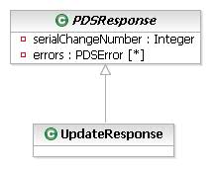
General Update Response

UpdateResponse
The UpdateResponse Class is merely a generalisation of a PDSResponse, and is included for consistency only. It has no attributes of its own.

Create Initial Record
Create Initial Record allocates an NHS Number for a new birth and creates their initial record in the PDS.

Create Initial Record Request

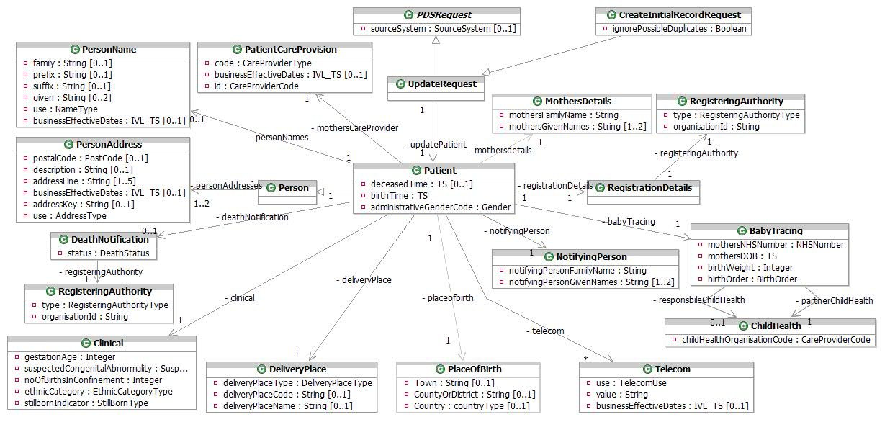
Create Initial Record Request

BabyTracing
This encapsulates the details of a baby’s birth.
Attribute | Type | Values | Cardinality | Definition
birthOrder | BirthOrder | 1 - 1  2 - 2  3 - 3  4 - 4  5 - 5  6 - 6  7 - 7  8 - Not applicable  9 - Not known | 1 | For a birth registration this is mandatory and describes the sequence in the case of multiple births (e.g. twins, triplets etc). For births that are not a part of a multiple birth, this will be set to 1. Note that permissible values are 1-9, with any value between 1 and 7 inclusive indicating the actual birth order number, 8 meaning "Not applicable" and 9 meaning "Not known".
birthWeight | Integer |  | 1 | The weight of the baby at birth. 4-digits, fixed length. 0000..9999 grams. 9999 meaning unweighed (according to NHS Data Dictionary). If 0000 is supplied, it will be treated as 9999.
mothersDOB | TS |  | 1 | This contains mother’s date of birth as a single point in time - date only, without time. The Mother’s NHS Number or the Mother’s Date of Birth must be present. Mother’s Date of Birth is mandatory for Accredited Systems.
mothersNHSNumber | NHSNumber |  | 1 | This contains the mother’s NHS number. The Mother’s NHS Number or the Mother’s Date of Birth must be present. Mother’s NHS Number is mandatory for Accredited Systems. This can only be a new style NHS number.

Partner ChildHealth
Partner Child Health Department details.
Attribute | Type | Values | Cardinality | Definition
childHealthOrganisationCode | CareProviderCode |  | 1 | Unique identifier for the child health department.

Responsible ChildHealth
Responsible Child Health Department details.
Attribute | Type | Values | Cardinality | Definition
childHealthOrganisationCode | CareProviderCode |  | 1 | Unique identifier for the child health department.

Clinical
Clinical information to be forwarded to PSIS. This will not be stored or validated by the PDS, and so is shown as optional.
Attribute | Type | Values | Cardinality | Definition
ethnicCategory | EthnicCategoryType | See http://www.connectingforhealth.nhs.uk/dscn/dscn2001/022001.zip | 1 | Details of the ethnic category of the baby.
gestationAge | Integer |  | 1 | Details of the gestational age of the baby. This will be a 2 digit (fixed length) number in the range 10-49 representing a number of weeks. 00 and 99 are also supported meaning "unknown".
noOfBirthsInConfinement | Integer |  | 1 | Details of the number of births in confinement. Values 1-6 and 9 are permissible, with 6 meaning 6 or more, and 9 indicating a validation error.
stillbornIndicator | StillBornType | 1 - Live  2 - Still birth, ante-partum  4 - Still birth, indeterminate  3 - Still birth, intra-partum | 1 | Indicator for if the baby was stillborn.
suspectedCongenitalAbnormality | SuspectedCongenitalAbnormalityType | N - No  U - Uncertain - further review required  Y - Yes | 1 | Indicates if a congenital abnormality is suspected.

CreateInitialRecordRequest
Extends an UpdateRequest to encapsulate the information required for the Create Initial Record request.
Attribute | Type | Values | Cardinality | Definition
ignorePossibleDuplicates | Boolean |  | 1 | Indicates that duplicate patients should be ignored when creating the PDS Record

DeathNotification
Details about the patient’s death if applicable.
Attribute | Type | Values | Cardinality | Definition
status | DeathStatus | 2 - Formal (Civil Registration)  1 - Informal | 1 | Coded value. From DeathNotification vocabulary.  1 (Informal) death notice received via an update from a local NHS Organisation such as GP or Trust  2 (Formal) death notice received from Registrar of Deaths, or if the birth was a still birth.

DeliveryPlace
The relevant national code for the hospital or maternity unit where the birth took place.
Attribute | Type | Values | Cardinality | Definition
deliveryPlaceCode | String |  | 0..1 | The relevant national code for the organisation name entered above. Must be present if Delivery Place type in [0,2,3,4,7].
deliveryPlaceName | String |  | 0..1 | The name of the hospital or maternity unit where the birth took place. This field should be bypassed if delivery place type code is not in a hospital. Must be present if Delivery Place type in [0,2,3,4,5,6,7].
deliveryPlaceType | DeliveryPlaceType | 1 - At a domestic address  2 - In NHS hospital - delivery facilities associated with consultant ward  4 - In NHS hospital - delivery facilities associated with consultant/GMP/midwife ward inclusive of any combination of two of the professionals mentioned  3 - In NHS hospital - delivery facilities associated with GMP ward  0 - In NHS hospital - delivery facilities associated with midwife ward  7 - In NHS hospital - ward or unit without delivery facilities  6 - In other hospital or institution  5 - In private hospital  8 - None of the above  9 - Not known | 1 | The type of organisation where the birth took place.

MothersDetails
Carries details of the baby’s mother.
Attribute | Type | Values | Cardinality | Definition
mothersFamilyName | String |  | 1 | The family name of the mother.
mothersGivenNames | String |  | 1..2 | The mandatory forename, and optional other forename of the mother.

NotifyingPerson
Carries details of the notifying person responsible for the birth.
Attribute | Type | Values | Cardinality | Definition
notifyingPersonFamilyName | String |  | 1 | The family name of the notifying person.
notifyingPersonGivenNames | String |  | 1..2 | The mandatory forename, and optional other forename of the notifying person.

Patient
This class extends Person to hold additional information about the new patient.
Attribute | Type | Values | Cardinality | Definition
administrativeGenderCode | Gender | 2 - Female  1 - Male  0 - Not Known  9 - Not Specified | 1 | The gender of the patient.
birthTime | TS |  | 1 | The person’s date and time of birth. Full date and time must be given.
deceasedTime | TS |  | 0..1 | The person’s date and time of death where applicable.

PatientCareProvision
An instance of this class identifies a primary care organization responsible for the mother.
Attribute | Type | Values | Cardinality | Definition
businessEffectiveDates | IVL_TS |  | 0..1 | The effective dates for this care provision relationship as a range, supplied in the Low and High attributes of the IVL_TS. Business Effective Dates are full dates without time.
code | CareProviderType | P3 - Dispensing Doctor  P2 - Medical appliance  P1 - Nominated pharmacy  1 - Primary care | 1 | Coded value. From PatientCareProvisionType vocabulary.Only "1" is valid in this case.
id | CareProviderCode |  | 1 | The mother’s GP Practice Code.

Person
Person is an abstract class that has the Patient Class as a generalisation class. Other generalisations exist but are not shown on this diagram for clarity.

PersonAddress
This class is used to hold address details for a person. The structure of this class is based on the HL7 AD data type. One instance identifying usual address is mandatory and one instance identifying a discharge (i.e. temporary) address is optional where different from usual address.
Attribute | Type | Values | Cardinality | Definition
addressKey | String |  | 0..1 | PAF Key
addressLine | String |  | 1..5 | 5 address lines - excludes postcode, may be vernacular or PAF-derived. For vernacular addresses, the following formatting convention should be used:  line 1: premises ID  line 2: no/thoroughfare  line 3: locality  line 4: post town  line 5: county  The following address lines are mandatory:  • 1 or 2 and  • 4
businessEffectiveDates | IVL_TS |  | 0..1 | The dates for which this data is/was current as a range, supplied in the Low and High attributes of the IVL_TS. Business Effective Dates are full dates without time.
description | String |  | 0..1 | Textual description of the usage of a temporary address. For example "On Holiday". For temporary address only (i.e. where the use="TMP").
postalCode | PostCode |  | 0..1 | The UK format Postcode, 8 character string: ZZ99 3VZ. AS PER BS7666.  The 8 characters field allows a space to be inserted to differentiate between the inward and outward segments of the code, enabling full use to be made of Royal Mail postcode functionality.
use | AddressType | PST - Correspondence address  H - Home address  TMP - Temporary address  WP - Work address | 1 | Coded value. From cs_PostalAddressUse HL7 data type. Only values 'H' (usual address) and 'TMP' are relevant to this interaction.

PersonName
This class is used to hold name details for a person within the NHS. The structure of this class is based on the HL7 PN data type.
Attribute | Type | Values | Cardinality | Definition
businessEffectiveDates | IVL_TS |  | 0..1 | The dates for which this data is/was current as a range, supplied in the Low and High attributes of the IVL_TS. Business Effective Dates are full dates without time.
family | String |  | 0..1 | The surname or family name of the patient.
given | String |  | 0..2 | Up to two given names. If the patient has more than 2 given names, these will be concatenated in the 2nd given name attribute with a space between each name.
prefix | String |  | 0..1 | A prefix, or title for the name, such as Mr, Mrs, etc.
suffix | String |  | 0..1 | The suffix for the patient name (i.e. Jnr or Snr).
use | NameType | A - Alias  PREFERRED - PREFERRED  PREVIOUS - PREVIOUS  PREVIOUS-BACHELOR - PREVIOUS-BACHELOR  PREVIOUS-BIRTH - PREVIOUS-BIRTH  PREVIOUS-MAIDEN - PREVIOUS-MAIDEN  L - Usual (current) name | 1 | The type of name this data represents. Only the usual name type is relevant to this interaction.

PlaceOfBirth
Details of the patient’s place of birth in as much detail as is available, i.e., may just be the country the patient was born in, but could also be the county and/or the town. At least one of these attributes must be populated.
Attribute | Type | Values | Cardinality | Definition
Country | countryType |  | 0..1 | Country of birth. Permissible values are limited to the set of England, Wales and the Isle of Man
CountyOrDistrict | String |  | 0..1 | County/Metropolitan district of birth.
Town | String |  | 0..1 | Town/City of birth.

RegisteringAuthority
Provides details of the authority for the PDS registration. These details will be used for the birth and also death (if death is also notified in the message).
Attribute | Type | Values | Cardinality | Definition
organisationId | String |  | 1 | Trust Code or national PCT code or non-NHS providers.
type | RegisteringAuthorityType | v - Appliance Contractor  f - Armed Forces  m - Breast Screening Unit  o - Department of Health  b - Director of Health and Social Care  d - GP Practice  h - IM&T Service  t - Local Authority  g - MOD Hospital  y - NHAIS  l - NHS Administration Unit  c - NHS Trust  s - Non-NHS Commissioner (except Local Authority)  p - Other Government Department  e - Other NHS Organisation  k - Other Statutory Authority  n - Pathology Laboratory  u - Pharmacy  x - Primary Care Trust  q - Registered non-NHS Provider  i - Special Trustee  w - Specialised Services Commissioning Consortium  a - Strategic Health Authority  j - University  r - Unregistered non-NHS Provider (except Local Authority) | 1 | Coded value from RegisteringAuthorityType vocabulary.

RegistrationDetails
Details of the Registration Process. In this case, this class has no attributes, and simply holds the RegisteringAuthority class.

Telecom
Specifies a means of communicating with the patient by telephone, fax, e-mail etc.
Attribute | Type | Values | Cardinality | Definition
businessEffectiveDates | IVL_TS |  | 0..1 | The dates for which this telecom data is/was current as a range, supplied in the Low and High attributes of the IVL_TS. Business Effective Dates are full dates without time.
use | TelecomUse | H - A communication address at a home  EC - A contact specifically designated to be used for emergencies  PG - A paging device suitable to solicit a callback or to leave a very short message  MC - A telecommunication device that moves and stays with its owner  HV - A vacation home, to reach a person while on vacation  AS - An automated answering machine  WP - An office address  HP - The primary home, to reach a person after business hours | 1 | Describes the kind of telecom contact information that is held, e.g. whether it is a home phone number, a work phone number, a mobile phone number etc. Coded value. From cs_TelecommunicationAddressUse HL7 data type.
value | String |  | 1 | The contact method and number separated by a colon. i.e. "tel:01234 567890".

UpdateRequest
Encapsulates the parameter information required for the update request.

Create Initial Record Response

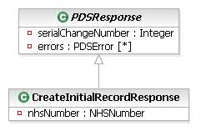
Create Initial Record Response

CreateInitialRecordResponse
Encapsulates the information returned from the Birth Notification request where no duplicate patients are found.
Attribute | Type | Values | Cardinality | Definition
nhsNumber | NHSNumber |  | 1 | NHS number of patient.

Create Initial Record Response (Duplicate Found)

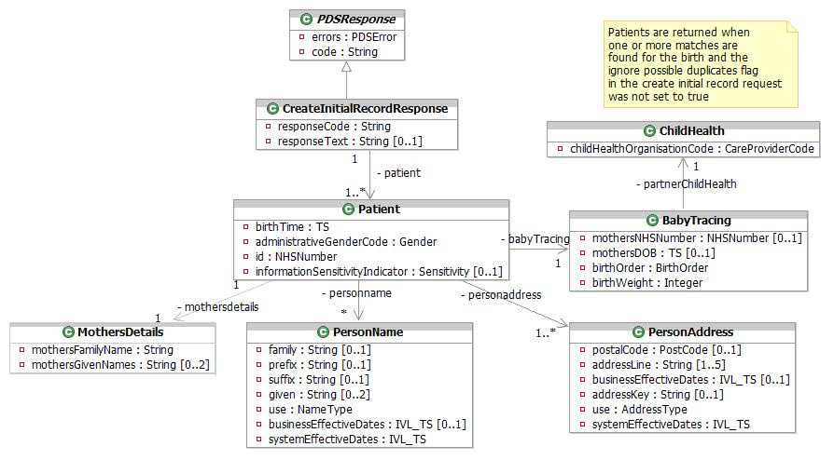
Create Initial Record Response

BabyTracing
This encapsulates data relating to the patient’s birth.
Attribute | Type | Values | Cardinality | Definition
birthOrder | BirthOrder | 1 - 1  2 - 2  3 - 3  4 - 4  5 - 5  6 - 6  7 - 7  8 - Not applicable  9 - Not known | 1 | For a birth registration this is mandatory and describes the sequence in the case of multiple births (e.g. twins, triplets etc). For births that are not a part of a multiple birth, this will be set to 1. Note that permissible values are 1-9, with any value between 1 and 7 inclusive indicating the actual birth order number, 8 meaning "Not applicable" and 9 meaning "Not known".
birthWeight | Integer |  | 1 | The weight of the baby at birth. 4-digits, fixed length. 0000..9999 grams. 9999 meaning unweighed (according to NHS Data Dictionary). If 0000 is supplied, it will be treated as 9999.
mothersDOB | TS |  | 0..1 | This contains mother’s date of birth as a single point in time - Date only - no time. At least one of mothersDOB and mothersNHSNumber will be returned
mothersNHSNumber | NHSNumber |  | 0..1 | This contains the mother’s NHS number. This can be new style, temporary NHS number issued by an NHAIS registration authority or Old style NHS number. At least one of mothersDOB and mothersNHSNumber will be returned

ChildHealth
Child Health Department details.
Attribute | Type | Values | Cardinality | Definition
childHealthOrganisationCode | CareProviderCode |  | 1 | Unique identifier for the child health department.

CreateInitialRecordResponse
Encapsulates the information returned from the Birth Notification request when duplicate patients are found.
Attribute | Type | Values | Cardinality | Definition
responseCode | String |  | 1 | A response code indicating the success or failure of the request.
responseText | String |  | 0..1 | A textual description of the response code.

Patient
This class extends Person to hold additional information for an NHS Patient.
Attribute | Type | Values | Cardinality | Definition
administrativeGenderCode | Gender | 2 - Female  1 - Male  0 - Not Known  9 - Not Specified | 1 | The gender of the patient.
birthTime | TS |  | 1 | The person’s date and time of birth as a single point in time.
id | NHSNumber |  | 1 | NHS number of patient. This will be a new style NHS number only
informationSensitivityIndicator | Sensitivity | B - Business Integration  I - Invalid  N - Not Sensitive  S - Sensitive  Y - Sensitive (P1R1 Legacy Value) | 0..1 | Indicates the patient’s details are marked as sensitive. Address and Child Health data will be withheld if this is set to "S".

PersonAddress
This class is used to hold address details for a potential duplicate baby. All address types will be returned, and any future and historic addresses will be returned where they exist. The structure of this class is based on the HL7 AD data type.
Attribute | Type | Values | Cardinality | Definition
addressKey | String |  | 0..1 | PAF Key
addressLine | String |  | 1..5 | 5 address lines - excludes postcode, may be vernacular or PAF-derived. For vernacular addresses, the following formatting convention should normally apply although there may be some exceptions:  line 1: premises ID  line 2: no/thoroughfare  line 3: locality  line 4: post town  line 5: county  The following address lines should normally be mandatory although there may be some exceptions:  • 1 or 2 and  • 4
use | AddressType | PST - Correspondence address  H - Home address  TMP - Temporary address  WP - Work address | 1 | Coded value. From cs_PostalAddressUse HL7 data type. Only the value 'H' (usual address) is relevant to this interaction.
businessEffectiveDates | IVL_TS |  | 0..1 | The dates for which this data is/was current as a range, supplied in the Low and High attributes of the IVL_TS. Business Effective Dates are full dates without time.
systemEffectiveDates | IVL_TS |  | 1 | System generated effective dates for this data item as a range, supplied in the Low and High attributes of the IVL_TS. For current and future dated data, only the Low attribute will be set. Always returned.
postalCode | PostCode |  | 0..1 | The UK format Postcode, 8 character string: ZZ99 3VZ. AS PER BS7666.  The 8 characters field allows a space to be inserted to differentiate between the inward and outward segments of the code, enabling full use to be made of Royal Mail postcode functionality.

PersonName
This class is used to hold name details for a person within the NHS. All name types will be returned, and any future and historic names will be returned where they exist. The structure of this class is based on the HL7 PN data type.
Attribute | Type | Values | Cardinality | Definition
businessEffectiveDates | IVL_TS |  | 0..1 | The dates for which this data is/was current as a range, supplied in the Low and High attributes of the IVL_TS. Business Effective Dates are full dates without time.
family | String |  | 0..1 | The surname or family name of the patient.
given | String |  | 0..2 | Up to two given names. If the patient has more than 2 given names, these will be concatenated in the 2nd given name attribute with a space between each name.
prefix | String |  | 0..1 | A prefix, or title for the name, such as Mr, Mrs, etc.
suffix | String |  | 0..1 | The suffix for the patient name (i.e. Jnr or Snr).
systemEffectiveDates | IVL_TS |  | 1 | System generated effective dates for this data item as a range, supplied in the Low and High attributes of the IVL_TS. For current and future dated data, only the Low attribute will be set. Always returned.
use | NameType | A - Alias  PREFERRED - PREFERRED  PREVIOUS - PREVIOUS  PREVIOUS-BACHELOR - PREVIOUS-BACHELOR  PREVIOUS-BIRTH - PREVIOUS-BIRTH  PREVIOUS-MAIDEN - PREVIOUS-MAIDEN  L - Usual (current) name | 1 | The type of name this data represents. Only usual name type ("L") is relevant to this interaction.

MothersDetails
Carries details of the baby’s mother.
Attribute | Type | Values | Cardinality | Definition
mothersFamilyName | String |  | 1 | The family name of the mother.
mothersGivenNames | String |  | 0..2 | The mandatory forename, and optional other forename of the mother.

Outbound Birth Notification

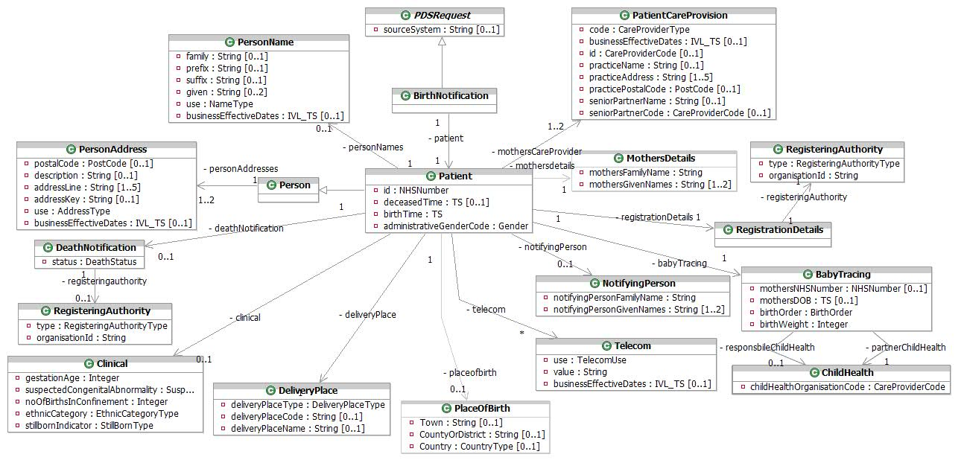
Outbound Birth Notification

BabyTracing
This encapsulates the details of a baby’s birth.
Attribute | Type | Values | Cardinality | Definition
birthOrder | BirthOrder | 1 - 1  2 - 2  3 - 3  4 - 4  5 - 5  6 - 6  7 - 7  8 - Not applicable  9 - Not known | 1 | For a birth registration this is mandatory and describes the sequence in the case of multiple births (e.g. twins, triplets etc). For births that are not a part of a multiple birth, this will be set to 1. Note that permissible values are 1-9, with any value between 1 and 7 inclusive indicating the actual birth order number, 8 meaning "Not applicable" and 9 meaning "Not known".
birthWeight | Integer |  | 1 | The weight of the baby at birth. 4-digits, fixed length. 0000..9999 grams. 9999 meaning unweighed (according to NHS Data Dictionary). If 0000 is supplied, it will be treated as 9999.
mothersDOB | TS |  | 0..1 | This contains mother’s date of birth as a single point in time - Date only - no time.
mothersNHSNumber | NHSNumber |  | 0..1 | This contains the mother’s NHS number. This can only be a new style NHS number.

BirthNotification
Extends an UpdateRequest to encapsulate the information required for the Outbound Birth Notification.

Partner ChildHealth
Partner Child Health Department details.
Attribute | Type | Values | Cardinality | Definition
childHealthOrganisationCode | CareProviderCode |  | 1 | Unique identifier for the child health department.

Responsible ChildHealth
Responsible Child Health Department details.
Attribute | Type | Values | Cardinality | Definition
childHealthOrganisationCode | CareProviderCode |  | 1 | Unique identifier for the child health department.

Clinical
Clinical information to be forwarded to PSIS. This will not be stored on the PDS.
Attribute | Type | Values | Cardinality | Definition
ethnicCategory | EthnicCategoryType | See http://www.connectingforhealth.nhs.uk/dscn/dscn2001/022001.zip | 1 | Details of the ethnic category of the baby.
gestationAge | Integer |  | 1 | Details of the gestational age of the baby. This will be a 2 digit (fixed length) number in the range 10-49 representing a number of weeks. 00 and 99 are also supported meaning "unknown".
noOfBirthsInConfinement | Integer |  | 1 | Details of the number of births in confinement. Values 1-6 and 9 are permissible, with 6 meaning 6 or more, and 9 indicating a validation error.
stillbornIndicator | StillBornType | 1 - Live  2 - Still birth, ante-partum  4 - Still birth, indeterminate  3 - Still birth, intra-partum | 1 | Indicator for if the baby was stillborn.
suspectedCongenitalAbnormality | SuspectedCongenitalAbnormalityType | N - No  U - Uncertain - further review required  Y - Yes | 0..1 | Indicates if a congenital abnormality is suspected.

DeathNotification
Details about the patient’s death if applicable.
Attribute | Type | Values | Cardinality | Definition
status | DeathStatus | 2 - Formal (Civil Registration)  1 - Informal | 1 | Coded value. From DeathNotification vocabulary.  1 (Informal) death notice received via an update from a local NHS Organisation such as GP or Trust  2 (Formal) death notice received from Registrar of Deaths, or if the birth was a still birth.

DeliveryPlace
The place of the patient’s birth.
Attribute | Type | Values | Cardinality | Definition
deliveryPlaceCode | String |  | 0..1 | The relevant national code for the hospital or maternity unit where the birth took place. Must be present if Delivery Place type in [0,2,3,4,7].
deliveryPlaceName | String |  | 0..1 | The name of the hospital or maternity unit where the birth took place. This field should be bypassed if delivery place type code is not in a hospital. Must be present if Delivery Place type in [0,2,3,4,5,6,7].
deliveryPlaceType | DeliveryPlaceType | 1 - At a domestic address  2 - In NHS hospital - delivery facilities associated with consultant ward  4 - In NHS hospital - delivery facilities associated with consultant/GMP/midwife ward inclusive of any combination of two of the professionals mentioned  3 - In NHS hospital - delivery facilities associated with GMP ward  0 - In NHS hospital - delivery facilities associated with midwife ward  7 - In NHS hospital - ward or unit without delivery facilities  6 - In other hospital or institution  5 - In private hospital  8 - None of the above  9 - Not known | 1 | The type of organisation where the birth took place.

MothersDetails
Carries details of the baby’s mother.
Attribute | Type | Values | Cardinality | Definition
mothersFamilyName | String |  | 1 | The family name of the mother.
mothersGivenNames | String |  | 1..2 | The mandatory forename, and optional other forename of the mother.

NotifyingPerson
Carries details of the notifying person responsible for the birth.
Attribute | Type | Values | Cardinality | Definition
notifyingPersonFamilyName | String |  | 1 | The family name of the notifying person.
notifyingPersonGivenNames | String |  | 1..2 | The mandatory forename, and optional other forename of the notifying person.

Patient
This class extends Person to hold additional information about the new patient.
Attribute | Type | Values | Cardinality | Definition
administrativeGenderCode | Gender | 2 - Female  1 - Male  0 - Not Known  9 - Not Specified | 1 | The gender of the patient.
birthTime | TS |  | 1 | The person’s date and time of birth as a single point in time.
deceasedTime | TS |  | 0..1 | The person’s date and time of death where applicable. yyyyMMddHHmm or Date Only.
id | NHSNumber |  | 1 | NHS number of patient.

PatientCareProvision
An instance of this class identifies a mother's GP or primary care organization. Either Practice Name or ID must be present. One mandatory repeat for GP Practice will be present. When a message is sent to non-NCRS compliant systems an additional repeat is mandatory for GP (senior partner of GP Practice).
Attribute | Type | Values | Cardinality | Definition
businessEffectiveDates | IVL_TS |  | 0..1 | The effective dates for this care provision relationship as a range, supplied in the Low and High attributes of the IVL_TS. Business Effective Dates are full dates without time.
code | CareProviderType | P3 - Dispensing Doctor  P2 - Medical appliance  P1 - Nominated pharmacy  1 - Primary care | 1 | Coded value. From PatientCareProvisionType vocabulary. Only a value '1' is relevant in this interaction.
id | CareProviderCode |  | 0..1 | The mother’s GP or GP Practice Code.
practiceAddress | String |  | 1..5 | The address of the GP Practice. Either Address Line 1 or Address Line 2 must be present.
practiceName | String |  | 0..1 | The name of the GP Practice.
practicePostalCode | PostCode |  | 0..1 | The UK format Postcode, 8 character string: ZZ99 3VZ. AS PER BS7666.  The 8 characters field allows a space to be inserted to differentiate between the inward and outward segments of the code, enabling full use to be made of Royal Mail postcode functionality.
seniorPartnerCode | CareProviderCode |  | 0..1 | The GP National code of the Senior Partner at the practice.
seniorPartnerName | String |  | 0..1 | The name of the Senior Partner at the practice.

Person
Person is an abstract class that has the Patient Class as a generalisation class. Other generalisations exist but are not shown on this diagram for clarity.

PersonAddress
This class is used to hold address details for a person. One instance identifying usual address is mandatory and one instance identifying a discharge (i.e. temporary) address is optional where different from usual address. The structure of this class is based on the HL7 AD data type.
Attribute | Type | Values | Cardinality | Definition
addressKey | String |  | 0..1 | PAF Key
addressLine | String |  | 1..5 | 5 address lines - excludes postcode, may be vernacular or PAF-derived. For vernacular addresses, the following formatting convention should normally apply although there may be some exceptions:  line 1: premises ID  line 2: no/thoroughfare  line 3: locality  line 4: post town  line 5: county  The following address lines should normally be mandatory although there may be some exceptions:  • 1 or 2 and  • 4
use | AddressType | PST - Correspondence address  H - Home address  TMP - Temporary address  WP - Work address | 1 | Coded value. From cs_PostalAddressUse HL7 data type. Only values 'H' (usual address) and 'TMP' are relevant to this interaction.
businessEffectiveDates | IVL_TS |  | 0..1 | The dates for which this data is/was current as a range, supplied in the Low and High attributes of the IVL_TS. Business Effective Dates are full dates without time.
description | String |  | 0..1 | Textual description of the usage of a temporary address. For example "On Holiday". For temporary address only (i.e. where the use="TMP").
postalCode | PostCode |  | 0..1 | The UK format Postcode, 8 character string: ZZ99 3VZ. AS PER BS7666.  The 8 characters field allows a space to be inserted to differentiate between the inward and outward segments of the code, enabling full use to be made of Royal Mail postcode functionality.

PersonName
This class is used to hold name details for a person within the NHS. The structure of this class is based on the HL7 PN data type.
Attribute | Type | Values | Cardinality | Definition
businessEffectiveDates | IVL_TS |  | 0..1 | The dates for which this data is/was current as a range, supplied in the Low and High attributes of the IVL_TS. Business Effective Dates are full dates without time.
family | String |  | 0..1 | The surname or family name of the patient.
given | String |  | 0..2 | Up to two given names. If the patient has more than 2 given names, these will be concatenated in the 2nd given name attribute with a space between each name.
prefix | String |  | 0..1 | A prefix, or title for the name, such as Mr, Mrs, etc.
suffix | String |  | 0..1 | The suffix for the patient name (i.e. Jnr or Snr).
use | NameType | A - Alias  PREFERRED - PREFERRED  PREVIOUS - PREVIOUS  PREVIOUS-BACHELOR - PREVIOUS-BACHELOR  PREVIOUS-BIRTH - PREVIOUS-BIRTH  PREVIOUS-MAIDEN - PREVIOUS-MAIDEN  L - Usual (current) name | 1 | The type of name this data represents. Only usual name type ("L") is relevant to this interaction.

PlaceOfBirth
Details of the patient’s place of birth in as much detail as is available, i.e., may just be the country the patient was born in, but could also be the county and/or the town. At least one of these attributes must be populated.
Attribute | Type | Values | Cardinality | Definition
Country | countryType |  | 0..1 | Country of birth. Permissible values are limited to the set of England, Wales and the Isle of Man
CountyOrDistrict | String |  | 0..1 | County/Metropolitan district of birth.
Town | String |  | 0..1 | Town/City of birth.

RegisteringAuthority
Provides details of the authority for the PDS registration. These details will be used for the birth and also death (if death is also notified in the message).
Attribute | Type | Values | Cardinality | Definition
organisationId | String |  | 1 | Trust Code or national PCT code.
type | RegisteringAuthorityType | v - Appliance Contractor  f - Armed Forces  m - Breast Screening Unit  o - Department of Health  b - Director of Health and Social Care  d - GP Practice  h - IM&T Service  t - Local Authority  g - MOD Hospital  y - NHAIS  l - NHS Administration Unit  c - NHS Trust  s - Non-NHS Commissioner (except Local Authority)  p - Other Government Department  e - Other NHS Organisation  k - Other Statutory Authority  n - Pathology Laboratory  u - Pharmacy  x - Primary Care Trust  q - Registered non-NHS Provider  i - Special Trustee  w - Specialised Services Commissioning Consortium  a - Strategic Health Authority  j - University  r - Unregistered non-NHS Provider (except Local Authority) | 1 | Coded value from RegisteringAuthorityType vocabulary.

RegistrationDetails
Details of the Registration Process.

Telecom
Specifies a means of communicating with the patient by telephone, fax, e-mail etc.
Attribute | Type | Values | Cardinality | Definition
businessEffectiveDates | IVL_TS |  | 0..1 | The dates for which this telecom data is/was current as a range, supplied in the Low and High attributes of the IVL_TS. Business Effective Dates are full dates without time.
use | TelecomUse | H - A communication address at a home  EC - A contact specifically designated to be used for emergencies  PG - A paging device suitable to solicit a callback or to leave a very short message  MC - A telecommunication device that moves and stays with its owner  HV - A vacation home, to reach a person while on vacation  AS - An automated answering machine  WP - An office address  HP - The primary home, to reach a person after business hours | 1 | Describes the kind of telecom contact information that is held, e.g. whether it is a home phone number, a work phone number, a mobile phone number etc. Coded value. From cs_TelecommunicationAddressUse HL7 data type.
value | String |  | 1 | The contact method and number separated by a colon. i.e. "tel:01234 567890".

Cross Check Trace
Cross Check Trace provides the facility to determine whether demographic data supplied for an NHS Number matches that held for the same NHS Number on the Spine, and to therefore provide an indication of quality of data held for a patient record by the requesting system. A summary set of demographic information (current and future dated), including the NHS number, is returned if a single exact match is found, otherwise a suitable status is returned. See the PDS [SSRS] for details of the responses returned by Cross Check Trace.

The informationSensitivityIndicator of the patient will affect the returned data – see the [SSRS] for details.

Cross Check Trace Request

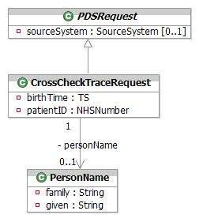
Cross Check Trace Request

CrossCheckTraceRequest
Encapsulates the parameters used in a Cross Check Trace with the intention of determining whether demographic data supplied for an NHS Number matches that held for the same NHS Number on the Spine, and to therefore provide an indication of quality of data held for a patient record by the requesting system.
Attribute | Type | Values | Cardinality | Definition
birthTime | TS |  | 1 | The date of birth of the person being cross checked as a single point in time – Full date only - no time.
patientID | NHSNumber |  | 1 | The NHS Number of the patient being cross checked. This may be a new style NHS Number only.

PersonName
This class is used to hold name details for a person within the NHS. The structure of this class is based on the HL7 PN data type.
Attribute | Type | Values | Cardinality | Definition
family | String |  | 1 | The surname or family name of the patient. At least the first 3 characters of the family name must be present when a PersonName is supplied.
given | String |  | 1 | The patient’s given, or forename. At least the first character of the given name must be present when a PersonName is supplied.

Cross Check Trace Response

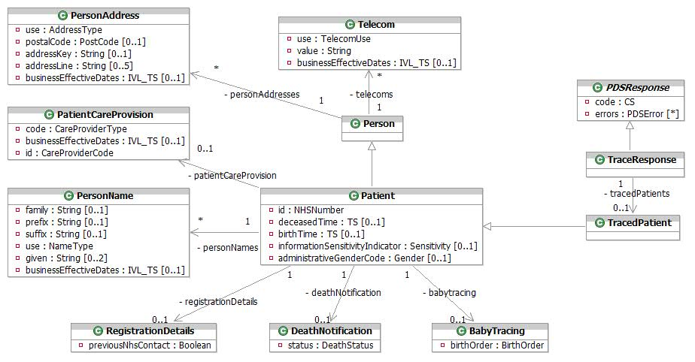
Cross Check Trace Response

BabyTracing
This encapsulates birth information about the patient.
Attribute | Type | Values | Cardinality | Definition
birthOrder | BirthOrder | 1 - 1  2 - 2  3 - 3  4 - 4  5 - 5  6 - 6  7 - 7  8 - Not applicable  9 - Not known | 1 | Describes the sequence in the case of multiple births (e.g. twins, triplets etc). For births that are not a part of a multiple birth, this will be set to 1. Note that permissible values are 1-9, with any value between 1 and 7 inclusive indicating the actual birth order number, 8 meaning "Not applicable" and 9 meaning "Not known".

DeathNotification
Details about a death notification.
Attribute | Type | Values | Cardinality | Definition
status | DeathStatus | 2 - Formal (Civil Registration)  1 - Informal | 1 | Coded value. From DeathNotification vocabulary.  1 (Informal) death notice received via an update from a local NHS Organisation such as GP or Trust  2 (Formal) death notice received from Registrar of Deaths

Patient
This class extends Person to hold additional information for an NHS Patient matched by the trace.
Attribute | Type | Values | Cardinality | Definition
administrativeGenderCode | Gender | 2 - Female  1 - Male  0 - Not Known  9 - Not Specified | 0..1 | The gender of the patient.
birthTime | TS |  | 0..1 | The person’s date and time of birth as a single point in time.
deceasedTime | TS |  | 0..1 | The person’s date and time of death as a single point in time.
id | NHSNumber |  | 1 | NHS Number or temporary NHS number issued by an NHAIS registration authority or Old style NHS number.
informationSensitivityIndicator | Sensitivity | B - Business Integration  I - Invalid  N - Not Sensitive  S - Sensitive  Y - Sensitive (P1R1 Legacy Value) | 0..1 | Indicates the patient’s details are marked as sensitive. Only values "B", "S" and "Y" are returned by Cross Check Trace.

PatientCareProvision
The patient’s current GP Practice.
Attribute | Type | Values | Cardinality | Definition
businessEffectiveDates | IVL_TS |  | 0..1 | The effective dates for this care provision relationship as a range, supplied in the Low and High attributes of the IVL_TS. Business Effective Dates are full dates without time.
code | CareProviderType | P3 - Dispensing Doctor  P2 - Medical appliance  P1 - Nominated pharmacy  1 - Primary care | 1 | Coded value. From PatientCareProvisionType vocabulary. Only a value of "1" is relevant to a Cross Check Trace.
id | CareProviderCode |  | 1 | The GP Practice Code.

Person
Person is an abstract class that has the Patient Class as a generalisation class. Other generalisations exist but are not shown on this diagram for clarity.

PersonAddress
This class is used to hold address details for a person. Cross Check Trace will only return the patient’s current (and any future) usual ("H") address. The structure of this class is based on the HL7 AD data type.
Attribute | Type | Values | Cardinality | Definition
addressKey | String |  | 0..1 | PAF Key
addressLine | String |  | 0..5 | 5 address lines - excludes postcode, may be vernacular or PAF-derived. For vernacular addresses, the following formatting convention should normally apply although there may be some exceptions:  line 1: premises ID  line 2: no/thoroughfare  line 3: locality  line 4: post town  line 5: county  The following address lines should normally be mandatory although there may be some exceptions:  • 1 or 2 and  • 4
businessEffectiveDates | IVL_TS |  | 0..1 | The dates for which this address data is/was current as a range, supplied in the Low and High attributes of the IVL_TS. Business Effective Dates are full dates without time.
postalCode | PostCode |  | 0..1 | The UK format Postcode, 8 character string: ZZ99 3VZ. AS PER BS7666.  The 8 characters field allows a space to be inserted to differentiate between the inward and outward segments of the code, enabling full use to be made of Royal Mail postcode functionality.
use | AddressType | PST - Correspondence address  H - Home address  TMP - Temporary address  WP - Work address | 1 | Coded value. From cs_PostalAddressUse HL7 data type. Only "H" will be returned from a Cross Check Trace.

PersonName
This class is used to hold name details for a person within the NHS. Multiple PersonName instances may be returned, representing alternative names for the patient. Only current (and any future) data is returned. The structure of this class is based on the HL7 PN data type.
Attribute | Type | Values | Cardinality | Definition
businessEffectiveDates | IVL_TS |  | 0..1 | The dates for which this name data is/was current as a range, supplied in the Low and High attributes of the IVL_TS. Business Effective Dates are full dates without time.
family | String |  | 0..1 | The surname or family name of the patient.
given | String |  | 0..2 | Up to two given names. If the patient has more than 2 given names, these will be concatenated in the 2nd given name attribute with a space between each name.
prefix | String |  | 0..1 | A prefix, or title for the name, such as Mr, Mrs, etc.
suffix | String |  | 0..1 | The suffix for the patient name (i.e. Jnr or Snr).
use | NameType | A - Alias  PREFERRED - PREFERRED  PREVIOUS - PREVIOUS  PREVIOUS-BACHELOR - PREVIOUS-BACHELOR  PREVIOUS-BIRTH - PREVIOUS-BIRTH  PREVIOUS-MAIDEN - PREVIOUS-MAIDEN  L - Usual (current) name | 1 | The type of name this data represents. Only usual, alias and preferred name types are relevant to this interaction

RegistrationDetails
Details of the Registration Process.
Attribute | Type | Values | Cardinality | Definition
previousNhsContact | Boolean |  | 1 | Previous contact with the NHS - i.e. 2nd Acceptance.

Telecom
Specifies a means of communicating with the patient by telephone, fax, e-mail etc. Multiple instances of Telecom will be returned representing multiple contact methods. Only current (and any future) data is returned.
Attribute | Type | Values | Cardinality | Definition
businessEffectiveDates | IVL_TS |  | 0..1 | The dates for which this telecom data is/was current as a range, supplied in the Low and High attributes of the IVL_TS. Business Effective Dates are full dates without time.
use | TelecomUse | H - A communication address at a home  EC - A contact specifically designated to be used for emergencies  PG - A paging device suitable to solicit a callback or to leave a very short message  MC - A telecommunication device that moves and stays with its owner  HV - A vacation home, to reach a person while on vacation  AS - An automated answering machine  WP - An office address  HP - The primary home, to reach a person after business hours | 1 | Describes the kind of telecom contact information that is held, e.g. whether it is a home phone number, a work phone number, a mobile phone number etc. Coded value. From cs_TelecommunicationAddressUse HL7 data type. Refer to NPfIT MIM for applicable values.
value | String |  | 1 | The contact method and number separated by a colon. i.e. "tel:01234 567890".

TracedPatient
Contains the current details of the matched patient where a match was found.

TraceResponse
Encapsulates the information returned from a trace request, containing the single matched patient.

References
Ref. | Doc No. | Document Title | Version No.
[LIM] | 3604 | 2007-A Demographics Logical Interface Model REQ075 | Issue 4
[SSRS] | 3585 | 2007-A PDS Subsystem Software Requirements Specification REQ090 | Issue 4

Glossary of Terms
Abbr’n | Full Name | Notes
CHRIS | Central Health Register Inquiry System | The system used to record and maintain a unique record for each patient, indexed using the NHS Number.
DIM | Design Interface Model | A design level abstraction of Spine Services
DSA | Demographic Spine Application | A back-office application for amending PDS data
LIM | Logical Interface Model | An analysis level abstraction of Spine Services
NN4B | NHS Numbers For Babies | System used to allocate NHS numbers to the new born
NSTS | NHS Strategic Tracing System | A database of people, places and NHS organisations in England and Wales.
ONS | Office for National Statistics
PDS | Personal Demographic Service | A central demographics service for NHS Care Records

End of Document.

